**AWS Certified Solutions Architect Associate - SAA-C03**

**Exam Blue Print:**

* 130 Minutes in Length
* 65 Questions (this can change)
* Multiple Choice
* 70% to pass. Results are between 100 and 1000 with 720 of passing score.
* Certification valid for 3 years.
* Scenario based questions.

**Exam Tips:**

* Don’t spend too much time in hard questions first. Flag them and review later.
* Watch for keyword indicators on certain scenarios.
* Remember the Well-Architected Framework pillars.

**Exam Guide:**

* **Scenario Based:** Large majority of the questions based on real-world scenarios.
  + Pay attention to key words and requirements.
* **Multiple choice questions:** One correct response and three incorrect (distractors)
* **Multiple response:** Two correct responses out of five response options.

**Exam Domains:**

* **Design Resilient Architectures** – 26%
  + Design a multi-tier architecture solution.
    - How to make them scalable
    - Loosely coupled (building flexible, standalone, scalable services.)
  + Multitier (Multiple layers, like front end, backend, etc)
  + Design high available and/or fault tolerant architectures.
    - Know difference between both.
  + Design decoupling mechanisms using AWS services.
    - Message Queues
    - Notification topics.
  + Choose appropriate resilient storage.
    - What are the requirements for the storage
    - How often is accessed
    - etc
* **Design High-Performing Architectures 24%**
  + Identify elastic and scalable compute solutions for a workload.
    - Autoscaling groups
    - Load Balancers for handling or dispersing load
  + Select best high-performing and scalable **storage** solutions for a workload.
  + Select best high-performing and scalable **network** solutions for a workload.
    - Do you need VPN
    - Or Direct connect?
    - Etc
  + Choose best high-performing database solutions for a workload.
    - You need relational database? Like Dynamodb
    - Or Amazon Redshift?
    - etc
* **Design Secure Architectures 30%**
  + Design secure access to AWS resources
    - IAM
    - AWS single sign-on
    - Etc
  + Design secure application tiers
  + Select appropriate data security options
    - Encryption at rest
    - Encryption in transit
    - etc
* **Design Cost-Optimized Architectures 20%**
  + Identify cost-effective storage solutions
    - Different tiers in S3 storage
  + Identity most cost-effective compute and database services
    - Aurora serverless
    - Spot instances for EC2
    - Etc
  + Designing cost-optimized network architectures

**AWS Fundamentals**

**The building Blocks of AWS: Availability Zones and Regions**

**Region:** Is a physical location, like London, New York, Sidney, etc

**Availability Zone (AZ):**

* Is a datacenter withing a region. Each region must have at least 3 or more AZ.
* An AZ could be several datacenters if they are close together, then will be grouped in an AZ.
* Each AZ must be separated between them by many kilometres, although all are within 100 km of each other.

**Edge Locations:**

* Endpoint used for caching content.
* There are many more Edge Locations than Regions.
* Typically consists of CloudFront, Amazon’s CDN

**Who Owns What in the Cloud**

**The Shared Responsibility Model:**

**Customer:**

Responsible for security **IN** the Cloud:



**AWS:**

Responsible for security **OF** the Cloud:



**Exam Tips:**

To know who is responsible (me or Amazon) ask:

Can I do it myself in the AWS management console?

**If yes**, you are likely responsible:

Security Groups, IAM users, patching EC2 OS, pathing db running in EC2.

**If not:**

Management of datacenters, security cameras, cabling, patching RDS OS, etc.

**Shared responsibility:**

Encryption is shared.

You could want to encrypt a volume, you are responsible of hitting the button and AWS is responsible of doing it.

**Compute, Storage, Databases, and Networking**

To make the exam easier we split things up into four key or core services:

* Compute
* Storage
* Databases
* Networking

**Compute:**

* EC2 🡪 Virtual Machines
* Lambda 🡪 Serverless, no virtual machines
* Elastic Beanstalk 🡪 Provisioning engine, to automate the deployment of my apps in AWS.

**Storage:**

* S3 🡪 To store files, etc.
* EBS, Elastic Block Store 🡪 Virtual hard disk attached to our virtual machines.
* EFS, Elastic File Service. 🡪 A way of store our files centrally.
* FSx 🡪 Fileserver storage for windows servers.
* Storage Gateway (connects on prem environment with cloud storage.)

**Databases:** Think about it as a spreadsheet (exel). It’s a reliable way to store and retrieve information.

* RDS, Relational Database Services
* DynamoDB, AWS non-relational database.
* Redshift, it’s a warehousing technology.

**Networking:**

* VPC’s, Virtual Datacenters in the cloud. Where are resources are going to live.
* Direct Connect, to connect our headquarters or on prem dc to AWS
* Route 53, DNS solution, from registering to pointing them out where we want.
* API Gateway, serverless way of replacing our webservers
* AWS Global Accelerator, a way to accelerating your audiences towards your applications within AWS.

**Exam Guide**

Is quite complex, have ~20 pages.

Tell you information about the exam and a lot of things related.

Have a read when you finish the course.

**Well-Architected Framework: Read this white paper before the exam:** <https://docs.aws.amazon.com/wellarchitected/latest/framework/welcome.html>

**Six Pillars of the Well-Architected Framework**

1. **Operational Excellence:**
   1. Running and monitoring systems to deliver business value, and continually improving processes and procedures.
2. **Performance Efficiency:**
   1. Using IT and computing resources efficiently
3. **Security:**
   1. Protecting information and systems
4. **Cost Optimization:**
   1. Avoiding unnecessary costs
5. **Reliability:**
   1. Ensuring a workload performs its intended function correctly and consistently when it’s expected to
6. **Sustainability:**
   1. Minimizing the environmental impacts of running cloud workloads.

**Exam Tips:**

**Region**: Physical location in the world. Consists in 3 or more AZ

**Availability Zone, AZ:**  Is one discrete datacenter, each with redundant power and networking.

**Edge Location:** Enpoints for AWS for caching content. Typically CloudFront (CDN)

**Who is responsible:**

Can you touch it by yourself: You

Is managed by AWS: AWS

**Compute:** EC2, Lambda, Elastic Beanstalk.

**Storage:** S3, EBS, EFS, FSx, Storage Gateway

**Databases:** RDS, DynamoDB, Redshift.

**Networking:** VPC, Direct Connect, Route 53, API Gateway, AWS Global Accelerator

Read the whitepaper of well architected framework.

**Identity and Access Management 101**

101 Means that is an introductory topic for a lecture. This is used in UK and the States.

**Ai** = I

**Ei** = A

**Em** = M

Ai Ei Em

**Root Account:**

* Is the email account you used to sign up for AWS.
* It has full administrative access to AWS.
* Is very important to SECURE this account.

**Exam Tips:**

* Enable Multi-factor authentication on the root account
* Create an admin group for your administrators and assign the appropriate permissions to this group.
* Create user accounts for your administrators.
* Add your users to the admin group.

**How do we control Permissions using IAM:** We assign permissions using policy documents, which are made up of JSON.

You will need to know how to read and understand JSON policy documents in the exam. [HERE](https://docs.aws.amazon.com/IAM/latest/UserGuide/access_policies.html#access_policies-json)

**IAM Policy Documents:** You can assign them to:

* **Groups** 🡪 you assign the user to a group and then assign the policy to the group.
* **Users** (is not typical to assign policies to users as makes difficult to manage)
* **Roles**

IAM does work at a Global level, any user, role, etc is created globally in all the regions of AWS.

**Apply or Create Policies:**

There are more than 1000 policy templates, or you can create your own one (which won’t have the orange box if you create it)

Example: AdministratorAccess policy

It grants access to all the services in AWS, the JSON is very simple:

{

"Version": "2012-10-17",

"Statement": [

{

"Effect": "Allow",

"Action": "*",

"Resource": "*"

}

]

}

Allow everything to all the resources.

**Exam Tips:**

* Assign permissions using IAM policy documents consisting of JSON
* In the exam you will have complicated S3 (could be other service) policy documents and will need to know that they do.
* Pick random policies and look how the JSON works.

**Permanent IAM Credentials:**

**User** = Human being. Should be a physical person.

**Groups**: We should group our users into Groups by Job Function (Admins, Marketing, BE Developers, etc)

**Roles:** For Internal usage within AWS. Allows a part of aws to access another part of aws. Like allowing an EC2 to access a S3 bucket.

**Best Practices:**

Inherit the permissions (Policies) from Groups instead of single users.

You can assign to users directly but is hard to manage as people comes and goes to the organization, or you have contractors, etc.

Is much easier to apply an IAM policy document to a group and the users in that group will inherit those permissions.

Never share user accounts.

**Principle of Least Privilege:**

Assign a user only the minimum number of privileges they need to do their job.

Example:

Sysadmin group will need full access to the AWS platform but not Finances or HR department.

If there is no Allow explicitly this means it’s a Deny.

**Tips when creating a user:**

* Add tags, tags are key value pairs

Use these ones:

Department: Front End Developer

Employee_ID: 123456

Now each time this user creates a resource, the resource will be tagged with this information and will be much easy to track who did it.

* Policy type Job function

AWS already have a few job functions policies set up, like Network Admin, Data Scientist, Support User, etc.

For instance: PowerUserAccess 🡪 Can use everything but can NOT create users and groups.

**Once created the user:**

It will give you the option so send the sign-in instructions via email.

You will see the url the user has to use to access the console (aws gui)

You will see the user and password there too.

And will give you the option to download the password. You won’t be able to retrieve this password again so have this in mind.

**Account Settings:** IAM – Access Management – Account Settings

You manage there the password policies, example:

* How much characters the password has to have.
* Capital Letters and/or lowercase?
* Do you want to use special characters?
* Password expiration
* etc

**Created user without group:** Could be a question for the exam.

If you create a user without assigning him a group the only thing he will be able to do is to change its own password.

IAM – Users – test_user – Permissions: Permissions policies 🡪 it will have only “

IAMUserChabgePassword” policy applied.

**Programmatic Access:** To use the command line.

IAM – Users – my_user – Access key 1: Create access key – Command Line Interface (CLI) – Next – add tag if you want – Create

It will create an user and password:

Access key = Username

Secret access key = Password

This access key / secret access key is SEPARATED from the access to the AWS Gui (console).

**Identity providers:** Allow us to connect IAM to things like Active Directory.

IAM –Access Management -- Identity providers

* SAML: To connect AD
* OpenID Connect: To use it with services such as Google, Salesforce, etc.

Possible Exam question: You need to use the same SSO (Single sign-on) that you are using to login in into your windows environment in order to access AWS Management Console, what would you do?

I will add an Identity provider with the provider type SAML.

**Explicit Deny:** When you edit a policy by yourself.

An explicit deny will always override any allow in any other policy.

So if there is an explicit deny, IT WILL ALLWAYS DENY IT, doesn’t matter if there is another policy Allowing the same resource.

Let’s say you have two policies applied to your user:

ec2-admin

all-admin

In both you can see/run/stop ec2 instances, but if you edit manually the policy applied to this user:

IAM – Users – user1 – Permissions – select ec2-admin for example – Edit – (it will redirect you to IAM – User Groups – ec2-admin) and you change the Effect *allow* for *deny*

{

"Version": "2012-10-17",

"Statement": [

{

"Action": [

"ec2:Describe*",

"ec2:StartInstances",

"ec2:StopInstances"

],

"Resource": "*",

**"Effect": "Allow" 🡪 before the change.**

},

**"Effect": "Deny" 🡪 after the change.**

Now we have two policies, ec2-admin (deny) and all-admin (allow), both applying to actions over ec2 instances.

If one says allow and the other says deny for the same resource it will DENY the use of that resource.

**Exam Tips:**

* **IAM is universal:** It does not apply to regions, is created across the world globally.
* **The root Account:** The account is created when you first set up your AWS account and which has complete admin access. Secure it as soon as possible and DO NOT use it to log in day to day.
* **New Users:**  No permissions when first created, we must add the permissions manually or add the user to a group. The user will have only the “IAMUserChabgePassword” policy.
* Access key ID and Secret access keys are not the same as usernames and passwords, are used for programmatic access to the AWS console. You only will see the access key and the password once, when you create it, so make sure you saved it.
* **Always set up password rotations:** You can create your own password rotation policies.
* **Identity Federation / IAM Federation:** Identity Providers: To Single Sign-On (SSO) into AWS Management Console using the user/password of another provider, like Active Directory, Salesforce, Google, etc. It uses these Protocols:
  + **SAML:** Security Assertion Markup Language, MS Active Directory
  + **OpenID Connect:** Salesforce, Google, etc
* **Explicit Deny:** If you have two policies applying to the same, full_access and sys_admin for instance, if you deny a policy in one of them, it will deny the same in the other.

**S3**

**S3 Is object-based storage:** Manages data as objects rather than in file systems or data blocks.

* Can NOT be used to run an OS or Database
* Upload any file type you can think of to S3
* Examples: Photos, videos, code, documents, and text files.

**S3 Basics:**

* Unlimited storage.
* Objects up to 5 TB in size.
* Buckets: Are the folders of S3, is where the files are stored.

**Working with S3:**

* **Universal Namespace:** The name of the buckets has to be globally unique.
  + **Naming**:
    - https://Bucket-name.s3.Region.amazonaws.com/key-name
    - <https://polla_99.s3.us-east-1.amazonaws.com/my_file.txt>
* **Successful code:** If you upload a file successfully you will receive a code 200.

**Key-Value Store:**

* **Key**: Name of the object: my_file.txt
* **Value**: The data itself, which is made of a sequence of bytes.
* **Version ID**:To store multiple versions of the same object (file).
* **Metadata**: Is data about data. Examples of metadata in s3:
  + The content type.
  + The last time the file was modified.
  + Etc

**Highly Available and Highly Durable:**

* **Built for Availability:** Built for 99.95% - 99.99% service availability, depending on the s3 tier.
* **Designed for Durability:** Designed for 99.999999999% (11 nines) durability for data stored in s3. You should NOT lose any object stored in S3.

**S3 Standard:** The default version of S3 when you store your objects.

* **High Availability and Durability:**
  + Data stored redundantly across multiple devices in multiple facilities (>= AZs):
    - 99.99% availability
    - 99.999999999% (11 nines) durability
* **Designed for Frequent Access:** Like reading and writing every second, or hour or day for insntance.
* **Suitable for Most Workloads:**
  + The default storage class
  + Use cases include websites, content distribution, mobile and gaming applications, and big data analytics.

**Tiered Storage:**

S3 offers a range of storage classes designed for different use cases.

**Lifecycle Management:**

Define rules to automatically transition objects to a cheaper storage tier or delete objects that are no longer required after a set period of time.

**Versioning:**

All versions of an object can be retrieved, including deleted objects.

**Securing your Data:**

* **Server-Side Encryption:** You can set default encryptions o a bucket to encrypt all the new objects when they are stored in the bucket.
* **ACL:** Define which AWS accounts or goups are granted access and the type of access. You can attach S3 ACLs to individual objects withing a bucket.
* **Bucket Policies:** This specify what actions are allowed or denied, example: Allow user Alice to PUT but not DELETE objects in the bucket. Are JSON policies attached to buckets.

**Data Consistency Model:** Strong Read-After-Write Consistency.

As soon as you written something to S3 it will be immediately available.

* **After a successful** write of a new object (PUT) or an overwrite of an existing one, any subsequent read request immediately receives the latest version of the object.

* **Strong Consistency:** For Lists operations, so after a write you can immediately perform a listing of the objects in a bucket with all changes reflected.

**Exam Tips:**

* Object Based storage that allows to upload files
* Files from 0 bytes to 5 TB.
* Not suitable for OS or DB Storage. Only flat or static files.
* Unlimited Storage.
* Files stored in buckets.
* S3 is a universal namespace (you cannot have two buckets with the same name)
* Successful CLI or API uploads will generate an HTTP 200 status code.
* S3 Object tips:
  + Key: The object name, like my_file.txt
  + Value: The data itself, which is made up of a sequence of bytes.
  + Version ID: Allows to store multiple versions of the same object.
  + Metadata: Data about the data you are storing, like last modified, etc.

**Securing your bucket with S3 Block Public Access:**

**ACL:** Object ACLs work on an individual object level.

You can make an individual file public or readable, you can adjust the permissions so certain AWS users could access and read that file or download it or write to it, or delete it, and then deny the right of other users to do that.

You can do that on an individual object or file level.

**Bucket Policy:** Work on an entire bucket level.

**Exam Tips:**

* **Buckets are private by default:** When you create an S3 bucket is private by default, including all objects within it. You must allow public access on both the bucket and its objects in order to make the bucket public.
* **Objects ACLs:** You can make individual objects public using object ACLs.
* **Bucket Policies:** You can make entire buckets public using bucket policies.
* **HTTP status code:**  When you upload an object to S3 and it’s successful, you will receive an HTTP 200 code**.**

**Hosting a Static Website using S3:**

**Static websites** don’t change, is basically html.

**Dynamic websites,** such as those that require Databases connections and can not be hosted in S3.

**Example:**

You can use a static S3 website to host a movie trailer and the websites him self’s on S3.

That way you can handle the load, you don’t have to worry about load balancers, capacity planning, etc, S3 will do all for us.

S3 scales automatically, so many enterprises will put static websites on S3 when they think there is going to be a large number of requests, like for a movie preview.

**Exam Tips:**

* **Bucket Policies:** Make entire buckets public using bucket policies.
* **Static Content:** Use S3 to host static content only (not dynamic).
* **Automatic Scaling:** S3 scales automatically with demand.

**Versioning Object in S3:**

**What is versioning:** You can enable versioning in S3 so you can have multiple versions of an object within S3.

**Advantages of versioning:**

* **All versions** of an object are stored in S3. This includes all writes and even if you delete an object.

* **Backup:** Can be a great backup tool.
* **Cannot Be Disabled:** Once enabled, cannot be disabled, only suspended.
* **Lifecycle Rules:** Can be integrated with lifecycle rules.
* **Supports MFA:** Can support MFA authentication.

**Important:** Old versions are not publicly available.

If you have a new version of an html code, for instance, and the code is public, and you go to the old version of the code and hit the link to see the public website, you WON’T be able.

Only the last version is publicly available.

**Delete an object:**

The object will be removed from the GUI but all the versions will be there.

You only have to enable “Show versions” in the bucket and they will appear.

A Type: “Delete marker” will appear showing that you deleted that object, but all the versions will be still available and restorable.

**Restore a deleted object:**

You have to delete the “Delete marker”.

Once this is done, the deleted object will appear again in the GUI, with all the versions.

**Exam Tips:**

* **All versions** of an object are stored in S3. This includes all writes and even if you delete an object.

* **Backup:** Can be a great backup tool.
* **Cannot Be Disabled:** Once enabled, versioning cannot be disabled, only suspended.
* **Lifecycle Rules:** Can be integrated with lifecycle rules.
* **Supports MFA**, typical exam question: How do you protect objects of deletion:
  + Enable Versioning
  + Enable MFA

**S3 Storage Classes**

**S3 Standard:**

* High Availability and Durability
  + Data is stored redundantly across multiple devices in multiple facilities >= 3AZs
    - 99.99% Availability
    - 99.999999999% (11 nines)
  + Designed for frequent accesses data
  + Suitable for most workloads
    - The default storage class
    - Use cases include websites, content distribution, mobile and gaming applications and bit data analytics.

**S3 Standard-IA:** Infrequent Access. Designed for infrequently accessed data.

* **Rapid Access**: Used for data that is accessed less but requires rapid access when needed.

* **You pay to Access the data:** There is a low GB storage price and a low GB retrieval fee.
* **Use Cases:** Great for long term-storage, backups and as data store for disaster recovery files.
* 99.9% Availability
* 99.999999999% (11 nines)

**S3 One Zone-Infrequent Access:** Data is stored redundantly within a single AZ.

For Non-Critical data. To save money.

* Costs 20% less than regular S3 Standard-IA
* Great for long-lived, infrequently accessed, non-critical data.
* 99.5% Availability
* 99.999999999% (11 nines)
* You can afford to lose the data, but you need to minimize costs

**S3 Intelligent-Tiering:** When you don’t know whether you data will be accessed frequently or infrequently

* Uses AI and machine learning to figure out how frequently you access your data and then will store on the storage class that’s going to save you most money based on your access patterns.
* Automatically moves your data to the most cost effective tier based on how frequently you access each object.
* 99.9% availability.
* 99.999999999% (11 nines) durability.
* Good for Optimizing Costs: Monthly fee of $0.0025 per 1000 objects.

**Glacier Options:**

* You pay each time you access your data.
* Use only for archiving data.
* Glacier is cheap storage.
* Optimized for data that is very infrequently accessed.
* 99.99% availability.
* 99.999999999% (11 nines) durability.
* Retrieval fee apply for all archive classes.
* **Glacier Instant Retrieval:** Provides long term data archiving with instant retrieval time for your data, examples like:
  + Recovery of production website or database.
* **Glacier Flexible Retrieval:** No require immediate access but needs the flexibility to retrieve large sets of data at no cost, such:
  + Backup or disaster recovery.
  + Can be minutes or up to 12 hours.
  + You only use this if you can wait up to 12 hours to access the data.
* **Glacier Deep Archive:**
  + Cheapest storage.
  + Designed to retain data sets for 7-10 years or longer to meet regulatory compliance.
  + The standard retrieval time is 12 hours.
  + Bulk retrieval time is 48 hours.



**Exam Tips:**



**Lifecycle Management with S3:**

**What is:** Automates moving your objects between the different storage tiers, thereby maximizing cost effectiveness.

It’s a way of automating moving your objects to save you money.

**Use it with versioning:** Move different versions of objects to different storage tiers.

**Exam Tips:**

* Automates moving objects between different storage tiers.
* Can be used in conjunction with versioning.
* Can be applied to current versions and previous versions.

**S3 Object Lock and Glacier Vault Lock:**

Will be in the exam

**S3 Object Lock:** You can use it to store objects using a write once, read many (WORM) model. It can help prevent objects from being deleted or modified for a fixed amount of time or indefinitely.

You can use it to meet regulatory requirements that require WORM storage or add an extra layer of protection against object changes and deletion.

**Modes:**

**Governance Mode:** Only some users can overwrite or delete.

Users cannot overwrite or delete an object version of alter its lock settings unless they have special permissions.

With governance mode, you protect objects against being deleted by most users, but you can still grant some users permissions to alter the retention settings or delete the object if necessary.

**Compliance Mode:** Nobody can overwrite or delete.

A protected object version cannot be overwritten or deleted by any user, including the root user in your aws account.

When an object is locked in compliance mode, its retention mode can’t be changed and its retention period can’t be shortened.

Compliance mode ensures an object cannot be overwritten or deleted for the duration of the retention period.

**Retention Periods:**

A retention periods protects an object version for a fixed amount of time.

When you place a retention period on an object version, S3 stores a timestamp in the object version’s metadata to indicate when the retention period expires.

After the retention period expires, the object version can be overwritten or deleted unless you also placed a legal hold on the object version.

**Legal Hold:** Can be placed and removed by the user with permissions.

S3 Object Lock also enables you to place a legal hold on an object version. Like a retention period, a legal hold prevents an object version from being overwritten or deleted. However, a legal hold doesn’t have an associated retention period and remains in effect until removed.

Legal holds can be freely placed and removed by any user who has the:

S3:PutObjectLegalHold permission.

**Glacier Vault Lock:**

Allows you to easy deploy and enforce compliance controls for individual S3 Glacier vaults with a vault lock policy.

You can specify controls, such as WORN, in a vault lock policy and lock the policy from future edits.

Once locked, the policy can no longer be changed.

**Exam Tips:**

* Use S3 Object Lock to store objects using write once, read many (WORM) model.
* Object Lock can be on individual objects or applied across the bucket as a whole.
* Object Lock comes in two modes:
  + Governance mode: Some users can modify or delete.
  + Compliance mode: No one can modify or delete, not even the root account.
* S3 Glacier Vault Lock: you can deploy and enforce compliance controls for individual S3 Glacier vaults with a vault policy.
  + You can specify controls, such as WORM, in vault lock policy and lock the policy from future edits. Once locked, the policy can no longer be changed.
* If you see WORM without S3 before it means that is talking about Glacier.

**Encrypting S3 Objects:**

Will be asked in the exam

**Types of Encryptions:**

**Encryption in Transit:** To avoid someone to sniff what you send over internet or other networks you encrypt the communication.

* SSH
* VPN
* SSL/TLS
* HTTPS

**At Rest:** You encrypt your files in your hard drive, database, or cloud storage. Then if someone stole the hard drive its content will be encrypted. This is encryption at rest.

**Encryption in Transit:** You send it encrypted. We do it using:

* SSL/TLS
* HTTPS (443)

**Encryption at Rest: Server-Side Encryption** Is when the object is in your server or in S3 Anything you put in S3 will be encrypted by default.

* **SSE-S3:** S3-managed keys, using AES 256-bit encryption.
  + AWS manages all the encryption and decryption for me.
  + The most common type of encryption and the easiest to use.
* **SSE-KMS:** AWS Key Management Service-managed keys.
  + You work with AWS with your own key management using the key management service (KMS).
  + This gives you more options, like key rotation, audit log, granular access.
* **SSE-C:** Customer-provided keys.

**Encryption at Rest: Client-Side Encryption** You encrypt the files yourself before you upload them to S3.

* You encrypted your objects on your desktop, for example, and then you uploaded them to S3.
* You control the encryption and decryption and all the objects inside S3 are encrypted.

**Encryption by default:**

All objects you put in S3 buckets will be encrypted SSE-S3 by default.

**Enforcing Server-Side Encryption for S3 Uploads:**

You can create bucket policies that deny any S3 PUT request that doesn’t include encrypted objects, it doesn’t include the encryption parameter in the request header.

You can enforce encryption using bucket policies.

**Exam Tips:**

* **Encrypt in Transit:**
  + SSL/TLS
  + HTTPS
* **Encrypt at Rest:** Server Side Encryption (encrypt the hard drive)
  + SSE-S3 (AES 256-bit)
  + SSE-KMS
  + SSE-C (customer)
* **Client-Side Encryption**
  + You encrypt the files yourself before you upload to S3
* **Enforcing Encryption with a Bucket Policy**
  + A bucket policy can deny all PUT requests that don’t include the x-amz-server-side-encryption parameter in the request header.

**Optimizing S3 Performance:**

**S3 Prefixes:** Is the folders before your object and after the bucket name.

my_documents/**studies/maths**/exam.docx

You have the bucket called: my_documents

Inside this bucket you have the folder: studies

And inside you have the folder: maths

And inside you have the object (file) exam.docx

The prefix is: studies/maths

Another example:

my_bucket_name/folder1/subfolder1/myfile.jpg

folder1/subfolder1/ 🡪 this is the S3 prefix.

**S3 Performance:** S3 has extremely low latency, 100-200 milliseconds.

It has high numbers of requests per second per prefix:

3,500 PUT/COPY/POST/DELETE

5000 GET/HEAD

**Get better performance:** The more S3 Prefixes you have the higher performance you are going to get.

Spread your reads across different prefixes:

* 2 x S3 Prefixes = 11,000 requests per second
  + Folder1 and Folder2
* 4 x S3 Prefixes = 22.000 requests per second
  + Folder1, Folder2, Folder3 and Folder4

**S3 Limitations when using KMS:** KMS comes with built-in limits and therefore will count on my KMS quota.

* If you are using SSE-KMS to encrypt S3 you will have KMS limits.
* When you upload a file, you will call GenerateDataKey in the KMS API.
* When you download a file, you will call Decrypt in the KMS API.

KMS Requests Rates:

* Uploading/Downloading will count in the KMS quota.
* Currently, you cannot request a KMS quota increase.
* Region-specific, however, its either 5,000 – 10,000 or 30,000 requests per second.

Possible exam question:

* If you get an encryption question you may be interested in using the default S3 encryption (SSE-S3)
* If you are asked to troubleshoot why encryption doesn’t work, it may be a KMS reached quota matter.

**Uploads: S3 Multipart Uploads:**

* Recommended for files over 100 MB
* Required for files over 5 GB
* Parallelize uploads (increases efficiency) You split into parts a big file and you upload all the parts at the same time.

Possible exam scenario:

How you can get a better performance in S3 uploads, consider multi part uploads.

**Downloads: S3 Byte-Range Fetches:**

* Parallelize downloads by specifying byte ranges.
* If there is a failure in the download, it’s only for a specific byte range.

Can be use to:

* Speed up downloads
* To download partial amounts of the file (e.g., header information)

**Exam Tips:**

* **Prefix**: my_documents/**studies/maths**/exam.docx
* You can also achieve a high number of requests per second:
  + 3,500 PUT/COPY/POST/DELETE
  + 5000 GET/HEAD
* You can get better performance by spreading your reads across different prefixes.
* **KMS:** Have in mind KMS limitation quotas.
  + Uploading/downloading will count towards KMS quota
  + Region specific, however, its either 5,000 – 10,000 or 30,000 requests per second.
  + Cannot request KMS quota increase.
* **Multipart Uploads:**
  + Using it increase performance when uploading to S3.
  + Should be used for any file over 100 MB and must be used for over 5 GB.
* **S3** **Byte-Range Fetches** (Downloads)
  + Increases performance downloading files from S3.
  + Split your file in several parts and download them at the same time.

**Backing Up Data with S3 Replication:**

Used to be called Crossed Region Replication but now you can do it in the same region as well, so it was renamed to S3 Replication.

**What is it:**  Way to replicate objects from one bucket to another.

* Versioning must be enabled on both the source and destination buckets.
* Objects in an existing bucket are not replicated automatically.
  + Once replication is turned on, all subsequent updated objects will be replicated automatically.
* Deleted markers are not replicated by default.

Possible exam scenario:

You have S3 buckets in Japan and you have earthquake problems there, what can you do to do a backup of your S3 objects?

Use S3 Replication. You can replicate them into Australia region or something similar.

**Exam Tips:**

* You can replicate objects from one bucket to another.
* Objects in an existing bucket are not replicated automatically, but you have the option to do it.
* Delete markers are not replicated by default.
* You need to enable versioning in source and destination buckets.

**EC2**

**Elastic Compute Cloud**: Secure, resizable compute capacity in the cloud.

* Is a virtual machine hosted in AWS instead of your DC.
* Designed to make web-scale cloud computing easier for developers
* The capacity you want when you need it.
* You are in complete control of your instances.
* Multi-tenant virtualization. You share hardware (CPU, RAM, etc) with other AWS customers. Avoid this using Dedicated Hosts instances type.

**Game changer:** Was introduced in 2006 and changed the industry overnight.

* Pay only for what you use.
* Select the capacity you need right now. Grow and shrink when you need.

**Before EC2:**

* Companies had to buy hardware they would need in the future making it much more expensive.
* They had to wait weeks even months to have it (in Rackspace was within10 to 20 working days.)

**Now with EC2:**

* It is provisioned immediately using an API call.
* You only need to provide credit card details and you are in.
* In 5 – 10 minutes you will have your web/db servers up and running.

**Pricing Options:**

* **On Demand:** Pay by the hour or the second, depending on the type of instance you run.
* **Reserved:** Reserved capacity for 1 or 3 years. **Up to 72%** discount on the hourly charge.
* **Spot:** Purchase unused capacity at a discount of **up to 90%.** Prices fluctuate with supply and demand.
* **Dedicated:** A physical EC2 server dedicated for your use. The most expensive option.

**Where do you use the pricing options:**

**On Demand:**

* **Flexibility:** Low cost and flexibility of EC2 without any upfront payment or long-term commitment.
  + Like when you build a website from scratch and want to see how it looks like.
* **Short-Term:** Applications with short-term, spiky, or unpredictable workloads that cannot be interrupted.
  + Like when you launch an app for the first time and you don’t know if will have a lot of traffic or not.
* **Testing the Water:** Applications being developed or tested on EC2 for the first time.
  + Test and dev purposes

**Reserved:** The opposite of On Demand.

* **Predictable Usage:** Applications with steady state or predictable usage.
* **Specific Capacity Requirements:** Applications that require reserved capacity.
  + You know your db or web servers are going to need 4 vCPUs and 16 G for instance.
* **Pay up Front:** You can make upfront payments to reduce the total computing costs even further.
  + The more you pay upfront the more discount you can get.
* **Standard RIs:** Up to 72% off the on-demand price if you pay 3 years upfront and you pay all upfront.
* **Convertible RIs:** Up to 54% off the on-demand price. Has the option to change to a different RI type equal or greater value.
* **Scheduled RIs:** Launch within the time window you define. Match your capacity reservation to a predictable recurring schedule that only requires a fraction of a day, week, or month.
  + Example: You are running an intranet inside your organization with 2000 seats. Every day at 9 am the people log in in the intranet for the first time. You will need extra capacity to handle 2000 people login in, but after that you can scale down as the rest of the day you won’t need extra capacity anymore.
* **Operate at Regional level:** If you are in us-east-1 you can only do the reservation in that Region, you cannot move it to another Region, like London or any other.
* **Super Flexible:** Can be used with other services like Lambda and Fargate.

**Spot Instances:** The price is moving like a stock market. You set the price where you want to run your instances. When it hits that price, your instances will run. Will terminate when the price changes.

* **Use cases:** when you have applications that have flexible start and end times.
* **Cost Sensitive:** Applications that are only feasible at very low computing prices.
* **Urgent Capacity:** Users with an urgent need for large amounts of additional computing capacity.
* **Examples:** 
  + Image rendering
  + Genomic sequencing.
  + Algorithmic trading engines.

**Dedicated Hosts:**

* **Compliance:** Regulatory requirements that may not support multi-tenant virtualization.
  + Banks
  + Government regulations

* **On-Demand:** Can be purchased on demand (hourly). Will be expensive.
* **Licensing:** Great for licensing that does not support multi-tenancy or cloud deployments.
  + Legacy Microsoft licensing
  + Oracle licensing.
* **Reserved:** Can be purchased as a reservation for up to 70% off the on-demand price.

**AWS Pricing Calculator:** Allows you to figure out what your infrastructure would look like on AWS.

Here the link: <https://calculator.aws/#/>

Exam question: You need to estimate the cost of a move to AWS what should you use?

AWS Pricing Calculator.

**Exam Tips:**

* EC2 is like a VM, hosted in AWS instead of your own data center.
  + Select the capacity you need right now.
  + Grow and shrink when you need.
  + Pay for what you use.
  + Wait minutes, not months.
* **Pricing Models:**
  + **On-Demand:** Pay by the hour or the second, depending on the type of instance you run. Great flexibility.
  + **Reserved:** Reserved capacity for 1 or 3 years. Up to 72% discount on the hourly charge. Great if you have known, fixed requirements.
  + **Spot:** Purchase unused capacity at a discount of up to 90%. Prices fluctuate with supply and demand. Great for applications with flexible start and end times.
  + **Dedicated:** A physical EC2 server dedicated for your use. Great if you have server-bound licenses to reuse or compliance requirements.

**Launching an EC2 Instance:**

**Security Group**: Is like a virtual firewall. You add rules to allow specific traffic in or out.

**AWS Command Line:**

**AWS Management Console / AWS Console:** Is the GUI.

Is the website in which you have all the AWS services and resources. You can create and remove them with the mouse.

**AWS Command Line:** Are the AWS commands (aws s3 ls). You run them via CLI.

To have programmatically access (CLI) to AWS resources.

* Installed by default in Amazon Linux AMI.
  + NOT installed in the other Linux OS. You can download it and use it on your PC, Mac, etc.
* **You need to configure it:**  Once aws command line is installed you need to create an access key and a secret access key to access the AWS resource.
  + **To configure the credentials:** Go via cli to the machine in which is installed:
    - Type: *aws configure*
    - Will ask for access key and secret access key: Generate them.
      * Go to AWS Console: IAM – User groups – Create group – Call it: Admin-S3 – Attach permissions: S3 – AmazonS3FullAccess – Create Group
      * Create User: IAM – User – Create user – name it, DON’T grant it access to AWS Console. – Add to Admin-S3 group – Create user.
      * Create Security Credentials: IAM – Select the user – Security credentials – Create access key – select Command Line Interface – Create Access key. **Copy and/or download the keys** because you cannot see the secret key again.
      * Go to CLI: aws configure – paste access key and secret access key, leave default region and default output, and that’s it. You now can type AWS commands from your CLI.
* **What can you do with it:**
  + To interact programmatically with AWS resources.
  + You can create resources using a script run in your local machine.

**Exam Tips:**

* **Least privilege:** Always give your users the minimum amount of access required to do their job. Like in the example above, we gave S3 admin access only.
* **Create IAM Groups:** And assign your users to those groups.
  + Group permissions are assigned using IAM policy documents.
  + Your users will inherit the permissions of the group they are assigned.
* **Secret Access Key:**
  + You generate it to access via cli to aws.
  + This is not your password to access AWS Console (GUI)
  + Once generated will be displayed only once, so copy/download it. If not you will need to generate another key pair.
  + Don’t share key pairs. Each developer/sysadmin should have their own access key ID and secret access key.
* **AWS CLI:** Supports Windows, Linux and MacOS.
  + You can install it on your local device, laptop, pc, etc.
  + You can use it directly from your EC2 instance (install it if is not there)

**AWS SDK:**

**AWS Software Development Kit:** Language-specific APIs (set of libraries). You will have an AWS SDK for a variety of programming languages.

* Enables you to access AWS services programmatically but you don’t use it with your terminal like AWS CLI. You embedded within your application.

* Support many different programming languages.

**Using Roles:**

**What is an IAM Role:** Is an identity you can create in IAM that has specific permissions.

You grant temporary permissions to an AWS service to access another service.

* Similar to an IAM User, it has permission policies (json) that determine what can and cannot do.
  + Instead of being uniquely associated with one person, a Role is intended to be assumable by anyone (service or person) who needs it.
* Much safer than Credentials (id access key / secret access key) as you don’t store any credentials in the service (EC2, Lambda, etc).
* Temporary Access: It lasts one hour.

Example: Create IAM Role: S3_role to connect EC2 to S3.

When you create the EC2 instance, you attach it to the S3_role and once deployed, the instance will be able to connect to S3 automatically via AWS Command Line without having to do the aws configure and paste id access key and private one.

**What Roles can also do:**

* Can be assumed by people, AWS services (EC2, Lambda, etc), or other system level accounts.
  + Cross-Account Access: One AWS account can interact with resources in other AWS accounts.

**Add Role to EC2 instance:** You need to create the role but is quite easy.

On your EC2 instance – Actions – Security – Modify IAM role – select the role you want.

Now you can access to the EC2 instance and type aws commands, it will work straight away, without having to add any credentials.

**Exam Tips:**

* A Role is the preferred option for security reasons rather than using Access/Secret Keys.
* Avoid hardcoding your credentials (access/secret keys): You have programmatic access without using access key id and secret access keys.
* Policies: The policies control the role’s permissions.
* Policies Updates: You can update a role policy and will take effect immediately.
* Attaching and Detaching: Attach and detach roles to running EC2 instances without having to stop or terminate those instances.

**Security Groups and Bootstrap Scripts:**

**What are Security Groups:** Are virtual firewalls for your EC2 instances. By default everything is blocked.

* To let everything in: 0.0.0.0/0
* You will need to open the ports for ssh/rdp/http or whatever you need.
* For web servers open all to http/https but not for ssh/rdp or other critical ports to avoid bruteforcing them from the attackers.

**Bootstrap Script, User Data:** It’s a script that runs with your instance first run.

* Will run at root level.
* It adds more time to boot the instance but allows you to automate the installation of applications.

#! /bin/bash 🡪 #! Shebang. /bin/bash 🡪 interpreter, bash in this example.

yum -y install httpd. 🡪 install Apache

yum service httpd start. 🡪 start Apache

**Exam Tips:**

* Changes to Security Group take effect immediately.
* You can have any number of EC2 within a security group.
* You can have multiple security groups attached to EC2 instances.
* All inbound traffic is blocked by default.
* All outbound traffic is allowed.

* **Bootstrap Script:** Script that runs when the instance first runs. It passes user data to the EC2 instance and can be used to install applications like webservers, to do updates, etc.
* **User Data:** bootstrap script is called “User Data”

**EC2 Metadata and User Data:**

**What is EC2 Metadata:** Is data about my EC2 instance.

This can include:

* Private and Public IP
* Hostname
* Security group
* Mac address.
* Etc

**How to retrieve Metadata:**

* Before was only necessary to do: curl PUBLIC_IP /latest/metadata.
* Now is much more complicated, won’t be asked in the exam.

**Exam Tips:**

* User data is simply bootstrap script.
* Metadata is data about my EC2 instance.
* You can use bootstrap scripts (user data) to access metadata.

**Networking with EC2:**

You can attach 3 different types of virtual networking cards to your EC2 instances:

* **ENI:** Elastic Network Interface, for basic day-to-day networking.
* **EN:** Enhanced Networking, uses single root I/O virtualization (SR-IOV) to provide high performance.
* **EFA:** Elastic Fabric Adapter, Accelerates High Performance Computing (HPC) and machine learning applications.

**ENI, Elastic Network Interface:**

* IPv4
* Public IPv4 Addresses
* Many IPv6 Addresses
* Mac Addresses
* 1or More Security Groups

* **Use Cases:**
  + Create management network.
  + Use network and security appliances in your VPC.
  + Create dual-home instances with workloads/roles on distinct subnets. (Private network addresses separated)
  + Create a low-budget, high-availability solution.

**EN, Enhanced Networking:** For High-Performance Networking.

Between 10 Gbps – 100 Gbps

* Single Root I/O Virtualization (SR-IOV): Provides higher I/O performance and lower CPU utilization.

* Performance: Provides higher bandwidth, higher packet per second (PPS) performance, and consistently lower inter-instance latencies.
* Depending on your instance type, EN can be enabled using:
  + **ENA**, Elastic Network Adapter: Supports speeds of up to **100 Gbps** for supported instance types.

* + **VF**, Intel 82599 Virtual Function Interface: For old instances, up to **10 Gbps.**
  + **Exam question:** Always use ENA over VF.

**EFA, Elastic Fabric Adapter:** For HPC. It’s a fiver network card.

* A network device you can attach to your EC2 to accelerate High Performance Computing and machine learning applications.

* Provides lower and more consistent latency and higher throughput than the TCP transport traditionally used in cloud-based HPC systems.
* **OS-Bypass:** Much faster and much lower latency. Enables HPC and machine learning applications to bypass the OS kernel and communicate directly with the EFA device. Only Linux, no Windows.

**Exam Tips:**

* **ENI**: For basic networking. Low cost. Possible scenarios:
  + Separated management network from production network.
  + Separated logging network.

* **EN:** For when you need speeds between 10 Gbps – 100 Gbps.
  + Reliable.
  + High throughput.

* **EFA:** HPC and machine learning.
  + OS-Bypass: To bypass the OS for much faster and lower latency. Only Linus.

**Optimizing EC2 Placement Groups:**

**Placement Groups:** They are a way of logically grouping your EC2 instances depending on what it is you want to do.

**Cluster Placement Groups:** Grouping instances within a single AZ.

* Recommended for applications that need low network latency, high network throughput, or both.
* Only certain types of instances can be launched into a cluster placement group.

**Spread Placement Groups:** Group of instances that are each placed on distinct underlying hardware.

* Recommended for applications that have a small number of critical instances that should be kept separate from each other.
* They are spread out instead of being together.
* Used for individual instances.
* **Example**: I don’t want my primary DB to stay in the same place than my backup DB.

**Partition Placement Groups:** Each partition has its own set of racks. Each rack has its own network and power source.

* No two partitions within a placement group share the same racks.
* This allows to isolate the impact of hardware failure within your application.
* EC2 divides each group into logical segments called *Partitions*.
* **Scenario Question:** When you have multiple instances and you want them to have their own dedicated power sources

**Exam Tips:**

* **Cluster Placement Groups:** Grouping in single AZ. Low network latency, high network throughput. For HPC.
  + Can’t span multiple AZ.
* **Spread Placement Groups:** Individual critical EC2 instances. Example: Main DB and slave DB.
* **Partition Placement Groups:**  Multiple EC2. Each logical segment is called *Partitions.*
  + Dedicated rack for each *Partition* to have their own network and power source. Each *Partition* have to be in different racks with different network and power source to avoid failures.
  + HDFS, HBase, and Cassandra.

* Only certain types of instances can be launched in a placement group (compute optimized, GPU, memory optimized, storage optimized).

* You cannot merge placement groups.
* You can move an existing instance into a placement group. Before you move the instance, the instance must be in the stopped state.
* You can move or remove an instance using the AWS CLI or AWS SDK, but you cannot doit via Console yet.

**Solving Licensing Issues with Dedicated Hosts:**

**Reminder:**

**Dedicated Hosts:**

* **Compliance:** Regulatory requirements that may not support multi-tenant virtualization.
  + Banks
  + Government regulations

* **On-Demand:** Can be purchased on demand (hourly). Will be expensive.
* **Licensing:** Great for licensing that does not support multi-tenancy or cloud deployments.
  + Legacy Microsoft licensing
  + Oracle licensing.
* **Reserved:** Can be purchased as a reservation for up to 70% off the on-demand price.

**Exam Tips:**

* **Scenario Question:** Any question about special licensing requirements is for Dedicated Hosts.
* Dedicated hosts allows you to use your existing:
  + Per-socket, per-core, or per-VM software licenses.
  + Including Windows Server, MS SQL Server, and Suse Linux Enterprise Server.

**Timing Workloads with Spot instances and Spot fleets:**

**What are EC2 Spot instances:** Are AWS’s unused EC2 capacity. It is up to 90% discount compared to on-demand prices.

**Spot Prices:** They work with Spot prices, like the stocks market. The price varies depending on the demand of EC2 resources from other customers.

The hourly Spot price varies depending on capacity and Region.

If Spot price goes above your maximum, you have 2 minutes to choose between:

* To stop the instance. It will resume your workload once the Stop price is below your maximum.
* Terminate your instance.

**2 minutes grace period:** Once the Spot price hits your maximum price, AWS will give you 2 minutes to close nicely all the applications and systems in your Spot instances.

So, when you create the Spot instance you add in the User Data (bootstrap script) the instructions to close nicely all your apps and save all you need.

AWS will send an Interruption Notice Metadata that will let you know that your Spot instance is going to be shut down in 2 minutes, then your system can act to close all programs or so.

**When to use Spot instances:** Workloads that you can turn down, like stateless, fault-tolerant, or flexible applications.

Are good for applications such as:

* Big data
* Containerized workloads
* CI/CD
* HPC **Uses to come in the exam,** for what is good Spot instances? For HPC
* and other test and development workloads.

NOT good for:

* Persistent workloads:
  + Web servers
  + Database servers
* Critical jobs

**How to use them:** You must first decide on your maximum Spot price.

The instance will be provided so long as the Spot price is BELOW your maximum Spot price.

Example (not with real prices):

* You are prepared to pay up to 1£ /hour.
* If the Spot price is 0.50£ /hour the EC2 Spot instance/s will be provisioned.
* If the Spot price changes to 1.50£ /hour your Spot instance/s will be stopped or terminated, depending on what you choose.

**When to terminate them:** When we create Spot instances, we create a **Spot Request**.

In the **Spot Request** we specify:

* Maximum price
* Desired number of instances
* Launch specification: AMI, etc.
* **Request type**: One-time | Persistent.
  + If persistent is chosen: Valid from, valid until.

**Request type: One-time:** Once created the Spot request:

1. The instances will be provisioned and launched.
2. As soon as the Spot price goes above our maximum price, the Spot instances will be stopped or terminated (depending on what is configured)

**Persistent Request:** Essentially is looking if is open, active, or disabled.

For the exam you have to know: How do you go in and terminate Spot instances under persistent Spot request?

You go in and you cancel the spot request and then you go in and you terminate your instances.

**Spot Fleets:** Is a collection of Spot instances and (optionally) On-Demand Instances.

Will try and match the target capacity with your price restraints.

It’s a way of meting your capacity within your budget.

* Spot Fleet attempts to launch the number of Spot Instances and On-Demand instances to meet the target.
* The request of Spot instances is fulfilled if there is available capacity and the maximum price you specified in the request exceeds the current Spot price.
* The Spot fleet also attempts to maintain its target capacity fleet if your Spot instances are interrupted.

**Spot Fleets Launch Pools:**

1. Set up launch pools. Define things like EC2 instance type, OS, and AZ.
2. You can have multiple pools, and the fleet will choose the best way of implement depending on the strategy you define.
3. Spot fleet will stop launching instances once you reach your price threshold or capacity desired.

**Spot Fleets Strategies:**

* **capatityOptimized:** The Spot Instances come from the pool with optimal capacity for the number of instances launching.

* **diversified:** The Spot instances are distributed across all pools.
* **lowesPrice:** The Spot instances comes from the pool with lowest price. This is default strategy.
* **InstancePoolsToUseCount:** The Spot instances are distributed across the number of Spot instance pools you specify. This parameter is valid only when used in combination with lowestPrice.

**Exam Tips:**

* Spot Instances save up to 90% of On-Demand prices.
* You can block Spot Instances from terminating by using Spot block.
* Useful for any type of computing where you don’t need persistent storage.
* A Spot Fleet is a collection of Spot Instances and (optionally) On-Demand instances.

**Deploying vCenter in AWS with VMware Cloud on AWS**

**Why Use VMWare on AWS:** VMWare is older than AWS.

* Is used by organizations around the world for Private Cloud deployments.
* Some organizations opt for a hybrid cloud strategy and would like to leverage (aprovechar) AWS services.

**Use Cases:**

* **Hybrid Cloud:** Connect your on-premises cloud to the AWS public cloud and manage a hybrid workload. You don’t know how much EC2 instances are you gonna use, or stuff like this.

* **Cloud Migration:** VERY COMMMON. Migrate your existing cloud environment to AWS using VMware’s built-in tools. From legacy private cloud in my DC to AWS using VMWare built-in tools.
* **Disaster Recovery:** VERY COMMMON. VMWare is famous for its disaster recovery technology. Using hybrid cloud, you can have an inexpensive disaster recovery environment on AWS.
* **Leverage (aprovecha) AWS:** Use over 200 AWS services to update your applications or to create new ones. Things that are not native in VMware.

**How is it deployed:**

* It runs on dedicated hardware hosted in AWS using a single AWS account.
* Each host has two sockets with 18 cores per socket, 512 GB Ram, and 15.2 TB Raw SSD storage.
* Each host is capable of running multiple VMware instances (up to the hundreds)
* Clusters can start with two hosts up to a maximum of 16 hosts per cluster.
  + Amazon ask for a minimum of 2 hosts for availability.
  + These clusters are going to be your vCenter clusters.

**Exam Tips:**

* You can deploy vCenter on AWS Cloud using VMware.
* Perfect solution for extending your private VMware Cloud into the AWS public cloud.

**Extending AWS Beyond the Cloud with AWS Outposts:**

**What is Outposts:** It brings the AWS data center directly to you, on-premises.

Outposts allows you to have the large variety of AWS services in your own data center.

You can have Outposts in sizes such as 1U, 2U servers all the way up to 42U racks and multiple-rack deployments.

**Benefits:**

* Create a hybrid cloud where you can leverage AWS services inside your own data center.
* Fully managed infrastructure. AWS can manage the ifr for you, you don’t need a dedicated team to look after your Outposts infrastructure.
* It brings consistency to the AWS Management Console, APIs, and SDKs into your data center, allowing uniform consistency in your hybrid environment.

**Family Members:**

* **Outposts Rack:**
  + **Hardware**: Available starting with a single 42u rack and scale up to 96 racks.
  + **Services**: Provides AWS compute, storage, database, and other services locally.
  + **Results:** Gives the same AWS infrastructure, services, and APIs in your own data center.
* **Outpost Servers:**
  + **Hardware:** Individual servers in 1U or 2U form factor.

* + **Use Cases:** Useful for small space requirements, such as retail stores, branch offices, healthcare provider locations, or factory floors.
  + **Results:** Provides local compute and networking services.

**Common exam scenario:** Which one of the family members you should be using.

**Process:**

1. **Order:** Log in to the AWS management console, and order your Outposts configuration.

1. **Install**: AWS staff will come on-site to install and deploy the hardware, including power, networking, and connectivity.
2. **Launch**: Using the AWS management console, you can launch instances on your Outpost on-site.
3. **Build:** Start building your on-site AWS environment.

**Exam Tips:**

* Scenario about extending AWS to your datacenter?
  + Think about AWS Outposts.

* AWS Outposts rack for large deployments.
* AWS Outposts servers for smaller deployments.

**Cool CLI commands for bootstrap script:**

#!/bin/bash

sudo apt-get update -y

sudo apt-get install apache2 unzip -y

sudo systemctl start apache2

sudo systemctl enable apache2

curl "https://awscli.amazonaws.com/awscli-exe-linux-x86_64.zip" -o "awscliv2.zip"

unzip awscliv2.zip

sudo ./aws/install

echo '<html><h1>Bootstrap Demo</h1><h3>Availability Zone: ' > /var/www/html/index.html

curl http://169.254.169.254/latest/meta-data/placement/availability-zone >> /var/www/html/index.html

echo '</h3> <h3>Instance Id: ' >> /var/www/html/index.html

curl http://169.254.169.254/latest/meta-data/instance-id >> /var/www/html/index.html

echo '</h3> <h3>Public IP: ' >> /var/www/html/index.html

curl http://169.254.169.254/latest/meta-data/public-ipv4 >> /var/www/html/index.html

echo '</h3> <h3>Local IP: ' >> /var/www/html/index.html

curl http://169.254.169.254/latest/meta-data/local-ipv4 >> /var/www/html/index.html

echo '</h3></html> ' >> /var/www/html/index.html

sudo apt-get install mysql-server -y

sudo systemctl start mysql

sudo systemctl enable mysql

curl http://169.254.169.254/latest/user-data --> Get the content of the bootstrap script.

**Exercise: Using EC2 Roles and Instance Profiles in AWS**

The exercise shows how to create a Policy, a Role and to attach this role to an EC2 instance.

It shows how to create them via CLI.

**Via CLI** is more complicated and has more parts:

1. It asks to get into a bastion host and run an aws configure
   1. No access/secret keys required, just hit enter.
   2. Add us-ease-1
   3. Add json as type
2. **Create IAM Trust Policy for an EC2 Role**
   1. vi trust_policy_ec2.json. 🡪 and paste the code below:

{

"Version": "2012-10-17",

"Statement": [

{

"Effect": "Allow",

"Principal": {"Service": "ec2.amazonaws.com"},

"Action": "sts:AssumeRole"

}

]

}

1. **Create the DEV_ROLE IAM Role**
   1. aws iam create-role --role-name DEV_ROLE --assume-role-policy-document file://trust_policy_ec2.json
2. **We want to grant this role read access to one of the S3 Buckets** (DEV_Bucket)**:**

Create an IAM Policy Defining Read-Only Access Permissions to an S3 Bucket

* 1. vi dev_s3_read_access.json
  2. This is the bucket name we are going to use:

cfst-3035-ada8da97f7dff243df4b5f6f2006-s3bucketdev-8rntes2fuokx

{

"Version": "2012-10-17",

"Statement": [

{

"Sid": "AllowUserToSeeBucketListInTheConsole",

"Action": ["s3:ListAllMyBuckets", "s3:GetBucketLocation"],

"Effect": "Allow",

"Resource": ["arn:aws:s3:::*"]

},

{

"Effect": "Allow",

"Action": [

"s3:Get*",

"s3:List*"

],

"Resource": [

"arn:aws:s3:::cfst-3035-ada8da97f7dff243df4b5f6f2006-s3bucketdev-8rntes2fuokx/*",🡪 dev_bucket

"arn:aws:s3:::cfst-3035-ada8da97f7dff243df4b5f6f2006-s3bucketdev-8rntes2fuokx"

]

}

]

}

/* Means apply to the bucket and all before it (subfolders)

No /* means apply only to the bucket

1. **Create IAM Policy referencing the file we just created in step 4:**
   1. aws iam create-policy --policy-name DevS3ReadAccess --policy-document <file://dev_s3_read_access.json>
2. **Attach (associate) the Policy to the Role:**
   1. Get the policy arn created in the step 5.
   2. aws iam attach-role-policy --role-name DEV_ROLE --policy-arn "arn:aws:iam::015518611331:policy/DevS3ReadAccess"
   3. List the policy attached to the role:
      1. aws iam list-attached-role-policies --role-name DEV_ROLE
      2. You will see the policy name DevS3ReadAccess and the arn mentioned in the step b
3. **Create instance profile:** This is not correct, but is taking too much time and efforts.
   1. aws iam create-instance-profile --instance-profile-name DEV_PROFILE
   2. Verify configuration: aws iam get-instance-profile --instance-profile-name DEV_PROFILE
4. **Add Role to the instance profile:**
   1. Copy the instance ID from the Web Server
   2. aws ec2 associate-iam-instance-profile --instance-id i-0e428b7538cf285c4 --iam-instance-profile Name="DEV_PROFILE"
   3. Verify: aws ec2 describe-instances --instance-ids i-0e428b7538cf285c4
   4. Check that the arn of the instance is attached to the instance profile:
      1. "Arn": "arn:aws:iam::015518611331:instance-profile/DEV_PROFILE"
5. **Check if works.** Ssh the webserver and aws s3 ls, didn’t worked in my case, you should be seeing the buckets and shit.

**Summary:**

1. Create the Trust Policy (trust_policy_ec2.json)
2. Create the Role (DEV_ROLE) mentioning the Trust Policy
3. Create the IAM Policy, dev_s3_read_access.json (which allows List and Get to the dev_bucket)
4. Attach the IAM Policy (dev_s3_read_access.json) to the IAM Role (DEV_ROLE)
5. Create Instance Profile
6. Add (associate) role to instance profile,
7. Attached the instance profile the EC2 instance.
8. Get into the webserver and type aws s3 ls, it should work, not in my case.

**Create a production role, a permissions policy and an instance profile via Console (GUI):**

* When you create and attach a role to an EC2 instance via GUI the creation and use of the Instance Profile is handled behind the scenes.
* From our side looks like we are only dealing with IAM roles, however aws automatically runs commands behind the scenes to replicate the the steps we did in the previous CLI exercise.

**Role:** What Can I do?

**Instance Profile:** Entity or container that’s used for connecting an IAM Role to an EC2 instance. Think of an instance profile as *who am I?*

IP provide temporary credentials which are rotate automatically.

* **Via AWS Console** (GUI): Generated automatically when you create the Role.
* **Via AWS Command Line**: You have to manually create it.

Trust Policy: We create it via CLI and we have to call it when creating a role via CLI too:

aws iam **create-role** --role-name DEV_ROLE --assume-role-policy-document file://**trust_policy_ec2.json**

Permissions Policy = IAM Policy

**Elastic Block Storage (EBS) and Elastic File System (EFS)**

**Understanding EBS Volumes:**

**EBS: Elastic Block Storage:** Is basically a virtual hard disk attached to your EC2 instance that’s automatically replicated within a single AZ.

Is a virtual disk in the cloud that’s attached to my EC2 instance.

* You can attach more than one EBS to your EC2 instance.
* You can use it the same way you use any system disk:
  + Create a file system.
  + Run Databases
  + Run Operating System
  + Store data.
  + Install Applications.

**Mission Critical:** EBS is designed to our mission critical data.

* **Production Workloads:** Designed for mission-critical workloads.
* **Highly Available:** Automatically replicated within a single AZ to protect against hardware failures. Is a virtual hard disk in the cloud but is not in a physical hard disk. EBS volume will exists across multiple disks in probably multiple Datacenters within a single AZ.
* **Scalable:** Dynamically increase capacity and change volume type with NO DOWNTIME or performance impact to your live systems.

**For the exam:**

* You don’t have to memorize the IOPS or throughputs. You only need to know their use cases.
* You won’t be asked to distinguish between gp2 or gp3 but if you have the option choose gp3 as it’s faster.
* For things like Big data, data warehousing, ETC, log processing, you want throughput not IOPS.

**IOPS:** Input Output Operations Per Second. Is the number of read or write operations a storage device can perform in one second.

**IOPS per GiB:** Is the IOPS each Giga of space in the disk.

Example: 500 IOPS / GiB for a 100 GiB EBS disk = 50,000 IOPS

**EBS Volume Types: Solid State Disk**

* **General Purpose SSD, gp2:**
  + Balance of price and performance:
    - 3 IOPS per GiB, up to maximum 16,000 IOPS per volume.
    - gp2 volume smaller than 1 TB can burst up to 3,000 IOPS.
    - Good for boot volumes or development and test applications that are not latency sensitive.
* **General Purpose SSD, gp3:**
  + Balance of price and performance:
    - Predictable 3,000 IOPS baseline performance and 125 MiB/s regardless of volume size.

* + - Ideal for applications that require high performance at a low cost, such MySQL, Cassandra, virtual desktops, and Hadoop analytics.
    - Customers that are looking for higher performance can scale up to 16,000 IOPS and 1,000 MiB/s for an additional fee.
    - Top performance of gp3 is 4 times faster than max throughput of gp2 volumes.
* **Provisioned IOPS SSD, io1: Or PIOPS**
  + Is the legacy one. Provisioned IOPS is the high-performance option and the most expensive.
    - Up to 64,000 IOPS per volume. 50 IOPS per GiB.

* + - Use if you need more than 16,000 IOPS, like for a Data base or something similar.
    - Designed for I/O-intensive applications, large databases, and latency-sensitive workloads.
* **Provisioned IOPS SSD, io2:**
  + Latest generation, higher durability and more IOPS. Same price than io1.
    - 500 IOPS per GiB. Up to 64,000 IOPS.

* + - 99.999% durability instead of up to 99.9%.
    - I/O-intensive apps, large databases, and latency-sensitive workloads. Applications that need high levels of durability.

**EBS Volume Types: Hard Disk Drive (MB/s-intensive)**

Magnetic Drives, no SSD.

* **Throughput Optimized HDD, st1:** 
  + Low-cost HDD volume:
    - Baseline Throughput of 40 MB/s per TB
    - Ability to burst up to 250 MB/s per TB.
    - Maximum Throughput of 500 MB/s per volume.
    - Frequently accessed, throughput-intensive workloads.
    - Big data, data warehousing, ETL, and log processing.
    - A cost-effective way to store mountains of data.
    - Cannot be a boot volume.
* **Cold HDD, sc1:**
  + Lowest cost option.
    - Baseline Throughput of 12 MB/s per TB.

* + - Ability to burst up to 80 MB/s per TB.
    - Max Throughput of 250 MB/s per TB.
    - A good choice for colder data requiring fewer scans per day.
    - Good for applications that need the lowest cost and performance is not a factor. Like if you want to store images and you don’t want to use S3 or something similar.
    - Cannot be a boot volume.

**IOPS vs. Throughput:**

**IOPS:**

* Measures the number of read and write operations per second.
* Import metric for quick transactions, low-latency apps, transactional workloads.
* Example, a busy online store, a customer goes to the checkout, he have everything in the cart, he hits the purchase button and you need to save this to a database, this is a very transactional thing.
  + You want as high IOPS as possible so you can conduct this transaction more quickly.
  + You can have thousands, even millions of transactions simultaneously.
  + If you have a transactional database you want to chose this option.
* The ability to action reads and writes very quickly.

* Chose Provisioned IOPS (io1 or io2)

**Throughput:**

* Measures the number of bits read or write per second (MB/s)
* Important metric for large datasets, large I/O sizes, complex queries
* The ability to deal with large datasets.
* Chose Throughput Optimized HDD (st1)

**Exam Tips:**

* Learning EBS: SSD Volumes. Highly available and scalable storage volumes you can attach to EC2.





**Volumes and Snapshots**

**What Are Volumes:** Are virtual hard disks.

* Volumes exist on EBS.
* You need a minimum of 1 volume per EC2 instance.
* This is called the root device volume.
  + Where the OS is installed.

**What Are Snapshots:** It’s a photograph of the virtual disk/volume.

* **Snapshots are stored on S3.** They are not stored in EBS.
* **Snapshots are point in time:**
  + When you take a snapshot, it is a point-in-time copy of a volume.

* **Snapshots are incremental:**
  + This means only the data that has been changed since your last snapshot are moved to S3. This saves dramatically on space and the time it takes to take a snapshot.
* The first snapshot will take more time to create as there is no previous point-in-time copy.

**Tips for Snapshots:**

* **Consistent Snapshots:** 
  + Snapshots only capture data that has been written to your Amazon EBS volume.
  + Data that has been locally cached or in RAM by your app or OS won’t be captured by the snapshot.
  + It is recommended to stop the instance for a consistent snapshot.
* **Encrypted Snapshots:**
  + If you take a snapshot of an encrypted EBS volume, the snapshot will be encrypted automatically.
* **Sharing Snapshots: Typical question in the exam**
  + You can share them, but only in the region in which they were created.
  + To share to other regions, you will; need to copy them to the destination regions fist.

**What to Know about EBS Volumes:**

* **Location:**
  + EBS volumes will always be in the same AZ as EC2:
    - Your EBS volume will always be in the same AZ as the EC2 instance to which is attached.
* **Resizing:** Resize on the fly.
  + You do not need to stop or restart the instance. However, you will need to extend the filesystem in the OS so the OS can see the resized volume.

* **Volume Type:** Switch volume type.
  + You can change the volume types on the fly (e.g., go from gp2 to io2).
  + You do not need to stop or restart the instance.

**How to migrate our EC2 instance from one region to another. Typical exam question.**

We create a snapshot.

1. Go to Volumes -- Click on the root device volume.
2. Actions – Create snapshot – name it and hit Create snapshot.
3. Check the snapshot in: EBS – Snapshots. Check if it’s completed (could take some minutes).
4. To move it to another region. Go to snapshots and select Actions – Copy snapshot – change the destination region. Cool idea: Create a gold template of your webserver and move it to different regions.
5. Change to the destination region – go to EBS – Snapshots, you have to see the snapshot there.
6. Create an Image from the snapshot. Select the snapshot – Actions – Create image from snapshot – give it a name – you can select the type of volume and other things – Create image.
7. The image is saved in Images – AMIs – select your image – Launch instance from AMI – do the typical EC2 instance creation process – and launch it.

**Summary:** How do you migrate an EC2 instance from one region to another:

1. Take a snapshot of the root device volume.
2. Copy the snapshot to the desired region.
3. Create an AMI Image from the snapshot.
4. Launch the EC2 instance from that AMI Image.

**Exam Tips:**

* Volumes exists on EBS, whereas snapshots exist in S3.
* Snapshots are point-in-time photographs of volumes and are incremental in nature.
* The first snapshot will take some time to create. For consistent snapshots, stop the instance and detach the volume.
* You can share snapshots between AWS accounts as well as between regions, but first you need to copy that snapshot to the target region.
* You can resize EBS volumes on the fly as well as changing the volume types.

**Protecting EBS Volumes with Encryption**

**EBS Encryption:**

* EBS encrypts your volumes with a data key using the industry-standard AES-256 algorithm.
* EBS Encryption uses:
  + AWS Key Management Services (AWS KMS)
  + Or customer master key (CMK) when creating encrypted volumes and snapshots.

**What happen when you encrypt an EBS volume:**

* Data at rest is encrypted inside the volume.
* All data in flight moving between the instance and the volume is encrypted.
* All snapshots are encrypted.
* All volumes created from the snapshot are encrypted.

**EBS Encryption explored:**

* **Handled Transparently:** Encryption and decryption are handled transparently, you don’t have to do anything.

* **Latency:** Encryption has a minimal impact in latency.
* **Copying:** Copying an unencrypted snapshot allows encryption. **Popular exam question.**
* **Snapshots:** Snapshots of encrypted volumes are encrypted.
* **Root Device Volumes:** You can now encrypt root device volumes upon creation.
* **Steps to encrypt an unencrypted volume: Popular exam question.**

You have a volume created ages ago and a new security measure comes forward from the CTO saying all EC2 instances must be encrypted. How do you do it?

1. Create a snapshot of the unencrypted volume.
2. Create a copy of the snapshot and select the encrypt option.
3. Create an AMI from the encrypted snapshot.
4. Use that AMI to launch new encrypted instances.

**Exam Tips:** Encrypted Volumes:

* Data at rest is encrypted inside the volume.
* All data in flight moving between the instance and the volume is encrypted.
* All snapshots are encrypted.
* All volumes created from the snapshot are encrypted.
* How to encrypt volumes: See steps above.

**EC2 Hibernation:**

**EBS Behaviours Reviewed:** What happen when we stop or terminate instances.

We have learned so far we can stop and terminate EC2 instances. If we stop the instance, the data is kept on the disk (with EBS) and will remain on the disk until the instance is started.

If the instance is terminated, then by default the root device volume will also be terminated, we can save the EBS volume if we want.

When we start our EC2 instance, the following happens:

* Operating System boots up.
* User data script is run (bootstrap script)
* Application start (can take some time, it may be MySql, webserver, etc.)

**EC2 Hibernation:**

When you hibernate an EC2 instance, the operating system is told to perform hibernation (suspend-to-disk).

Hibernation saves the contents from the instance memory (RAM) to your AWS EBS root volume.

We persists the instance’s EBS root volume and any attached EBS data volume.

**EC2 Hibernation in action:** When you start your instance out of hibernation:

* The EBS volume is restored to its previous state.
* The RAM contents are reloaded.
* The processes that were previously running on the instance are resumed.
* Previously attached data volumes are reattached and the instance retains its instance ID.

**What is good for:** With hibernation the instance boots a lot faster. The OS does not need to reboot because the in-memory state (RAM) is preserved. This is useful for:

* Long-running processes.
* Services that take time to initialize.

**Exam Tips:**

* EC2 hibernation preserves the in-memory RAM on persistent storage (EBS)
* Much faster to boot up because don’t need to reload the OS.
* Instance RAM must be less than 150GB.
* Instance families include General Purpose, Compute Memory and Storage Optimized Groups (not necessary to know this for the exam).
* Available for Windows, Amazon Linux and Ubuntu.
* Instances can’t be hibernated for more than 60 days.
* Available for On-demand instances and Reserved intances.

**EFS Overview:**

**What is EFS:** Amazon Elastic File System. Managed NFS. Basically, is shared storage.

* Managed NFS (Network File System) that can be mounted on many EC2 instances at once.
* EFS works with EC2 instances in multiple AZ.
* Highly available and scalable, but it is expensive.
* You can have thousands of EC2 connected to it. You will need to have a Mount Target. Is a way to sharing data.

**Use cases:**

* **Content Management:** Great fit for CMS (Wordpress), as you can easily share content between EC2 instances.
* **Webservers:** Great fit for webservers. Have just a single folder structure for your website.
  + The typical webserver setup keeps in their own local storage the website files and if you have 100 webservers you will need to replicate exactly 100 times all the files in all the webservers.
  + Having a centralized solution minimizes the risks of inconsistency in the website files, etc.

**Differences between EFS and S3:**

* **EFS**:
  + Is fully managed, scalable that provides file storage for traditional file system access semantics such as NFS.
  + Designed to provide low-latency to shared-file systems.
  + Provides strong consistency, changes made to the file system are immediately visible to all the clients
* **S3**:
  + Object-storage service. Designed for storing and retrieving large amounts of unstructured data.
  + Eventual consistency over PUTS and DELETES, meaning it takes some time for updates to become visible to all the S3 servers.

**EFS Overview:**

* Uses NFSv4
* Compatible with Linux AMI, Windows is not supported (see FSx)
* Encryption at rest using KMS.
* File system scales automatically, no capacity planning required. If you need more spaces, it does it automatically.
* Pay per use.

**EFS Performance:**

* Can support thousands of concurrent connections (EC2 instances.) This is 1000s of connections from the EC2 instances at the same time.
* Up to 10 Gbps throughput.
* Petabyte scaling.

**Controlling Performance:** When creating an EFS file system, you can set what performance characteristics you want.

* **General Purpose:** Webservers, CMS, etc.
* **Max I/O:** Big data, media processing, etc.

**Storage Tiers:** It comes with storage tiers and lifecycle management, allowing you to move your data from one tier to another after x number of days.

* **Standard:** For frequently accessed files.
* **Infrequently Accessed:** For file not frequently accessed.

**Exam Tips:**

* Supports NFSv4
* Only pay for the storage you use (no pre-provisioning required)
* Can scale up to terabytes.
* Can support thousands of concurrent NFS connections.
* Data is stored across multiple AZs within a Region.
* Read-after-Write consistency (updates are visible immediately for everyone.)
* **Scenario question:** If you have a scenario-based question around highly scalable shared storage using NFS, think about EFS.

**FSx Overview:**

**FSx for Windows:** Fully managed native MS Windows file system.

So, you can move your Windows-based applications that require file storage to AWS.

* Amazon FSx is built on Windows Server.
* **Scenario question:** If you hear something like Share point migration and you need shared storage you think about FSx for Windows.

**Differences between FSx and EFS:**

**FSx:**

* A managed Windows Server that runs Windows Server Message Block (SMB)-based file.
* Designed for Windows and Windows applications.
* Supports AD users, access control lists, and security policies, along with Distributed File System (DFS) namespaces and replication.

**EFS:**

* A managed NAS filer for EC2 instances based on NFSv4.
* One of the first network file sharing protocols native to Unix and Linux.

**FSx for Lustre:** Anything to do with AI and machine learning.

A managed file system that is optimized for compute-intensive workloads.

* High Performance Computing.
* Machine Learning
* Media Data Processing Workflows.
* Electronic Design Automation.

With AWS FSx for Lustre you can process massive datasets at up to hundreds of gigabyts per second of throughput, millions of IOPS, and sub-milliseconds latencies.

**Exam Tips:**

* In the exam you will be given different scenarios and asked to choose between:
  + **EFS**: For linux. Distributed, highly resilient storage, for linux applications.
  + **FSx for Windows:** When you need centralized storage for windows-based applications, such as Share Point, SQL Server, Workspaces, IIS Web Server, or any other native app.
  + **FSx for Lustre:** When you need high-speed, high-capacity distributed storage.For HPC, financial modelling, etc. Can store data directly on S3.

**Amazon Machine Images: EBS vs. Instance Store**

**What is an AMI:** Amazon Machine Image provides the information required to launch an instance.

You must specify an image when you launch an instance.

**5 things you can base your AMI on:**

* Region
* OS
* Architecture (32 bits or 64 bits)
* Launch permissions.
* Storage for root device (root device volumes)

**EBS vs Instance Store:**

* **Amazon EBS:** The root device for an instance launched from the AMI is an EBS volume created from an EBS snapshot.

* **Instance Store:** The root device for an instance launched from the AMI is an instance store volume created from a template stored in Amazon S3.

**Instance Store Volume:** Ephemeral Storage.

Instance Store volumes are ephemeral storage. Instance Store volumes cannot be stopped.

If the underlying host fails, you will lose your data.

You can, however, reboot your instance without losing your data.

If you delete the instance, you will lose the instance store volume.

**Why to use it:** Is faster and cheaper.

* Temporary Data and High I/O Performance
* Stateless Applications and Caching
* Batch Processing and High-Performance Computing (HPC)

**Particularities:**

* You cannot use all the instances types, c3.large is the smallest one you can use.
* To get a compatible AMI go to: Community AMIs – filter by: Root device type: Instance store.
* If you try to stop an EC2 instance based in an Instance Store volume an error will show up informing that the instance doesn’t have an ebs root device type and cannot be stopped.
* You can only terminate it to get rid of the instance.

**EBS volumes:** EBS-backed instances can be stopped. You will not lose your data of the instance if it stopped. You can also reboot an EBS volume and not lose your data.

By default, the root device volume will be deleted on termination. However, you can tell AWS to keep the root device volume with EBS volume.

**Exam Tips:**

* Instance Store volumes are sometimes called ephemeral storage.
* Instance Store volumes cannot be stopped. Only terminated. If the underlying hardware fails, you will lose your data.
* EBS-backed instances can be stopped. You will not lose the data on this instance if it is stopped.
* You can reboot both volumes and you won’t lose the data.
* By default both volumes will be deleted on termination, but you can tell AWS to keep the EBS volume.
* An AMI is just a blueprint for an EC2 instance.

**AWS Backup:**

**What is AWS Backup:** Allows you to consolidate your backups across multiple AWS services, such as:

* EC2, EBS, EFS, Amazon FSx for Lustre and Windows and AWS Storage Gateway.
* Can include other services, such as database technologies like RDS or DynamoDB.

**AWS Backups in Organizations:** Is a way to have multiple AWS accounts and consolidating into one Organization.

* Backups can be used with AWS Organizations to backup multiple account into your organization.
* It gives you centralized control across all AWS Services, in multiple AWS accounts across the entire AWS organization.

**Benefits:**

* **Central Management:** Use a single, central backup console, allowing you to centralize your backups across multiple AWS services and multiple AWS accounts.
* **Automation:** You can create automated backup schedules and retention policies. You can also create lifecycle policies, allowing you to expire unnecessary backups after a period of time.
* **Improved Compliance:** Backup policies can be enforced while backups can be encrypted both at rest and in transit, allowing alignment to regulatory compliance. Audit is made easy due to a consolidated view of backups across many AWS services.

**Exam Tips:**

* **Consolidation:** Use AWS Backup to backup AWS services such as: EC2, EBS, EFS, Amazon FSx for Lustre and Windows and AWS Storage Gateway.

* **Organizations:** You can use AWS Organizations in conjunction with AWS Backup to back up your different AWS services across multiple AWS accounts.
* **Benefits:** Backups gives you centralized control, letting you automate your backups and define lifecycle policies for your data. You get better compliance, as you can enforce your backup policies, ensure your backups are encrypted, and audit them once completed.

**EBS Exam Tips:**

























**Databases**

**Relational Databases:** Have been around for many years, since the early 70s and are the heart of many applications, like:

* A game that you are playing in your phone.
* Or a shop you are interacting with.

A lot of that data will be stored in a relational db.

**Tables:** Data is stored in tables. Think about is like spreadsheet (is not exactly like this).

* Think about it like Excel, you have workbook one, workbook two, etc.
* They are all contained within an Excel file.

**Rows:** Contains the data items. This could be your individual customers, etc.

**Columns:** The fields in the database.

Horizontal: Rows, containing a particular customer.

Vertical: Column.



Spreadsheets are not a database, is a simple example.

**Relational Databases Engines:**

* SQL Server
* Oracle
* MySQL
* PostgreSQL
* MariaDB
* Amazon Aurora

**RDS Advantages:**

* Is basically an EC2 instance but you don’t have access to the OS, only to the DB.
* You will be running one of the 6 engines.
* You can have multiple AZ, having the primary db in one AZ and the secondary in another AZ.
* Allows you to have automated failover built in, if you lose one AZ will automatically fail over the other AZ.
* Allows you to do automated backup.
* Up and running in minutes. Before RDS you needed to spend 8 days or more to set all up.

**When would we use an RDS db:**

* RDS is generally used for Online Transaction Processing (OLTP) workloads.

**OLTP vs OLAP:**

**OLTP:** Online Transaction Processing

* Processes data from transactions in real time, like customer orders, banking transactions, payments, and booking systems.
* All is stored in a single transaction.
* Comes and goes very quickly.
* Writing transaction to a db.
* Is all about data processing and completing large numbers of small transactions in real time.

**OLAP:** Online Analytical Processing.

* Processes complex queries to analyse historical data, like analysing net profit figures from the past 3 years and sales forecasting.
* Is all about data analysis using large amounts of data, as well as complex queries that take a long time to complete.

**Increasing Read Performance with Read Replicas:**

**What is a Read Replica:** Used to improve performance in RDS.

* Is a read-only copy of your primary database.
* When you design your application, you don’t query your main db, you query the replica.

**Is good for:**

* Read-heavy workloads and takes the load off your primary database.

**Location:**

* Can be in the same AZ or in a different AZ.
* Can be cross-region, you can put it in a completely different region.

**DNS Endpoint:** Each replica has its own DNS Endpoint.

* If you lose your primary db it fails over to the secondary, AWS updates that DNS endpoint to point to another IP address.

**Scenario questions:** They will try to confuse you with:

* **Multi-AZ:** Only for disaster recovery
* **Read Replica:** For boosting performance (NOT used for disaster recovery).

**Can be promoted to be their own databases:**

* You can have your read replica and promote it to make it its own independent db.
* This breaks the replication.
* Once promoted you could connect a business intelligence server and run all kind of queries.
* Typically, you want to do this when you do online analytics processing and you are about to do a massive query towards your db and you don’t want to overload your db.

**Key Facts:**

* Scaling Read Performance: Primarily used for scaling, not for disaster recovery.
* Requires Automatic Backup: Automatic backups must be enabled in order to deploy a read replica.
* Multiple Read Replicas are supported: MySQL, MariaDB, PostgreSQL, Oracle, and SQL Server allow you to add up to **5** read replicas to each DB instance.

**Exam Tips:**

* Where to use Multi-AZ and Read Replica:
  + **Multi-AZ:**
    - An exact copy of your production db in another AZ
    - Used for disaster recovery.
    - In the event of a failure, RDS will automatically fail over to the standby instance.
  + **Read Replica:**
    - A read-only copy of your primary db in the same AZ, cross-AZ or cross-region.
    - Used to increase or scale read performance.
    - Great for read-heavy workloads and takes the load off your primary db for read-only workloads (e.g., Business Intelligence reporting jobs).

**Amazon Aurora:**

**What is Aurora:** Amazon’s proprietary RDS solution. They invented it.

Is MySQL and PostgreSQL compatible relational db engine that combines the speed and availability of high-end commercial db’s with the simplicity and cost-effectiveness of open-source db’s.

**Performance:**

* 5 times better performance than MySQL
* 3 times better performance than PostgreSQL

At much lower price point, while delivering similar performance and availability.

**Things to know about Aurora:**

* Start with 10 GB. Scales in 10-GB increments to 128 TB (storage Auto Scaling)
* Compute resources can scale up to 96 vCPUs and 768 GB of memory.
* 2 copies of your data are contained in each AZ, with a minimum of 3 AZ. 6 copies of your data.

**Scaling Aurora:**

* Aurora is designed to transparently handle the loss of up to 2 copies of data without affecting database write availability and up to 3 copies without affecting read availability.
* Aurora storage is also self-healing. Data blocks and disks continuously scanned for errors and repaired automatically.

**Aurora Replicas Types:**

* Aurora Replicas: You can currently have 15 read replicas with Aurora.
* MySQL Replicas: You can have up to 15 read replicas with Aurora MySQL.
* PostgreSQL: You can have up to 15 read replicas with Aurora PostgreSQL.

**Backups with Aurora:**

* Automated backups are always enabled on Aurora DB instances.
  + Backups do not impact database performance.
* You can also take snapshots. Does NOT impact on performance.
* You can share Aurora snapshots with other AWS accounts.

**Aurora Serverless:**

* An on-demand, auto-scaling configuration for the MySQL and PostgreSQL compatible editions of Amazon Aurora.
* Aurora Serverless DB cluster automatically starts up, shuts down, and scales capacity up or down based on your application’s needs.
  + You are only paying when are you are using it.

**Scenario question:** When you need the performance of Aurora, but you’re going to have spiky workloads, you will choose Aurora Serverless.

**Serverless Use Cases:**

Provides a relative simple, cost-effective option for infrequent, intermittent, or unpredictable workloads.

**Exam Tips:**

* 2 copies of your data are contained in each AZ, with a minimum of 3 AZ. 6 copies of your data.
* You can share Aurora snapshots with other AWS accounts.
* 3 types of replicas available:
  + Aurora replicas. Automated failover only with Aurora replicas.
  + MySQL replicas
  + PostgreSQL replicas.
* Aurora has automated backups turned on by default. You can also take snapshots with Aurora. You can share these snapshots with other AWS accounts.
* Use Aurora Serverless if you want a simple, cost-effective option for infrequent, intermittent, or unpredictable workloads.

**DynamoDB Overview:**

**What is DynamoDB:** Amazon’s NoSQL database service.

* For applications that need single-digit millisecond latency at any scale.
* Fully managed db that supports both document and key-value data models.
* Its flexible data model and reliable performance make it a great fit for:
  + Mobile
  + Web
  + Gaming
  + Ad-tech
  + IoT

**Facts about DynamoDB:**

* Stored on SSD storage.
* Spread across 3 geographically distinct data centres.
* Eventually consistent reads (default) 🡪 Written data takes a second to be read.
* Strong consistent reads. 🡪 Written data is immediately readable.

**Eventually consistent reads vs Strongly consistent reads:**

* **Eventually:** Consistency across all copies of data is usually reached within a second. Repeating a read after a short time should return the updated data. Best read performance.

* **Strongly:** You don’t have to wait a second to read any new change. A strongly consistent read returns a result that reflects all writes that received a successful response prior to the read.

**DynamoDB Accelerator (DAX):**

* Fully managed, highly available, in-memory cache.
* 10x performance improvement.
* Reduces request time for milliseconds to microseconds – even under load.
* No needs for developers to manage caching logic.
* Compatible with DynamoDB API calls.

**How this works:**

* Traditional Cache: Your application will query the cache, and if the data is not there will query the database.
* Caching with DAX: Your applications speaks directly with DAX, doesn’t have to worry about connecting the cache, then to the db.

**On-demand capacity:**

* Pay-per-request pricing.
* Balance cost and performance
* No minimum capacity
* Pay more per request than with provisioned capacity.
* Use for new product launches.

**Security:**

* Encryption at rest using KMS
* Site-to-site VPN
* Direct Connect (DX)
* IAM policies and roles.
* Fine-grain access.
* CloudWatch and CloudTrail
* VPC endpoints.

**Exam Tips:**

* Stored on SSD storage
* Spread across 3 geographically distinct data centres.
* Eventually consistent reads (defaults)
* You can also have Strongly consistent reads.
  + **Eventually**: It takes more time (1 second) to read any new change but is cheaper, has better performance for read heavy workloads.
  + **Strongly**: The updates are immediately available to read. Whenever you read data, you always get the most recent version.

**When do we use DynamoDB Transactions:**

**ACID:** Means all or nothing.

* **Atomic:** All changes to the data must be performed successfully or not at all.
* **Consistent:** Data must be in a consistent state before and after the transaction.
* **Isolated:** No other process can change the data while the transaction is running.
* **Durable:** The changes made by a transaction must persist.

**Use cases:**

* Processing financial transactions
* Fulfilling and managing orders.
* Building multiplayer game engines
* Coordinating actions across distributed components and services.

**Transactions:**

* Multiple all-or-nothing operations
* Financial transactions
* Fulling orders
* 3 options for reads:
  + Eventual Consistency
  + Strong Consistency
  + Transactional
* 2 options for writes:
  + Standard
  + Transactional
* Up to 25 items per go or 4 MB of data per transaction.

**Exam Tips:**

* If you see any scenario question that mentions ACID requirements, think DynamoDB Transactions.
* DynamoDB Transactions provides developers Atomicity, Consistency, Isolation and Durability across one or more tables with a single AWS account and region.
* All-or-nothing transactions.
  + All: Transaction succeeds across 1 or more table
  + Nothing: Transaction fails.
* You can use transaction when building applications that require coordinated inserts, deletes, or updates to multiple items as part of a single logical operation.

**Saving your data with DynamoDB Backups:**

**On-Demand Backup and Restore:**

* Full backups at any time.
* Zero impact on table performance or availability.
* Consistent within seconds and retained until deleted.
* Operates within same region as the source table.

**Point-in-Time Recovery (PITR):**

* Protects against accidental writes or deletes.
* Restore to any point in the last 35 days.
* Incremental backups
* Not enabled by default
* Latest restorable: 5 minutes in the past.

**Taking your data global with DynamoDB Streams and Global Tables:**

This means that you are using your non-sql db in different regions and are updated super-fast among other things. Remember to enable Global Tables, typical exam question.

**Streams:** Time-ordered sequence of item-level changes in a table.

First in first out streams of your data.

* Every time your data changes it comes with a sequence number, and it’s completely sequenced.
* Stored for 24 hours.
* **Shards:** Bunch of data that has sequential sequence numbers.
  + Every time you make a change to a DynamoDB table, that data is going to be stored sequentially in a stream record, which is broken up into shards.
* Changes are things like:
  + Inserts
  + Updates
  + Deletes.
  + Every time you do one of the 3 things above is going to give you a FIFO time sequence. Those changes are going to be stored in a dynamodb stream and to make it manageable, we split those sequences up into shards.
* You can combine it with Lambda functions for functionality like stored procedures in traditional db.

**Global Tables:** Managed Multi-Master, Multi-Region Replication:

* Globally distributed applications
* Based on DynamoDB streams
* Multi-region redundancy for disaster recovery or high availability
* No applications rewrites.
* Replication latency under 1 second

**Exam Tips:**

* If you are asked for a NoSQL db think about DynamoDB (native to AWS, high performance)
* If you want to make it to go global you have to enable Global Tables and for that you need DynamoDB Streams needs to be turned on.
  + This will allow you to deploy your DynamoDB tables around the world.

**Operating MongoDB-Compatible Databases in Amazon DocumentDB:**

**What is MongoDB:** Is a document database that allows for scalability and flexibility with your data as well as robust querying and indexing features.

Is a key-value pair database. Uses JSON-like documents.

**What is Amazon DocumentDB:** Managed database service that allows to run MongoDB on the AWS cloud.

* Scales with your workload and safely and durably stores your database information.

**When to use it:** When you want to take your mondodb and you don’t wanna refactor anything. You select DocumentDB to do it.

**Why use it:** You no longer have to worry about all the manual tasks when running MongoDB workloads, such as cluster management software, configuring backups, or monitoring production workloads.

Get rid of your operational overheads.

**Exam Tips:**

**Typical Exam Question:** You want to move your MongoDB database to AWS:

1. MongoDB On-Premises
2. AWS Database Migration Service
3. Select: Amazon DocumentDB (you cannot migrate MongoDB to DynamoDB)

**Running Apache Cassandra Workloads with Amazon Keyspaces:**

**What is Cassandra (Apache):** Distributed database (which means that runs in many machines) that uses NoSQL.

* Used for big data solutions.
* Netflix use Cassandra on their backend.

**Amazon Keyspaces:** Fully managed Apache Cassandra database service.

Amazon manages it.

**Why use it:** Fully managed by AWS, you don’t have to worry about managing servers, software, patching, etc.

* Keyspaces is serverless.
* You pay for the resources you use, and the service can automatically scale tables up and down in response to your applications.

**Exam Tips:**

* Scenario question talking about migrating a big data Cassandra cluster to AWS, think about Amazon Keyspaces.

**Implementing Graph Databases Using Amazon Neptune:**

**What is a Graph Database:** Stores Nodes and Relationships instead of tables or documents.

* **Nodes**: Individual pieces of information, such as a person, a place, or an object.
* **Relationships:** Are the connections between nodes.

**Neptune:** AWS graph database service.

* Fast, reliable, fully managed graph database service that makes it easy to build and run applications.

**Use cases:**

* Representing complex relationships and finding connections between different pieces of data.
* Used in social networks (to show who knows who)
* Recommendation systems (to suggest things you might like based on what others like)
* Network analysis (to understand how things are connected in a network).
* Build Connection between Identities
* Build Knowledge graph applications.
* Detect Fraud Patterns
* Security graphs to improve IT security.

**Exam Tips:**

* Used as a distractor, to distract you from the correct answer.
* If the scenario does not talks about Graph databases, do not select Neptune answer.

**Leveraging Amazon Quantum Ledger Database (QLDB) for Ledger Databases:**

**What is a Ledger Database:** It’s a NoSQL database.

* Immutable
* Transparent
* And has a cryptographically verifiable transaction log that is owned by one authority.
* You cannot update a record (replace old content) in a ledger database.
* Instead, an update adds a new record to the database.

**Used for:**

* Bitcoin. Etherum, etc.
* Used in shipping companies for tracking packages.
* Pharmaceutical companies use it to track creation and distribution of drugs.
* Store financial transactions.
* Reconcile supply chain.
* Maintain Claims history
* Centralize Digital Records.

**QLDB:** Fully managed ledger database by AWS.

**Exam Tips:**

* Used as a Distractor, if the question doesn’t talk about Ledger don’t select it.

**Analysing Time-Series Data with Amazon Timestream:**

**Time-Series Data:** Data points that are logged over a series of time, allowing you to track your data.

* Examples could be temperature readings from weather stations around the world, on the hour every hour for years.

**Time-Series Data Examples:**

* **IoT**: IoT sensors relay thousands, millions and billions of points of information depending on the setup. One use case if for agriculture.
* **Analytics:** Large websites such as Netflix server millions of users per second. Need to analyse incoming and outgoing web traffic.
* **DevOps Applications:** Apps that change in response to users needs may need to be monitored continuously so they can scale correctly.

**Amazon Timestream:** Fully managed database service for time-series data.

* Analyze trillions of events per day
* Up to 1,000 times faster
* 1/10th little cost of traditional relational db.

**Exam Tips:**

* If the question talks about time-series data think about Timestream.

**VPC, Virtual Private Cloud Networking:**

**For the exam:** Lear how to build a VPC from memory from scratch for the exam.

**What is a VPC:**  Think as a virtual data centre in the cloud.

* Logically isolated part of AWS Cloud where you can define your own network.
* You have complete control of virtual network, including:
  + Your own IP addresses range
  + Subnets
  + Route tables
  + And network gateways.
* Is a fully customizable network: You can leverage (aprovechar) multiple layers of security, including:
  + Security groups
  + Network ACL to help control access to EC2 instances in each subnet.

Example: Three-tier architecture:

* **Web tier**: Webservers. Public-facing subnet. Must be accessible via 80 and 443.
* **Application tier:** Private subnet. Can only speak to web tier and db tier.
* **Database tier:** Private subnet. Backend. Can only speak to application tier.

**VPNs:** You can create a hardware VPN connection between your corporate data center and your VPC and leverage (aprovechar) the AWS Cloud as an extension of your corporate DC.

**Network Diagram:**

In this course we will use 10.0.0.0 / 16 which gives you 64.000 Ips.



**What can we do with a VPC:**

* Launch instances into a subnet of your choosing.
* Create custom IP ranges for each subnet. Example:
  + 10.0.**1**.0/24 for our public network.
  + 10.0.**2**.0/24 for our private network.
* Configure Route Tables between subnets
* Create and attach an Internet Gateway to our VPC.
* Much more security control over your AWS resources.
* NACL, Network access control lists, for instance, block specific IP addresses.

**Typical Exam Question:** What do you do to block IP addresses:

Security Groups or NACL? You use NACL

**Comparing VPCs:** Default VPC vs Custom VPC

* **Default VPC:** Every account withing AWS comes with a default VPC in every single region.
  + Is user friendly.
  + All subnets have a route out to the internet.
  + Each EC2 instance has both a public and a private IP address.

* **Custom VPC:**
  + Fully customizable.
  + Takes time to set up.

**Exam Tips:**

* Think about VPC as a logical data center in AWS.
* Consists of:
  + Internet Gateways (or virtual gateways)
  + Route Tables
  + Network access control lists, NACL
  + Subnets
  + Security Groups.
* 1 subnet is always in 1 AZ. You cannot have a subnet that spans multiple AZs.
* The default VPC is set up for us (in every region) when we open our AWS account.

**Demo: Provisioning a VPC Watch it several times for the exam**

* **Exam topic:** Route Table, NACL and a Security Group by default are created when you create a VPC.
* 1 subnet = 1 AZ. Each subnet is created in each AZ of the region, you cannot have the same subnet in several AZs.
* **Possible exam question:** Creating the VPC IPv4 it must be between: /16 and /28

* VPC – Create VPC – VPC only – give the vpc a name: acloudguru-vpc – leave IPv4 CIDR manual input – Ipv4 CIDR: 10.0.0.0/16
* **Tenancy**:
  + Default: Choose this one.
  + Dedicated: Dedicated infrastructure, much more expensive
* Create VPC

**Creating the subnets:** In the previous step we choose the “VPC only” creation, the other option is “VPC and more”.

VPC only doesn’t create the subnets, so we are going to do it now.

Go to: VPC – Subnets – Create subnet – Select the previous created vpc – name it: a good naming would be the IP range / mask – Public/Private – az 🡪

so: 10.0.1.0/24 – Public – us-east-1a

Then select the AZ (us-east-1a in this example)

Then enter the IP and mask you want to use: 10.0.1.0/24

Create subnet

**IP reservations:** Once you create the subnet go and check it:

VPC – Subnets – select the subnet you created

You will see that you have available 251 IP addresses for the /24, you should have 254 as usual. **Exam question:** AWS reserves 5 IP addresses for it self.

This is because AWS reserve for itself 3 IP addresses, excluding Network and broadcast addresses:

* The first 3 IP addresses:
  + 10.0.1.1: For VPC router
  + 10.0.1.2: For the DNS server
  + 10.0.1.3: For AWS future use
* Network and Broadcast IP address as usual:
  + 10.0.1.0 Network
  + 10.0.1.255 Broadcast.

**Create the rest of the subnets:** As we did in the previous step.

We will create a private subnet:

Name: 10.0.2.0/24 -Private – us-east-1b

CIDR: 10.0.2.0/24

**Enable Auto-assign IPv4:** In the VPC we’ve created before we didn’t select this option.

We want 10.0.1.0 /24 to have public IP for the webservers, to enable it, do:

* VPC – Subnets – select the one you created – Edit subnet settings – tick “Enable auto-assign public IPv4 address” – save

**Create Internet Gateway**: Make it a public subnet: You have to create a new internet gateway.

VPC – Internet gateways – Create internet gateway – Give it a name: MyIGWACG – hit create.

**Attach it:** As it appears as detached.

Select the Internet gateway you’ve just created – Actions – Attach to VPC – select the VPC: acloudguru-vpc – hit Attach internet gateway.

**Exam Topic:** A VPC can only be attached to one Internet Gateway, **ONLY ONE.**

Example question: We want to increase the throughput and one of the possible answers is to add another Internet Gateway to the VPC 🡪 WRONG as a VPC can have only one.

**Create a route out to the internet:** Get to the **Route Table** of your VPC (acloudguru-vpc), remember the route table is created by default when creating the VPC.

VPC – Route tables – select your VPC (acloudguru-vpc):

* You will see in the tab “Routes” the whole network you created: 10.0.0.0/16
* If you go to the tab Subnet associations you will see in Subnets without explicit associations, which is where all my subnets are: 10.0.1.0/24, 10.0.2.0/24
* Because the route table is the Main one, every new subnet will be attached to that Main Route Table and if we add a rule to make it public to internet every new subnet will be published publicly to internet, and we don’t want this because is a security risk.
* **Create** a new Route Table: VPC – Route tables – Create route table—name: MyInternetRT – select the VPC – Create route table
* Select it – Edit routes – Add route – 0.0.0.0/0 – Target: Internet gateway – select the internet gateway I’ve created before – Save changes. Now we have a route out to the internet.
* **Associate** our public subnet to the new route: Select the new route table – Subnet associations – in the section: Explicit subnet associations: Edit subnet associations – select 10.0.1.0/24 – Save associations – that’s it, now all related with 10.0.1.0/24 will have access to internet.
* If you check the Main Route Table, you won’t see in Subnets without explicit associations the subnet 10.0.1.0/24

**Let’s test it:** Will create an EC2 instance to confirm that has access to Internet.

* Create an EC2 – call it Web01 – select the typical set up
* Then in Network settings: Select the VPC we’ve created, not the default one that comes by default – select the public subnet: 10.0.1.0/24-us-east-1a – you will see the Auto-assign public IP as “Enable”
* Create a security group and allow http traffic from anywere –
* Create a bootstrap script (User data) that installs apache, starts it, enables it and creates a hello world website – Create the instance.

Get the public IP and access using <http://public_IP> because by default will try https

If all is fine you will see the instance has a public IP address.

Access the public IP address via web browser to see the hello world page created by the bootstrap script.

**Create a database server in the private subnet:**

* **Create the security group**:
  + Inbound: ssh – select the VPC: acloudguru-vpc – give a name to the new security group: MyDBSG
  + Inbound - Add rule – Type: SSH – Source: Custom: WebDMZ (security group created earlier) – Create security group

* **Create the ec2 instance** – call it MyDBServer – get usual things – edit Network settings – select the VPC you’ve created (acloudguru-vpc) – select the private subnet: 10.0.2.0/24 – select the new security group: MyDBSG – launch instance

**Access the MyDBServer from Web01:**

* Copy your private key (one that you have or create a new one)
* ssh web01 – sudo su
* Create mykp.pem and paste there the private key,
* Get 400 permissions
* Now get the private IP of MyDBServer from AWS Console
* Back again in Web01 ssh to MyDBServer:
  + ssh -i mykp.pem [ec2-user@10.0.2.231](mailto:ec2-user@10.0.2.231)
* You have to be able to access the database server from the webserver.

**Cannot update MyDBServer:** Because is in a private subnet with no Internet Gateway so with no access to Internet to get updates.

**Summary of all this Demo:**

* We built a custom VPC in us-east-1 for network: 10.0.0.0/16
* As soon as we created the VPC it automatically created:
  + A Route Table
  + A Network ACL
  + A Security Group
* We created the subnets (10.0.1.0/24, 10.0.2.0/24) adding them to the new VPC.
* We enable auto-assign public IP for 10.0.1.0/24
* We then created the Internet Gateway and attached it to the new VPC.
* We created another Route Tables pointing to 0.0.0.0/0 and to the Internet Gateway and has been associated to the public network 10.0.1.0/24.
* We added another Security Group, WebDMZ, with incoming 0.0.0.0/0 to http.
* We deployed a Webserver (adding it in the public subnet), checking that we can see the hello world website created on it via browser using the public IP
* We deployed a Database server (adding it in the private subnet), creating a new security group allowing ssh from WebDMZ security group (the webserver)
* From the webserver we’ve sshed to the database server successfully after copying our private key in the webserver.
* We can see that the database server cannot be updated because has no access to internet.
* We will see how to solve this in the next lesson.

**Using NAT Gateway for Internet Access:**

**What is a NAT Gateway:** Use it to grant Internet access or other AWS services to instances in a private subnet using NAT.

At the same time, you prevent the internet to initiating a connection with the instances in the private subnet.

Here a picture of the previous exercise now showing the NAT Gateway:



* NAT Gateway is always in the Public subnet.
* Is managed by Amazon, you don’t have access to the hardware/software.
  + NAT Gateway is more than one EC2 instance.

**Demo:** Providing a VPC Continuation:

**Create a NAT Gateway**

* VPC – NAT gateways – Create NAT gateway – name it: MyNG
* Subnet: select the public subnet (10.0.1.0/24)
* Leave connectivity type as Public.
* Hit “Allocate Elastic IP”
* Hit “Create NAT gateway “
* It can take 5-10 minutes to create.

**Route tables:** Add route to Internet.

We will create a subnet that will be able to connect to internet to do yum -y updates, etc, but we don’t want to be public by default.

* VPC – Route tables – go to the Main route table of the new VPC (acloudguru-vpc), in the tab “Main” is the one that says “yes”
* Edit routes – Destination: 0.0.0.0/0 – Target: Nat Gateway: select the one we just created “MyNG” Save changes.
* Now go to MyDBServer which is in the private subnet (10.0.2.0/24). You have to be able to run yum -y update successfully.

**Exam Tips:**

* Redundant inside the AZ
* Starts at 5Gbps and scales currently to 45 Gbps
* No need to patch, Amazon handle it for you.
* No associated with security groups, no need to open ports.
* Automatically assigned a public IP address.
* High availability with NAT Gateways:
  + If you have resources in multiple AZ and they share a NAT gateway, in the event the AZ there the NAT G. is goes down, resources in the other AZ lose internet Access.
  + To create an AZ independent architecture, create a NAT G. in each AZ and configure routing to use the resources of the same AZ.

**Protecting Your Resources with Security Groups:**

Refresher lecture about Security Groups as we will talk about NACL in the next lecture.

**Protocols and Ports:** Computers communicate between them using protocols and each protocol has a different port.

SSH port 22

DNS port 53

HTTP port 80

HTTPS port 443

Etc

**What are Security groups:** Stateful firewall at Instance level.

* Are a virtual firewalls for EC2 instances.
* By default, everything is blocked.
* Are the last line of defence in your VPC.
* 0.0.0.0/0 to let everything IN
* In order to communicate to your EC2 instances via ssh, rdp, or http, you will need to open up the correct ports.

**Troubleshoot any internet connectivity:** 3 things you have to check always in the real life and in the exam.

* Route Table
* Network ACL
* Security Group

**Exam Tips:**

* Security groups are **stateful:** Responses to allowed inbound traffic are allowed to flow out, regardless of outbound rules.
  + **Stateful** means that if there is an inbound rule allowing a port, it will allow the same port in the outbound even if there is no rule there or there is a rule denying it.
  + The inbound rules have preference over the outbound rules. If inbound allows and outbound denies the same port, the connection will be allowed.
  + Stateful is not only applied in AWS, but traditional firewalls are also implementing it.
  + Stateful simplifies the management of the network.
  + Stateless is used in NACL.

**Controlling Subnet Traffic with Network ACLs:**

**What is a NACL:** Optional Stateless Firewall at Subnet level.

* Optional layer of security for your VPC.
* Is Stateless.
* Acts as a firewall for controlling traffic in and out of one or more subnets.
* You might set up NACL with rules similar to your security groups in order to add another layer of security to your VPC.

**NACL Overview:**

* **Default Network ACLs:** Your VPC automatically comes with a default NACL and by default allows all outbound and inbound traffic.
* **Custom NACL:** You can create custom NACL. By default, denies all inbound and outbound traffic until you add rules.
* **Subnet Associations:** Each subnet in your VPC must be associated with a NACL. If you don’t explicitly associate a subnet with a NACL, the subnet is automatically associated with the default NACL.
* **Block IP Addresses:** To block IP addresses you use NACL, security group cannot do it. **Exam topic.**
* **Work with subnets:** NACL rule subnets while Security Groups don’t. SG are associated with the instance and they rule over all the subnets the instance have.

**NACL Tips:**

* You can associate a NACL with multiple subnets; however, a subnet can be associated with only 1 NACL at a time.
  + When you associate a NACL with a subnet, the previous association is removed.
* NACL contain a numbered list of rules that are evaluated in order, starting with the lowest numbered rule.
* NACL have separate inbound and outbound rules, and each rule can either allow or deny traffic.
* NACL are **STATELESS**; responses to allowed inbound traffic are subject to the rules for outbound traffic (and vice versa)

**Create a NACL:**

* VPC – Network ACLs – Create network ACL – name it: MyNACL
* Select the VPC: acloudguru-vpc and hit Create network ACL

**Add subnets to new NACL:**

* VPC – Network ACLs – select the new nacl: MyNACL
* Edit subnet associations – select the public subnet (10.0.1.0/24 – Public – us-east-1a)
* You have to see it selected and hit Save changes.
* Now the public subnet has a custom NACL, so the inbound and outbound rules are denying everything. **The webserver Web01 won’t be available,** you won’t be able to access the website.

**Create Inbound rules:**

* VPC -- – Network ACLs – select MyNACL – Inbound rules – Edit inbound rules
* Add new rule:
  + Rule number: 100. 🡪 Amazon recommends starting with 100. The rule number are evaluated sequentially. For the next rules add 100 to the last one.
  + Type: HTTP. Leave the rest by default.
  + Rule number: 200
  + Type: SSH. Leave the rest by default.
  + Hit Save changes.

**Create Outbound rules:**

* VPC -- – Network ACLs – select MyNACL – Outbound rules – Edit outbound rules
* Add new rule:
  + Rule number: 100 – Type HTTP
  + Rule number: 200 – Type SSH
  + Rule number: 300 – Type Custom TCP – Port Range: 1240-65535 🡪 Ephemeral ports
  + Hit Save changes.
* Now the website from Web01 will be available again.

**Ephemeral Ports:** AKA Dynamic Ports

* How it works:
  + The client is going to send a request to the server through the port 80
  + The server is going to choose a random port to reply on.
  + That random port is going to be open for the length of the session.

**Funny test:** In the Inbound rules let’s deny the port 80 as rule 300.

* Remember that the rule 100 allows port 80.
* Nothing will happen, the website is still available.
  + This is because the rule 100 is evaluated first and it allow the 80.

**Another funny test:**

* Modify the rule 300. Change it for 50.
* So now the rule 50 is denying the port 80 inbound.
* Now the first rule is the 50 so the website is now unreachable.

**How to block a specific IP or range:** **Exam question**

* VPC -- – Network ACLs – select MyNACL – Inbound rules – Edit inbound rules
* Add new rule – give it the 99 to make it the first one
* For HTTP
* Deny
* Source: add a specific IP/32 (e.g. 23.45.93.4/32)
* Save changes

Now you are allowing the inbound for 80 except for the IP 23.45.93.4/32

**Exam Tips:**

* You can associate a NACL with multiple subnets; however, a subnet can be associated with only 1 NACL at a time.
* When you associate a NACL with a subnet, the previous association is removed.
* NACL contain a numbered list of rules that are evaluated in order, starting with the lowest numbered rule.
* NACL have separate inbound and outbound rules, and each rule can either allow or deny traffic.
* NACL are **STATELESS**; responses to allowed inbound traffic are subject to the rules for outbound traffic (and vice versa)

**Private Communication Using VPC Endpoints:**

**What are VPC Endpoints:** Connect your VPC with supported AWS services **internally**.

The traffic does not leave Amazon network.

They enable you to privately connect your VPC to supported AWS services and VPC endpoint services powered by PrivateLink without requiring:

* An internet gateway.
* NAT device
* VPN connection
* or AWS Direct Connect connection.

It’s going via Amazon’s backbone network.

Instances in your VPC do not require public IP addresses to communicate with resources in the service.

**Easy explanation:** By default, AWS uses **Public Endpoints** for some services. These endpoints have public DNS names and are accessible from any location with internet connectivity, example:

* S3 buckets can be accessed using a public endpoint (s3.amazonaws.com)
* EC2 instances have public IP addresses.

By using VPC Endpoints (Private Endpoints) you access the AWS services privately from your VPC, with private IPs. Only your VPC can access the AWS services.

**Study tip:** Endpoints are virtual devices.

They are horizontally scaled, redundant, and highly available VPC components that allow communication between instances in your VPC and services without imposing availability risks or bandwidth constraint on your network traffic.

**Example:** Using instances that are writing to S3

* NAT Gateway has a limit in the bandwidth, you don’t want to use it because will affect the bandwidth requirements.
* You use VPC Endpoints.

**VPC Endpoints Types:** There are two types.

* **Interface Endpoints:**
  + Is an elastic network interface with a private IP address that serves as an entry point for traffic headed to a supported service. They support a large number of AWS services.
  + It supports connection to several AWS services such EC2, S3, EFS, cloudwatch, SNS, SQS, CloudFormation, DynamoDB,etc.
* **Gateway Endpoints:**
  + Similar to NAT gateways, a gateway endpoint is a virtual device you provision. It only supports connection to S3 and DynamoDB.

**Differences between VPC Endpoints and PrivateLink:**

* **VPC endpoints:**
  + Are specific to individual AWS services and are created and managed per service.
  + Traffic doesn’t go through internet.
* **AWS PrivateLink:**
  + Provides a unified solution for accessing multiple AWS services, AWS Marketplace SaaS products, and endpoint services through a consistent interface.

**VPC Peering:**

**Multiple VPC:** You may need to have several VPC for different environments and you may need to interconnect these VPCs.

Example for an Online Store:

* Production Web VPC: For the external website.
* Content VPC: We upload all our product information to.
* Intranet: We do all the backend stuff for sales.

You will need to all these VPCs to talk to each other, that’s when VPC Peering comes in.

**VPC Peering:**

* Allows you to connect 1 VPC with another via a direct network route using private IP addresses.
* Instances behave as if they were on the same private network.
* You can peer VPCs with other AWS accounts as well as with other VPCs in the same account.
* Peering is in a star configuration: 1 central VPC peers with 4 others. **No transitive peering.**
* You can peer between regions.

**Transitive Peering:** Means that you have to be **directly** connected to the VPC you want.

If you are not connected you won’t be able to communicate with the destination VPC.

See the image below, VPC A is in the center of a star configuration.

If you want to connect from VPC B to VPC C you will need a direct connection between them (B - C).

If B – C connection is not made, you won’t be able to connect B - C via VPC A.



**Create Peering Connection:** In AWS Console

* VPC – Peering connections – Create peering connection – name it: MyPeer
* VPC ID (**Requester**): we will select our custom VPC **acloudguru-vpc**
  + Notice the IP address range, **10.0.0.0/16**
* Peer with your account and in the default region (us-east-1 in this example)
* VPC ID (**Accepter**): following the VPC created in the previous lectures we will use the default VPC that comes when you create your AWS account.
  + Notice the IP address range, **172.31.0.0/16**
  + If the Requester and Accepter IP range is the same, it won’t work.
* Hit Create peering connection.
* You will need to Accept or Reject the connection request in the “Actions” menu.
  + VPC – Peering connections – select the new one: MyPeer – Actions – Accept request – Accept request.

**Exam Tips:**

* Allows you to connect 1 VPC with another via a direct network route using private IP addresses.
* Transitive peering is not supported. This must always be in a hub-and-spoke model.
  + If VPC-A is in the center of a star network, if you want to send traffic from VPC-B to VPC-C you won’t be able to do it via VPC-A, you need to create a connection between VPC-B and VPC-C
* You can peer between regions.
* No overlapping CIDR addresses ranges. Two VPC cannot have the same IP range when peering.

**Network Privacy with AWS PrivateLink:**

**What is AWS PrivateLink:** A bit similar to VPC Endpoint, grants you access to AWS services without traversing the public internet.

* But you don’t need to create a connection for each service you want to connect like VPC Endpoint, it creates a secure connection with:
  + AWS Services
  + AWS Marketplace SaaS products, like Jira, Datadog, Zendesk, etc
  + Endpoint services hosted by other AWS customers.
* You will need a Network Load Balancer, and an ENI in your VPC.

**Opening your services in a VPC to another VPC:**

* We learn that we can open up our services in a VPC to another VPC.
* We can do that in two ways:
  + Open up the VPC to the internet:
    - Security considerations: everything in the public subnet is public.
    - Has a lot more to manage, internet gateways, route tables, etc.
  + Use a VPC peering:
    - You will need to create and manage many peering relationships.
    - The whole network will be accessible. Not good if you have multiple apps within your VPC.

**Exam Tips:**

* If you see a question asking about peering VPCs to ten’s, hundreds, or thousands of customers VPCs, thin of AWS PrivateLink.
* Doesn’t require VPC peering no route tables, NAT gateways, internet gateways, etc.
* Requires a Network Load Balancer on the sevice VPC and an ENI (Enhanced Network Interface) on the customer VPC.
* Is a way to scale up your VPC properly, you won’t need to create a VPC peering for each service.

**Securing Your Network with VPN CloudHub:**

**VPN CloudHub:** Is a way to manage centrally several VPN.

If you have multiple sites, each one with its own VPN connection, you can use CloudHub to connect those sites together.

* Works in a Hub-and-spoke model.
* Low cost and easy to manage.
* Operates over the public internet, but all traffic between the customer gateway and the AWS VPC CloudHub is encrypted.



**Exam Tips:**

* If you have multiple sites, each one with its own VPN connection, you can use CloudHub to connect those sites together.
* Low cost and easy to manage, all traffic between the customer gateway and CloudHub is encrypted.
* **Scenario based question:** A way of aggregating your VPN connections from all your different customer sites all over the world, think about CloudHub.

**Connecting On-Premises with Direct Connect:**

**Direct Connect:** Cloud service solution that makes it easy to establish a dedicated network connection from your premises to AWS.

**Private Connectivity:** Using AWS Direct Connect, you can establish private connectivity between AWS and your data center or office.

* In many cases you can reduce your network costs, increase bandwidth throughput, and provide a more consistent network experience than internet-based connections.
* Rather than just having a VPN, you have a dedicated line into AWS and for that reason you will have a more consistent network experience.

**Types of Direct Connect Connection:**

* **Dedicated Connection:**
  + A physical Ethernet connection associated with a single customer.
  + Customers can request a dedicated connection through the AWS Direct Connect Console, the CLI, or the API.
  + You use Amazon cables.

* **Hosted Connection:**
  + A physical Ethernet connection that AWS Direct Connect Partner (like BT, Verizon, AT&T, Telefonica) provisions on behalf of a customer.
  + Customers request a hosted connection by contacting a partner in the AWS Direct Connect Partner Program, who provisions the connections.

**Diagram of Direct Connect:**



* **Left:** We have our AWS Cloud with a private VPC or a public VPC.
* **Center:** Then we have the Direct Connect (DX) Location, which are scattered all across the world. Is a physical location.
  + **AWS Cage:** Cage owned by AWS where they have their own Direct Connect Routers.
    - You will use this one if you are Direct Connect Dedicated Connection.
  + **Customer/Parner Cage:** You will use this one if you use AT&T, Verizon, BT,etc, for Hosted Connection.They have their own routers there.
  + **Cust/Provider Link:** From the Customer Wan you can have a line provided by the customer or a provider to the proper cage (Dedicated or Hosted)
    - This line could be an MPLS circuit, a dedicated line, etc.

* + **AWS Backbone Network:** Connects our VPCs to the cage in the DX Location.

* + **DX Connection:** AWS have a Direct Connect connection running over the AWS backbone network from the AZ where your VPCs are directly to the DX location.
  + **X-Connect:** You run a Cross Connect between Cust/Partner Cage and AWS Cage.
  + **Last Mile Lan Extension:** We can create connections from our customer side directly to our VPC, which could be a public or private VPC.
* **Right:** Customer WAN or LAN

**VPNs vs. Direct Connect:**

* **VPNs:** allow private communication, but it still traverses the public internet to get the data delivered. It can be painfully slow.
* **Direct Connect:**
  + Fast
  + Secure
  + Reliable
  + Able to take massive throughput.

**VPN over Direct Connect:** To have the last lever in security.

**Exam Tips:**

* Direct Connect directly connects your data center to AWS.
* Useful for high-throughput workloads (e.g., lots of network traffic)
* Helpful when you need a stable and reliable secure connection.
* **Scenario based question:** If your vpn is kicking out, or you need to reduce your network costs, or you need to increase your network throughput think about Direct Connect.

**Simplifying Networks with AWS Transit Gateway:**

**Transit Gateway:** Connects VPCs and on-premises networks through a central hub.

This simplifies your network and puts an end to complex peering relationships.

It acts as a cloud router, each new connection is only made once.

So you connect the VPCs to Transit Gateway and all the VPC will see each other.

Not like VPC Peering that needs to connect each VPC to each other in a Mesh network to work the same.

**Transit Gateway Facts:**

* Allows you to have transitive peering between thousands of VPCs and on-premises data centers.
* Works on a hub-and-spoke model, similar to VPC peering.
* Works on regional basis but you can have multiple regions.
* You can use it across multiple AWS accounts using RAM (Resource Access Manager)

**Exam Tips:**

* You can use route tables to limit how VPCs talk to one another.

* Works with Direct Connect as well as VPN connections.
* Supports IP multicast (not supported by any other AWS service.)
  + IP multicast: Allows a host to send a single packet to thousands or hosts across a routed network, like internet.
  + Mostly used for audio, like radio as well as video distribution.

**5G Networks with AWS Wavelength:**

**5G Networks:** 5G provides mobile devices with higher speed, lower latency, and greater capacity than 4G LTE networks.

It is one of the fastest, most robust technologies the world has ever seen.

With 5G you can be in a crowded event that you will be able to use the mobile network at super-fast speed without problem and no jam.

**AWS Wavelength:** Embeds AWS compute and storage services within 5G networks, providing mobile edge computing infrastructure for developing, deploying, and scaling ultr-low-latency applications.

**How this works:** Example: You have an application in your car and you want to do some compute or storage ad edge using 5G.

* The car will communicate to the 5G network.
* There will be an AWS device in that network tower.
* It will be doing the computing and the storage at edge.
* Then will be communicating back to your car.
* 5G network will also then transfer your data to AWS, depending on how you architect it.

**Scenario questions:** Any question about Mobile Edge Computing, think about AWS Wavelengths.

**Summary of all Network Technologies:**

**VPC:** Virtual Datacenter network

Default VPC is created when you create the AWS account

Automatically creates: Route tables, NACL and Security Group.

**NAT Gateway:** Used to give Internet access (outbound traffic) to private subnets. Like to do yum updates, etc.

At the same time prevents the internet to connect the private network (inbound traffic)

Is always located in a Public subnet.

Managed by AWS, consists in several EC2 instances for redundancy.

**Security Groups:** Is a virtual firewall for EC2 instances.

Blocks everything by default.

Stateful

**Network ACL**: NACL. Stateless

You can block IPs, Security Groups cannot.

**VPC Endpoints:** Private Endpoints. Connect VPC internally with AWS Services.

You need one connection to connect each service, so 2 services = 2 connections and so on. By default AWS uses Public endpoints (accessible by Internet), with VPC Endpoints only your VPC will access AWS services.

Interface Endpoints: Connects to a lot of AWS services: EC2, S3, DynamoDB, EFS, CloudWatch, etc.

Gateway Endpoints: Only connects S3 and DynamoDB.

**AWS PrivateLink:** Grants access to all AWS services, AWS marketplace, and endpoint services

Hosted by other AWS customer. Only one connection to all services and stuff, not like VPC Endpoints.

You will need a Load Balancer and an ENI in your VPC.

Do not use internet networks, only AWS private networks.

**VPC Peering:** Connects VPCs to other VPCs, and will act like they were in the

same network. **No transitive peering,** so you need to connect directly to

all the VPCs you want to access.

Works on hub-and-spoke model (star network)

**AWS Transit Gateway:** Connects VPC and on-premises networks through a central hub.

Simplifies your network and puts an end to complex peering relationships. Is much more scalable.

You connect all VPCs to the Transit Gateway, then all the VPCs will see the

rest (VPC Peering have to connect individually all the VPCs making it much more complex)

Supports IP multicast (used for radio and video distribution.)

**Direct Connect:** Dedicated network connection from your premises to AWS. Is a physical ethernet connection associated with a single customer.

You need a Last mile lan extension from customer's office. A direct connection location (DX)

with a customer/provider cage and an Amazon cage, an AWS backbone network to AWS.

Dedicated connection: Amazon hardware/cage

Hosted connection: Parker (BT, Telefonica, AT&T, etc) cage.

**VPN CloudHub:** To manage VPNs centralized.

**AWS Wavelength:** 5G Networks connected to AWS compute and storage services.

Questions about Mobile Edge Computing will use AWS Wavelength.

**Route 53:**

**What DNS is:** Domain Name System.

We use it to convert human-friendly domain names into IP addresses.

Example: Google.com to 172.217.169.78

Is like a Phone book in which you have (convert) the name of a person or company in a phone number.

**Top Level Domains, TLD:** Is the last word in a domain name.

google**.com**

acloud.**guru**

bbc.co.**uk** 🡪 .uk top-level domain. 🡪 .co second-level domain (is optional, depends on the domain name)

**IANA:** Internet Assigned Numbers Authority. TLD are controlled by IANA.

* TLD are controlled in a root zone database, which is a database of all available top-level domains.

**Domain Registars:** Is an authority that can assign domain names directly under one or more TLD.

* **InterNIC :** These domains are registered with InterNIC, a service of ICANN.
* **ICANN:** Enforces uniqueness of domain names across the internet.
* **WHOIS:** Central database where each domain name becomes registered.
* Popular Domain Registers:
  + GoDaddy
  + Hover
  + AWS
  + Domain.com

**Common DNS Record Types:**

**DNS Zone:** Is where all DNS records, such as SOA, NS, MX, A, TXT, etc, are stored and managed. All this is contained in the DNS Zone file.

The DNS Zone File is stored in the Authoritative Name Server, NS.

In the NS server is where you have installed Bind, which is a DNS server software that lets you to create, edit, modify, the DNS Zone file.

**NS:** Name server records. Authoritative name server.

Tells you where the DNS Zone is, the server that contains all the records (MX, A, CNAME, TXT) of a certain domain.

Why you need to know the NS: For instance, if you want to transfer your domain form one registrant to another.

You will check if the new registrant, like Godaddy, is already replicated on internet, which can take 24-48 hours to see the changes applied in all the networks.

You will check it doing: dig pollas.com ns

**SOA,** Start Of Authority. SOA record stores information about:

* The name of the server that supplied the data for the zone. 🡪 ns1.google.com
* The administrator of the zone. 🡪 dns-admin.google.com
* The current version of the data file. 🡪 413649095
* The default number of second of the TTL on resource records.

google.com. IN SOA ns1.google.com. dns-admin.google.com. (

413649095 ; serial

900 ; refresh (15 minutes)

900 ; retry (15 minutes)

1800 ; expire (30 minutes)

60 ; minimum (1 minute)

**How all this works:**

* You type google.com in your browser.
* The browser will go to the TLD server that has the .com records.
* The TLD server will give my browser the NS authoritative server for google.com
* The NS server contains the DNS Zone file, so the browser will query this server for the record that he needs, like mx, a, txt, soa, cname, etc.

**Records:**

* **A:** Address, used by a computer to translate the name of the domain to an IPv4.
* **CNAME:** Canonical Name, can be used to resolve one domain name to another.
  + Example: You may have a mobile website with the domain m.pollas.com
  + Is a way of translating (map) one DNS name to another.
  + **Cannot** be used for Naked domain names (Zone Apex Record, example.com)
  + You cannot have a Cname for example.com, it has to have a subdomain, like mobile.example.com
* **Alias:** Used only in AWS ecosystem, is not a generic DNS thing. Used to map one DNS name to another, like CNAME.
  + Can be used for a Naked domain name/Zone Apex Record.
  + You can map from [www.example.com](http://www.example.com) to elb1234.elb.amazonaws.com

**TTL:** Time To Live. Used to keep DNS records fresh and accurate, as they can change over time. Is how long are you going to cache your DNS records on internet.

* When you visit a website, your computer asks DNS servers for the website IP.
* The server responses with the IP and a TTL attached to it.
* This TTL value tells your computer how long it can keep using that UP address without asking again.
* After the TTL expires, your computer needs to ask the DNS servers again for the updated information.

Explanation from acloudguru:

* The length that a DNS record is cached on either the resolving server or the user’s own local PC is equal to the value of the time to live, TTL, in seconds.
* The lower the time to live, the faster changes to DNS records take to propagate throughout the internet.

**Example:**

* We have the domain pollas.com that goes to 10.20.30.40.
* We change the datacenter provider so we have a new webserver with a new IP address.
* We want to migrate the DNS records from one server to another.
* We will upgrade the IPv4 address in the DNS Zone file, among other places.
* The changes won’t take effect immediately because some other browsers or DNS servers would have cached the old IP address.
* The old IP record will sit in the cache until the TTL expires.
* The lower the time to live, the faster changes to DNS records take to propagate throughout the internet.
* **Advice for sysadmin:** A couple of days before the migration, lower the TTL from 48 hours to 5 minutes, so when we updated the A record, the migration will only take 5 minutes as opposed to 48 hours.

**Route 53:** Is Amazon’s DNS service.

Allow you to register domain names, create hosted zones, and manage and create DNS records.

**Exam Tips:**

* Understand the difference between an Alias record and a CNAME.
  + **Alias** Record: Can map onto naked domain names/Zone Apex domain.
  + **CNAME:** Cannot map to naked domains.
  + **Exam question:** If given the choice, always choose an Alias record over a CNAME
* Common DNS Record Types:
  + **SOA**: Start of Authority
  + **CNAME**: Map one domain name to another.
  + **NS** records: Name server record, authoritative server. Where the information is stored.
  + **A:** Maps your domain name to an IPv4 address.

**Register a Domain Name:**

**Registering a Domain Name:**

* You can buy domain names directly with AWS.
* It can take up to 3 days to register depending on the circumstances.

**Hosted Zone:** Is where you create, modify, change the DNS records in AWS.

Path in AWS Console: Route 53 – Hosted Zones – mydomain.com

When you register a domain in AWS in the hosted zone will be created automatically the NS and SOA records.

Then you can create all the records you need, A, MX, CNAME, etc.

**Simple Routing Policy:**

**Simple Routing Policy:** If you choose this policy, you can only have one record with multiple IP addresses.

If you specify multiple values in a record, Route 53 returns all values to the user in a random order.

**Example:** The user types pollas.com, in Route 53 there are several IP addresses for that domain, so Route 53 will select a random address every time.

If you have two addresses will select the first one and next time will select the other one.

**How to test it:**

* Create 2 EC2 instances with public IPs in 2 different regions.
* Create a domain, create an A record with both public IPs and add it as Simple Routing Policy:
* Route 52 – Hosted zones – pollas.com – Create record – don’t add a subdomain, leave the naked domain.
* Record type: A – Value: add both IPs – TTL: 60 seconds – Routing policy: Simple routing.
* Create records.
* Open a browser in incognito mode and type the domain.
* Open another browser and access the domain.
* Previously you added the name of the region in the “hello world (region name)” html code.
* You should see in one browser: Hello world London
* And in the other browser: Hello world Tokyo. 🡪 or the region you choosed.

**Exam Tips:**

* If you choose the Simple Routing policy, you can only have one record with multiple IP addresses.
* If you choose multiple values in A record, Route 53 returns all values to the user in a random order.

**Weighted Routing Policy:**

Allows you to split your traffic based on different weighs assigned.

Example: You can set 10% of your traffic to go to us-east-1 and 90% to go to eu-west-1.

**Health Checks:** You can set health checks on individual record sets, individual instances, individual load balancers, individual records such as weightings.

If a record set fails a health check, it will be removed from Route 53 until it passes the health check.

Example: 10% traffic to London region, 90% traffic to Tokyo region.

If London fails, Route 53 will automatically remove London and will send 100% traffic to Tokio until the health check in London passes again.

You can set SNS notifications to alert you about failed health checks.

**Demo:** Create weighted policy with health check.

* **Create the health check:** Route 53 – Health checks – Create health check –
* Name: London-HC – Specify endpoint by: IP address – Protocol: HTTP –
* Ip address: paste the naked IP address (of one of the EC2 instances), remove the http:// stuff, leave only the IP.
* Host name: index.html
* Leave the rest by default and hit Next
* Get notified when health check fails (SNS), say No – Create health check.
* Create another health check for the Tokyo region instance.

Once the health checks are created you will see both health checks status, info, monitoring, etc.

**Modify threshold:** In the advanced configuration you can modify the threshold from 3 failure to 1 or the amount you want. Then if the health check only once will appear as error.

This means instead of waiting 90 seconds (threshold 3), will give you error if fails in 30 seconds (1).

**Create the Weighted routing policy:**

* Route 53 – Hosted zones – click on your domain name – Create record
* Don’t add any subdomain – Record type: A
* Value: paste London IP address – TTL: 60 seconds
* Routing policy: Weighted – Weight: 30
* Health check ID: select London-HC
* Record ID: London – Create records
* Create another record for Tokyo but use Weight: 70. 🡪 this one will have more weight.

**Exam Tips:**

* You send the % of traffic to an IP in one region and the other % of the traffic to another IP in another region. If one fails Route 53 will send the traffic to the other one.
* Health checks: To monitor the status of each IP, if the IP is unreachable for the set up threshold it will send all the traffic to the other IP.
* You can set up SNS notifications.

**Failover Routing Policy:**

**What is:** Used when you want to create an active/passive set up.

Route53 will monitor the health of your primary site using a health check.

Example: You may want your primary site to be in eu-west-2 (London) and your secondary Disaster Recovery site in ap-southeast-2 (Tokyo).

**Example scenario:**

* eu-west-2 (London) is the Active
  + It has a Load Balancer with 1000 instances behind.
* ap-southeast-2 (Tokyo) is the passive.
  + It has a load balancer and 100 instances just if the Active fails.

If the Active fails, Route53 automatically will redirect our traffic to the Passive.

**Create a Failover Routing Policy:**

* Route 53 – Hosted zones – select your domain (hellocloudgurus2023-rian.com) –
* Create record – leave empty the subdomain – Value: London IP – TTL: 60s
* Record type: A – Routing policy: Failover – Failover record type: Primary –
* Health check ID: London-HC – Record ID: London
* Add another record – Leave it with the naked domain name – Value: Tokyo IP
* TTL: 60s – Record type: A – Routing policy: Failover –
* Failover record type: Secondary – Health check ID: Tokyo-HC – Record ID: Tokyo
* Create records.

**How to prove it:** Go to the ec2 server in London and remove the port 80 from the inbound rules in the security group.

It will take 30 seconds to failover to the passive one, because we set up the health check to be ran every 30 seconds.

**How to check it:** Go to Route 53 – Health checks – you may need to hit refresh, and London-HC has to appear as “Unhealthy”

Check the hello world website and you should see is appearing as Tokyo.

**Exam Tips:**

* You got an application architected to have an Active site and a Passive site.
* If the Active fails it will failover automatically to the Passive site.

**Geolocation Routing Policies**

**What is:** Let’s you choose where your traffic will be sent based on the geographic location of your users (i.e., the location from which DNS queries originate, the end location of your end users).

**Use cases:**

* You may want all queries from Europe to be routed to a fleet of EC2 instances that are specifically configured for your European customers.
* The European serves may have the local languages of your European customers and display all prices in euros.

**Create Geolocation Policy:**

* Route 53 – Hosted zones – select your domain (hellocloudgurus2023-rian.com) –
* Create record – use the naked domain name – Value: Tokyo IP – TTL: 60s
* Routing Policy – Geolocation – Location: you can select continents or countries –
* Choose the Tokyo Health check – Record ID: Tokyo
* Add another record – leave naked domain and A record type – Value: London IP –
* TTL: 60 – Routing policy: Geolocation – Location: Europe – use London-HC –
* Record ID: London – Create records.

**Exam Tips:**

* **Scenario based question**: If you want to send your European customers to an European website that has specific languages, you have to use Geolocation Routing Policy.

**Geoproximity Routing Policy:**

**What is:** Allows you to build extremely complex and highly customisable traffic rules.

**To know for the exam:** If you have a really complex DNS requirements think about Geoproxymity Routing Policy.

**Route 53 Traffic Flow:** You can use Route 53 traffic flow to build a routing system that uses a combination of:

* Geographic location
* Latency
* Availability to route traffic.

from your users to your cloud or on-premises endpoints.

Is a way of doing very highly complex routing of your DNS traffic across multiple assets across multiple regions in the world.

You do it via GUI.

* You can build your traffic routing policies from scratch.
* Or you can pick a template from a library and then customize it.

**Geoproximity Routing:** Only available when you create Traffic Flow.

* Let’s Amazon Route 53 route traffic to your resources based on the geographic location of your users and your resources.
* You can also optionally choose to route more traffic or less to a given resource by specifying a value, known as a **bias**.

Example: I want the majority of my traffic to go to North America because is where the majority of my customers are but it there’s latency issues or an embargo or something and you need to route customers to a particular region then you can use Geoproximity routing.

**Bias:** A bias expands or shrinks the size of the geographic region from which traffic is routed to a resource.

**Create a Traffic Flow:**

* Route 53 – Traffic flow – Traffic policies – Create traffic policy – Give it a name: Test
* Next – DNS type: A – Connect to: Weighted rule
  + Weight: 30 – Connect to: Failover rule –
  + Weight: 70 – Connect to: Failover rule –

**Exam Tips:**

* Geoproximity routing lets Route 53 route traffic to your resources based on geographic location of your users and your resources.
* You can also optionally choose to route more traffic or less to a given resource by specifying a value, known as a **bias**.
* To use geoproximity routing you must use Route 53 Traffic flow.

**Latency Routing Policy:**

**What is:** Allows you route your traffic based on the lowest network latency for your end user. (i.e., which region will give them the fastest response time)

**Latency Resource Record Set:** To use latency-based routing, you create a latency resource record set for the EC2 (or ELB) resource in each region that hosts your website.

When route 53 receives a query for your site, it selects the latency resource record set for the region that gives the user the lowest latency.

Route 53 then responds with the value associated with that resource record set, in this case the IPv4 for the EC2.

**Latency Routing Policy:** We have two AZ in two regions, London and Tokyo.

The user is in South Africa and want’s to connect to our website, stored in London and Tokyo

In this example Route 53 sent traffic to eu-west-2 (London) because ap-southwest-2 has higher latency: 54 ms over 300 ms.

**Create Latency routing policy:**

* Route 53 – Hosted zones – select your domain – leave naked domain name and A record – Value: London IP
* TTL 60s – Routing policy: Latency – Region: EU-London – Health check ID: London-HC – Record ID: London
* Add another record – leave all as default – Value: Tokyo IP – 60 s –
* Routing policy: Latency – Region: Asia Pacific (Tokyo) –
* Health check id: Tokyo – Record ID: Tokyo
* Create records

**Exam Tips:**

* This policy routes on the basis of latency.
* It routes the client to the region with less latency from the user is.
* Latency changes depending on network conditions.

**Multivalue Answer Routing Policy:**

**What is it:** Lets you configure Route 53 to return multiple values, such as IP addresses for your webservers, in response to DNS queries.

**Similar to Simple routing:**

You can specify multiple values for almost any record, but multivalue answer routing also lets you check the health of each resource, so Route 53 returns only values for healthy resources.

Is like Simple Routing but with Health checks on each record set.

Remember the Health Check monitors the health of your end point.

**How it works:**

* The user wants to visit pollas.com
* The user visits Route 53
* We have 2 IP addresses (2 Records)
  + 30.0.0.1
  + 30.0.0.2
* If 30.0.0.1 falls the health check will detect it and will stop sending traffic to it until is up again.

**Create Multivalue Answer Routing policy:**

* Route 53 – Hosted zones – select your domain (hellocloudgurus2023-rian.com) –
* Create record – leave empty the subdomain – Value: London IP – TTL: 60s
* Record type: A – Routing policy: Multivalue answer –
* Health check ID: London-HC – Record ID: London
* Add another record – do the same for Tokyo
* Create records

**Exam Tips:**

* Multivalue Answer is like Simple routing but with Health check.

**Elastic Load Balancer, ELB:**

**What is ELB:** Automatically distributes incoming application traffic across multiple targets, such as EC2 instances. This can be done across multiple AZs.

**Types of Load Balancers in AWS:**

* **Application Load Balancer:** Intelligent Load Balancer. **Exam topic**
  + Best suited for load balancing of HTTP and HTTPS traffic. They operate at Layer 7 in OSI and are application aware.
  + You can make intelligent Load Balancer decisions. You can send your traffic to different EC2 depending on your application is doing.
* **Network LB:** Performance Load Balancer. **Exam topic**
  + Operating at connection level, Layer 4.
  + Capable of handling millions of request per second, while maintaining ultra-low latencies.

* **Gateway Load Balancer:** Doesn’t come to the exam often, is quite niche.
  + For inner virtual appliances load balancing.
  + OSI Layer 3.
  + Use it when deploying inline virtual appliances where network traffic is not destined for the Gateway Load Balancer itself.

* **Classic Load Balancer:** Classic/Test/Dev LB. Can be exam topic.
  + Legacy LB.
  + You can load balance HTTP/S apps and use Layer 7 specific features such as:
    - X-Forwarded
    - Sticky sessions.

**Health Checks:**

* All AWS LB can be configured with health checks.
* HC periodically send requests to load balancers registered instances to test their status.
* Querying the EC2 behind the LB and checking that are up and running.
* The status of the healthy instances is called: **InService**
* The status of the instances at the time of the HC that are unhealthy is called **OutOfService**.
* The LB performs HC on all registered instances, whether the instance is in a healthy state or an unhealthy state.
* LB routes requests only to the healthy instances.
  + When the LB determines an instance is unhealthy, it stops routing requests to that instance.
  + The LB resumes routing requests to the instance when it has been restored to a healthy state.

**Exam Tips:**

* Application Load Balancers: 🡪 **Exam Topic**
  + Layer 7
* Network LB: 🡪 **Exam Topic**
  + Layer 4
  + Extreme performance.
* Gateway LB:
  + Inline virtual appliances
* Classic LB:
  + Test/Dev
* Health Checks:
  + To route your traffic to instances or targets that are healthy.

**Using Application Load Balancers:**

**Layer 7 Load Balancer:** LB that functions at OSI Layer 7.

* After the LB receives a request, it evaluates the **listener** rules in priority order to determine which rule to apply.
* Then selects a target from the target group for the rule action.

**Listeners:** Checks for connection requests from clients, using the protocol and port you configure.

* You define rules that determine how the load balancer routes request to its registered targets.
* Each rule consists of:
  + A priority
  + One or more actions
  + And one or more conditions.

**Rules:** When the conditions for a rule are met, then its actions are performed (like if-then).

* You must define a default rule for each listener.
* You can optionally define additional rules.
* Example: If you receive a request from this IP address, then you route that request to this target group.

**Target Groups:** Each target group routes requests to one or more registered targets, such as EC2 instances, using the protocol and port number you specify.

* Example: You can have a TG for your webservers, or your media servers with all your images on it, TG for your DB servers, etc.
* Basically, the registered targets are EC2 instances that sit within that target group and then you are gonna be using the protocol and port you specify.

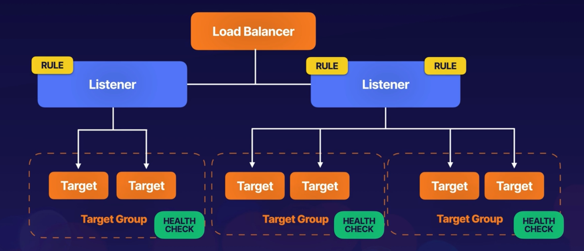

**Path-Based Routing:** **Common Exam Scenario**

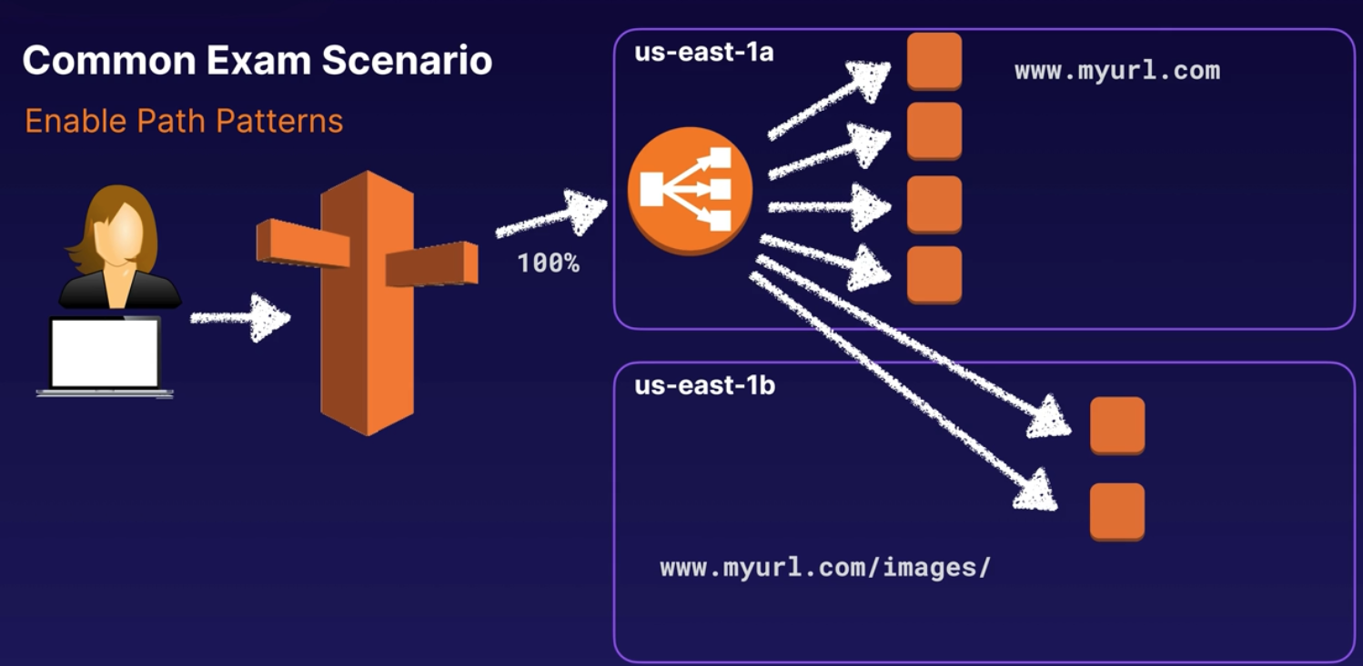

* The user types myurl.com that hits Route 53 and sends the traffic to the App LB.
* The LB sends the traffic where the webservers are, us-east-1a
* But if they’ve got a path that says myusl.com/images/ the App LB needs to send the traffic to us-east-1b EC2 instances.
* To enable that we need to enable Path Patterns.
* If the LB is intelligent it can look at the pathway and make routing/LB decisions based on that path.
* **For the exam:** Application LB are layer 7 aware, and you can do intelligent routing based on your paths, to do that you need to enable **Path Patterns.**

**Limitations of Application LB:** Only supports HTTP/HTTPS, it doesn’t support any other Listeners.

**HTTPS Load Balancing:** To use an HTTPS listener, you must deploy at least one SSL/TLS server certificate on your LB.

* The LB uses a server certificate to terminate the frontend connection and then decrypt requests from clients before sending them to the targets.
* The decryption is done in the LB itself.
* If you use Route 53 to register your domain, Amazon will generate the SSL certificate for you, as they are a certificate signing authority, then you add that certificate to the LB.

**Create Application LB:** Demo. We will launch 3 EC2 instances, each one in the same region but different AZ.

* **Create EC2 instances** in London, Linux, all basics – Name: Webserver1
* Security Group: WebDMZ – Enable inbound HTTP
* User Data (bootstrap script): Download apache and create hello world website, saying “This is Webserver1”
* Create the other 2 servers with the same specs but changing them to another AZ within London, naming them Webserver2 and Webserver3 and mentioning this in the html code.
* To access them via browser remember to copy the public IP address and access to it using https://IP, because if you follow the “open address” link in the GUI will use https and won’t load nothing.

* **Create the Load Balancer:** EC2 – Load Balancing – Load Balancers – Create LB
* Application Load Balancer: Create – name it: MyALB – leave internet facing and IPv4 as it is
* Select the VPC – Mappings: select the 3 AZ – Security Group: WebDMZ (you can add up to 5), leave the default sg as well
* Listeners and routing – leave port 80, you can add 443 if you want – Default action:
* **Create target group** – Chose a target type: Instances –Target group name: MyTG
* leave the rest as default – Health checks – Advanced health checks settings – lower everything to the minimum – Next –
* Register targets: Select all 3 instances – Include as pending below –
* Create target group.

* Go back to the Application Load Balancer creation tab –
* Back to “Listeners and routing” – Default action: select MyTG – leave the rest by default – Create load balancer.

* **Check and get DNS name:**
* Will take a while, wait till you see the State as “Active”
* Once active, copy DNS name (which is the public dns name of the lb).
* EC2 – Load Balancing – Target Groups – select MyTG – check you have the registered targets (the 3 instances)
* Now paste the DNS name in a browser, you will get balanced between all 3 webservers.

**Enable Sticky Session:** We have to go to the Target Group.

* EC2 – Load balancing – Load Balancers – select your LB: MyALB –
* tab “Listeners and rules” – Forward to target group: MyTG (click on it) –
* tab “Attributes” – Edit – Target selection configuration – Stickiness –
* tick “Turn on stickiness” – leave Load balancer generated cookie and 1 day –
* Save changes.
* If all is fine you have to land always in the same server if you refresh your browser.

**Exam Tips:**

* **Listeners:** A listener checks for connection requests from clients, using the protocol and port you configure (80 or 443).
* **Rules:** Determine how the load balancer routes requests to its registered targets. Each rule consists of a priority, one or more actions, and one or more conditions. You could do it in:
  + Your host heather.
  + The IP
  + The path
  + On query string.
  + Etc.
* **Target groups:** Each target group routes requests to one or more registered targets, such as EC2, using the protocol and port number you specify.
* **Limitations:** Only Http and Https
* **Https:** To use https listener, you must deploy at least one SSL/TLS server certificate on your LB. The LB uses a server cert to terminate the frontend connection and then decrypt requests from clients before sending them to the targets.

**Network Load Balancers:**

**Layer 4 Load Balancing:**

* Layer 4 connexion
* For thousands or tens of thousands of connections.

**Requests Received:**

* After the load balancer receives a connexion request, it selects a target from the target group for the default rule.
* It attempts to open a TCP connection to the selected target on the port specified in the listener configuration.

**Listeners:**

* A listener checks for connection requests from clients, using the protocol and port you configure.
* The listener on the Network LB then forwards the request to the target group.
* There are no rules, unlike with Application LB.

**Target Groups:**

* Each target groups routes requests to one or more registered targets, such as EC2 instances, using the protocol and port number you specify.

**Ports and Protocols:**

* Protocols: TCP, TLS, UDP, TCP_UDP
* Ports: 1 – 65535

**Encryption:**

* You can use TLS listener to offload the work of encryption and decryption to your LB so your applications can focus on their business logic.
* If the listener protocol is TLS, you must deploy exactly one SSL certificate on the listener.

**Exam Tips:**

* Network LB are best suit for load balancing of TCP traffic where extreme performance is required.
* Operates at layer 4.
* Can handle millions of requests per second, while maintaining ultra-low latencies.
* Used also when you need to use protocols that Application LB don’t support.
* Can encrypt and decrypt traffic, but you will need to install the certificate on the load balancer.

**Classic Load Balancers:**

**What it is:** Are the legacy load balancers. Used for test and dev purposes.

* You can load balance HTTP/HTTPS applications.
* Use Layer 7 specific features, such as X-Forwarded and sticky sessions.
* You can use Layer 4 LB for applications that use TCP protocol.

**X-Forwarded-For: Exam Topic question**

* When traffic is sent from a load balancer, the server access logs contain the IP address of the proxy or load balancer only.
  + When your EC2 are logging, all the data coming from the LB have the internal IP address of the LB or the proxy.
* To see the original IP address of the client, the X-Forwarded-For request heather is used.

**Gateway Timeouts: Exam Topic question**

* If you application stops responding, the Classic LB responds with a 504 error.
* This means the application is having issues.
* This could be either at the web server layer or database layer.

**Provision Classic LB:**

* EC2 – we have 3 instances running from the previous exercise, webserver 1, 2, and 3.
* Load Balancing – Load Balancers – Create load balancer – Classic Load Balancer: Create
* Name it: MyClassicLB – internet-facing – VPC: use all 3 AZ creates in previous exercises.
* Security Groups: WebDMZ – Listeners, leave port 80 – Health checks –
* Advanced health check settings, leave all by default –
* Instances – Add instances: select the 3 instances – leave the rest by default and hit Create load balancer, can take a couple of minutes.
* Once all is working check that is balancing between the servers.

**Exam Tips:**

* A 504 error means the gateway has timed out.
  + This means the application is not responding within the idle timeout period.
* Troubleshoot the application.
  + Is the web server or the database server?

* Need the IPv4 address of your end user?
  + Look for the X-Forwarded-For heather.

**Sticky Session:**

**What are Sticky Sessions:** Allows you to bind a user’s session to a specific EC2 instance.

* Classic LB route each request independently to the registered EC2 instances with the smallest load.
* Could be that a user is saving data locally on that EC2 instance.
* You want to make sure when that user is visiting the website they’re always going to the same EC2 instance because is where the data is being saved.
* This ensures all requests from the user during the session are sent to the same instance.

**Scaling Issues:** If we remove an EC2 instance from the LB pool, the LB is still going to route the request of our end user to that EC2 instance, and the user will get an error.

* The way to avoid this is to Disable Sticky Sessions.

**Exam Tips:**

* Sticky Sessions enable your users to stick to the same EC2 instances.
  + Can be useful for storing information locally on that instace.
* You can enable sticky session for Application LB as well, but the traffic will be sent at the target group level.
  + If you have multiple EC2 instances in that target group, it will go to other EC2 instances.
  + **Scenario question:** You remove an EC2 from a pool, but the LB continues to direct traffic to that EC2 instance 🡪 Disable Sticky Sessions

**Leaving the Load Balancer with Deregistration Delay:**

In Classic LB is called Connection Draining.

**What is Deregistration Delay:** Allow LB to keep existing connections open if the EC2 instances are de-registered or become unhealthy.

* This enables the LB to complete in-flight requests made to instances that are de-registering or unhealthy.
* You can Disable Deregistration Delay if you want your LB to immediately close connections to the instances that are de-registering or have become unhealthy.

**How to do it:**

**Classic LB:**

* EC2 – Load Balancing – Load Balancers – select yours: MyClassicLB –
* Instances – Connection Draining (Deregistration Delay for Classic LB): Edit –
* Uncheck Enable Connection Draining – Save

**Application LB:**

* EC2 – Load Balancing – Target Groups – select MyTG – Attributes – Target deregistration management: Edit – Deregistration delay (draining interval): change it to 0

**Exam Tips:**

* **Scenario question:** If is talking about Deregistration Delay or Connection Draining, remember to enable deregistration delay.
  + Will keep existing connections open if the EC2 becomes unhealthy.
* Disable deregistration delay: if you want your LB to immediately close connections when the EC2 become unhealthy.

**Monitoring:**

**CloudWatch:**

* Monitoring and observability platform that was designed to give us insight into our AWS architecture.
* It allows us to monitor multiple levels of our applications and identity potential issues.

**CloudWatch Features:** To know for the exam and real world.

* **System Metrics:** Metrics that you get out of the box (AWS supports those metrics by default)
  + The more managed the service is (how much AWS handles the backend infrastructure), the more system metrics you get.
  + Metrics is not only for EC2. It can include S3, SQS, etc.

* **Application Metrics:** By installing the **CloudWatch agent**, you can get information from inside your EC2 instances.
  + Like memory utilization or disk space.

* **Alarms:** Can alert you when something goes wrong.

**Type of Metrics:**

* **By Default:** These metrics are provided out of the box and do not require any additional work on your part to configure.
  + **CPU Utilization:** How much of your virtual CPU resources on your computer or instance are actually being utilized over a specified amount of time.
  + **Network Throughput:** Network in/out. How many packets are going in/out.
* **Custom:** These metrics will need to be provided by using the CloudWatch agent installed on the host and configured to send those metrics. The host will need connectivity and permissions for the CloudWatch API.
  + **EC2 Memory Utilization:** How much of your available memory is being utilized on your instances. **Exam topic**. This is not viewable via any default metric.
  + **EBS Storage Capacity:** Another one that is not included in the default ones.

**Create an alarm:** That will send you an email when the CPU goes high.

* CloudWatch – Alarms – Create alarms – Create alarm – Select metric –
* Browse (Remember this is a regional service) –
* AWS namespaces:
  + Are all the categories and the services that are sending metrics and logs to CloudWatch.
  + You can create your own if you need too.
* EC2 – Per-Instance Metrics – filter for the instance ID you want, click on “Search for this only”
* Select “CPUUtilization” 🡪 is not a typo, is written like this.
* You can access metrics from already deleted machines, CloudWatch keeps it 15 months by default.
* The graph has the date in the X axis (horizontal) and the Y has the utilization.
* Select metric – Statistic: Maximum –
  + Period: Time intervals at which the different data points are being collected and then aggregated for your specific metric.
* Leave Period in 5 minutes – Conditions: (conditions to alert)
  + Static: You can use a static value as a threshold number.
  + Anomaly detection: It scan your different metric results and if something is out of the normal will alert me (you can use it to trigger alarms).
* Static – Whenever CPUUtilization is… -- Greater/Equal – than… :50
* **What this says is:** If our CPU utilization Maximum over our period of 5 minutes ever is Greater/Equal to 50%, you wanna trigger this alarm.
* Additional configuration: Datapoints to alarm – 1 our of 1 🡪 this means that if the alarm is triggered one time it will send an alert. You can add 2 out of 2 or more, so it will send the alert if the problem happens 2 times instead of one.
* Missing data treatment: **Treat missing data as bad** (breaching threshold)
  + This says that if there is any missing data go ahead and trigger the alarm.
* Next – Notifications – In alarm – Select an existing SNS topic –
* Send notifications to… : (if you already have an SNS topic, then select it, if not create it, I don’t know how yet ☹)
* Interesting Options you can select: We won’t use them in this example but you have to know them:
  + Auto Scaling action: You can select the trigger and the autoscaling options, like scale in, scale out, etc.
  + EC2 action: Select the trigger and choose between stopping, terminating or rebooting the instance.
  + Systems Manager action: Create Opsitem or an Incident for the ops team to investigate.
* Next – Alarm name: CPUTooHigh – Next – Preview and create – Create alarm.

**Check the new alarm:**

* CloudWatch – Alarms – select your alarm: CPUTooHigh – you need to wait some time for the data to be collected.
* After one of two minutes the alarm will be triggered as we set the alarm as “Missing data”,
* Once the alarm is triggered you will see it highlighted in the panel and you will receive an email informing about this with all the data that collected with a lot of details.

**Exam Tips:**

* What tool do we use to monitor: Amazon CloudWatch
* Default Metrics: Included by AWS:
  + CPU utilization
  + Network Throughtput
* Custom: You need to install **CloudWatch agent** in your instances.
  + Memory utilisation
  + EBS storage capacity
* There are no default alarms. Anything must be created.
* The more managed by AWS the service is, the more check you get out of the box, meaning that are already prepared, ready, pre-configured, operational, etc.
* Differences between:
  + Basic Intervals: 5 minutes monitoring. You are not paying extra for that.
  + Detailed Intervals: 1 minute monitoring. You pay extra for it.

**Application Monitoring with CloudWatch Logs:**

**What CloudWatch Logs are:** Centralize all your logs there. Is like Datadog, Elasticksearch.

* Monitor, store, and access log files from a variety of different sources.
* You can query your logs to look for potential issues or data that is relevant to you.
* For custom logs use CloudWatch agent. The agent allows users to collect and monitor systems and application metrics on their AWS instances and on-premises servers.

**CloudWatch Log Terms:**

* **Log Event:** This is a record of what happened. It contains a timestamp and data.
* **Log Stream:** A collections of Log Events from the same source creates a Log Stream.Think of one continuous set of logs from a single instance.
  + Example: Linux log file like /var/log/secure being sent to CloudWatch, all these records and events go to the same Log Stream, making it easy to identify.
* **Log Group:** Collection of Log Streams. Logical grouping of Log Streams.
  + Example: You would group all your Apache web servers logs across hosts together.
    - So you have Webserver1, Webserver2, and Webserver3 running Apache.
    - You create a Log Group called “ApacheLogs”
    - Inside ApacheLogs you create 3 Log Streams:
      * LogStream1: Webserver1
      * LogStream2: Webserver2
      * LogStream3: Webserver3

**CloudWatch Logs Features:** You collected the logs, now what?

* **Filter Patterns:** Look for specific terms in your logs Like “error 400”
* **CloudWatch Logs Insights:** You can query all your logs using SQL interactive solutions. Investigate and fix issues in real time.
* **Alarms:** Once you’ve identified your terms or patterns, it’s time to set up alerts for them.
  + CloudWatch Alarms once triggered allows you to send notifications or initiate automated remediation processes.

**Console Demo:** Configure CloudWatch agent and view filter patterns.

We will deploy a custom EC2 instance in a default VPC. We will install and configure CloudWatch agent. We will send some logs from the instance to CloudWatch to see how this works.

* **Deploy EC2 instance:**
  + Name: AppServer
  + Amazon Linux 2023
  + t.3.medium
  + Security Group: Default (no rules)
  + Advanced Details: IAM Instance profile: AmazonEC2SessionManagerRole (it has permissions to put our CloudWatch logs)
  + User Data (bootstrap scrip ):

#!/bin/bash

sudo yum update -y

sudo yum install amazon-cloudwatch-agent -y

dnf install rsyslog -y 🡪 in Amazon Linux 2023 AMI rsyslogs is not installed.

systemctl enable rsyslog --now

* + Launch Instance

* **IAM Role:** 
  + IAM – Roles – AmazonEC2SessionManagerRole -- [Policie in Github](https://github.com/pluralsight-cloud/aws-certified-solutions-architect-associate/blob/main/11-monitoring/application-monitoring-with-cloudwatch-logs/iam_policies/AmazonEC2SessionManagerRole.json) –
  + This policy allows you to connect CloudWatch Logs and other stuff.

* **Access the instance:** Create CW agent configuration file.
  + Check the agent is installed – sudo ls /opt/aws/amazon-cloudwatch-agent/etc –
  + if you see 2 files there then all good.
  + Create the conf file for CW agent – sudo vi /opt/aws/amazon-cloudwatch-agent/etc/amazon-cloudwatch-agent.json
  + Here the json: [amazon-cloudwatch-agent.json](https://github.com/pluralsight-cloud/aws-certified-solutions-architect-associate/blob/main/11-monitoring/application-monitoring-with-cloudwatch-logs/amazon-cloudwatch-agent-conf.json) . The files does:
    - **Agent**: You set the collection interval, the region, running it as root and enabling the debug mode.
    - **Logs**:In this demo we send logs. We send the logs to the same group, instance_id, but we separate them in two streams:
      * log_stream_name: messages 🡪 /var/log/messages
      * log_stream_name: secure 🡪 /var/log/secure
  + Fetch the configuration file:
    - Use the CW agent control service to fetch in ec2 mode and pointing to the json file we just created.
  + In theory we should be pushing logs to our CW log group.

* **Check the logs:** And filter them to see specific stuff.
  + CloudWatch – Logs – Log groups – select the log group, it will have a random long mix of letters and numbers (instance ID log group) – click on it –
  + Log streams – you will see the log stream “messages”, secure is still not created as there is no logs yet.
  + Click on messages – you will see all the log events, every log entry from messages is there.
  + Copy a part of the text of one log event – go back to “messages” –
  + Subscription filter – Create – you can create a filter that will look for a specific word of line in your logs, I didn’t understood it well so I will leave this here.

**Exam Tips:**

* Logs should go to CloudWatch Logs.
  + Except for situations where we don’t need to process them, then, they should go straight to S3.
* Any logging scenarios? Go to Cloud Watch Logs.
  + Except for real-time needs, which is Kinesis Data Streams.

* CloudWatch alarms can be used to alert if your filter patterns are found.

* CloudWatch agent must be installed and configured to send custom logs to CW.
* SQL, if the exam mentions SQL, think about **CloudWatch Logs Insights.**

**Monitoring with Amazon Managed Service for Prometheus and Amazon Managed Grafana:**

**What is Grafana:** Widely deployed data visualization tool, popular because it extensive data plugin support.

**What is Amazon Managed Grafana:**

Fully managed AWS service allowing secure data visualizations for instantly querying, correlating, and visualizing your operational metrics, logs, and traces from different sources.

**Overview:**

* Easily deploy, operate, and scale Grafana within your AWS accounts.
* **Logical separation:** with this service you create **Workspaces**, logically isolated Grafana servers.
  + Within this Workspaces, you create Dashboards and visualizations for your metrics, and your logs, and your traces.
* **AWS Managed:** AWS handles scaling, setup, and maintenance of all Workspaces, you only worry about tasks.
* **Built-in Security:** features, help you to meet corporate governance and compliance requirements. Including tools like:
  + Single sign-on
  + Data control
  + Reporting for audit purposes.
* **Pricing:** Based per active user in a workspace.
* **Data Sources:** Integrated with several sources including:
  + Amazon CloudWatch
  + Amazon Managed Service for Prometheus
  + Amazon OpenSearch Service
  + Amazon Timestream
  + And many more data sources.

**Use Cases:**

* **Container Metric Visualization:** Connect data sources like Prometheus for visualizing EKS, ECS, or your own K8s cluster metrics.
* **Internet of Things, IoT:** Vast data plugins make the service a perfect fit for monitoring IoT and edge device data.
* **Troubleshooting:** Centralizing dashboards allows for more efficient operational issue troubleshooting.

**Amazon Managed Service for Prometheus:** Serverless, Prometheus-compatible service used for securely monitoring container metrics at scale.

**Overview:**

* **Open-source Prometheus:** Leverage the open-source Prometheus data model with AWS-managed scaling and availability.
* **Automatic Scaling:** Let AWS manage automatic scaling based on ingestion, storage, and querying of metrics.
* **Designed for High Availability:** AWS replicates data across 3 AZ in the same region.
* **Choose your Kubernetes:** Works with clusters running on Amazon EKS or self-managed Kubernetes clusters.
* **PromQL:** Leverage the open-source PromQL query language for exploring and extracting data.
* **Data retention:** Data is stored in workspaces for 150 days (automatically deleted afterward)

**Exam Tips:**

* **What is Amazon Managed Grafana:** Fully managed service for data visualization. Allows instantly querying, correlating, and visualizing your operational metrics, logs, and traces.
* **What is Amazon Managed Prometheus:** Managed serverless, Prometheus-compatible service used for securely monitoring container metrics at scale.
* **Security and Scaling:** Both services let AWS handle the high availability and automatic scaling of infrastructure. Leverage VPC endpoints for secure VPC access.
* **Grafana Data Sources:** Several built-in data sources , including Amazon CloudWatch, Amazon Managed service for Prometheus, and AWS X-Ray.
* **Amazon Managed Services for Prometheus Uses:** Leverage the service for Amazon EKS clusters or even self-managed K8s cluster.
* **Amazon Managed Grafana Uses:** Container metric visualisation (EKS, ECS, or self-hosted K8s cluster), IoT edge device data, and operational teams.

**High Availability and Scaling:**

**Horizontal vs Vertical Scaling:**

**Vertical Scaling:** Add additional resources to your EC2 instances.

* Example: if you have a t2.micro you can turn it off and resize it to an m4.large
* You can do this again and again but at the end your applications won’t perform as expected or won’t be highly available, etc.
* There are scenarios in which Vertical scaling is good, like when you need to add resources to your DB.

**Horizontal Scaling:** A collection of EC2 instances that can grow when is necessary.

* Benefits:
  + Increases high availability.
    - Redundancy
    - Backups
  + You can spin up as many instances as you need.

**The 3 W’s of Scaling:**

* **What:** What do we scale:
  + Are we scaling an EC2 instance?
  + Are we scaling a DB?
  + How do you spin up that instance appropriately?
  + Where is that template coming from?
  + How do I decide when it’s time to scale?
  + What I need to bring online?
* **Where:** Where do we scale.
  + Where in the VPC?
  + How many AZ am I using?
  + What LB are those resources going to be registered behind?

* **When:** When do we scale?
  + How do we know we need more?
  + CloudWatch alarms can tell us when it’s time to add more resources.
  + Most of the time CloudWatch is gonna be the one that will

**Exam Tip:**

* Anytime you see an autoscaling question, keep the 3 W’s in mind.
  + What do we scale?
  + Where do we scale?
  + When do we scale?

**What Are Launch Templates and Launch Configurations?**

**What is a Launch Template:**

* Specifies all the needed settings that goes into building out an EC2 instance.
* It’s a collection of setting you can configure so you don’t have to walk through the EC2 instance wizard over and over.

**Launch Templates vs. Launch Configurations:** L. Configuration is legacy software, try not to use it, just use Launch Templates.

|  |  |
| --- | --- |
| **Launch Templates** | **Launch Configurations** |
| * Capable of leveraging all EC2 Auto Scaling features.      * Support Versioning * Allow more granularity. * Recommended by AWS | * Only for certain EC2 Auto Scaling feature.      * Immutable * Limited configuration options * Try not to use them |

**Demo:**

**Create a Launch Template:**

* EC2 – Instances – Launch Templates – Create launch template –
* Launch template name: WebServer – Template version description: This is our webserver.
* Template tags – Key: Environment – Value: Production
* Source template 🡪 we will leave empty but is good to know that we can use previous templates to create a new one and use its settings.
* Launch template contents – Application and OS images (AMI) -- select Amazon Linux (but you can leave it empty as is optional)
* Instance type: (optional too) t2.small – Key pair is optional too.
* Network settings – (typically you don’t select nothing at this level and you do it in the autoscaling group, for this exercise we will select a VPC)
* Security group: select an existing allow http one – Advance network configuration –
* Network interface 1 – Auto-assign public IP: Enable (as the template is for a webserver) –
* Storage (volumes) – EBS volumes – Add new volume – leave default values –
* Resource tags – Key: Environment – Value: Prod – Resource types: Instances, Volumes
* Advanced details, I will explain just a few of the options:
  + Request spot instance: if you tick it you will request a spot instance for each instance using this template (leave it unticked).
  + IAM instance profile: You can assign an IAM role to the instance to allow us to connect via systems/session manager.
  + There is a lot of options, such as Terminate the instance, CloudWatch monitoring, kernel ID, etc. You should be familiar with them.
  + User Data (bootstrap scrip): Paste [this](https://github.com/pluralsight-cloud/aws-certified-solutions-architect-associate/blob/main/12-ha-and-scaling/what-are-launch-template-launch-configurations/user_data.sh) bootstrap script.
* Create launch template.

**Create a new version of the Launch Template:**

* EC2 – Launch templates – Actions – Modify template (Create new version) –
* Template version description – Our second webserver template
* Leave all like it is, just remove some data into User data, remove the line that gives you the AZ in which you are.
* Create template version.

**Set default version:**

* EC2 – Launch templates – Launch template version details – Versions – select version 2 (which is not the default one) – Actions – Set default version – Template version: 2
* Set as default version.
* Now every time we reference the template ‘WebServer’ is going to launch the version 2 as default.

**Launch instance from template:**

* EC2 – Launch templates – WebServer – Actions – Launch instance from template –
* You will see, WebServer, the version, and all the options we selected when creating the template.

**Exam Tips:**

* You need to know what goes inside a launch template; it includes:
  + AMI
  + EC2 instance size
  + Security groups
  + And potentially networking information.

* **Launch Templates:** Are the most up to date and flexible way to create a template for an EC2 instance.
* **Launch Configurations:** The predecessor of L. Templates. If possible don’t use it.
* **User Data** is included in the template or configuration.
* **Versions:** You can create versions of the templates. Templates are immutable so you will need to create a new version and selected if you want to modify it and use it.
* **Networking:** Launch Configurations do not include Network information. Launch Templates can.
  + Optional. People use Networking with autoscaling groups. And within your autoscaling groups is where you specify your networking information, however if you want to, you can specify the network in your template.

**Scaling EC2 Instances with Auto Scaling:**

**Auto Scaling Groups:** Contains a collection of EC2 instances that are treated as a collective group for purposes of scaling and management.

* This is how you take advantage of cloud compute to scale up and down as you need it.

**Auto Scaling Steps:**

* **Define your Template:** You pick from your available launch templates or launch configurations.

* **Networking and Purchasing:** Pick networking space and purchasing options. You want to use multiple AZs to allow high availability (HA) and easy recovery. Have this in mind for the exam.
* **ELB Configuration:** EC2 instances can be registered behind a load balancer. The Auto Scaling group can be set to respect the load balancer health checks for maintaining instance count.
* **Set Scaling Policies:** Minimum, maximum, and desired capacity needs to be set to ensure you don’t have too many or too few resources and then you can build on top of that some auto-scaling policies themselves.
* **Notifications:** SNS can act as a notification tool, allowing you to let someone know when a scaling event occurs.

**Setting Capacity Limits:**

**Auto Scaling Restrictions:**

* How much should we scale?
* **Minimum:** This is the lowest number of EC2 instances you’ll ever have online. The auto-scaling group resource will not dip below this.

* **Maximum:** The highest number of EC2 instances you’ll ever provision. You won’t go above this.
* **Desired:** How many instances do you want right now? This is just an initial setting that gets ignored after you start scaling up and down.

**Lifecycle Hooks:** Is like Liveness proves and Readiness proves in K8s.

* Perform custom actions on instances when corresponding lifecycle events occur.
* Get your instance to wait for up to 2 hours. Means that it won’t be an active member of the auto-scaling group until that wait process is completed.
* Example: Once the scaling policy or health check determines that is going to scale down an instance, you can create a “terminate lifecycle hook” that does a gracefully shut down of any running services.

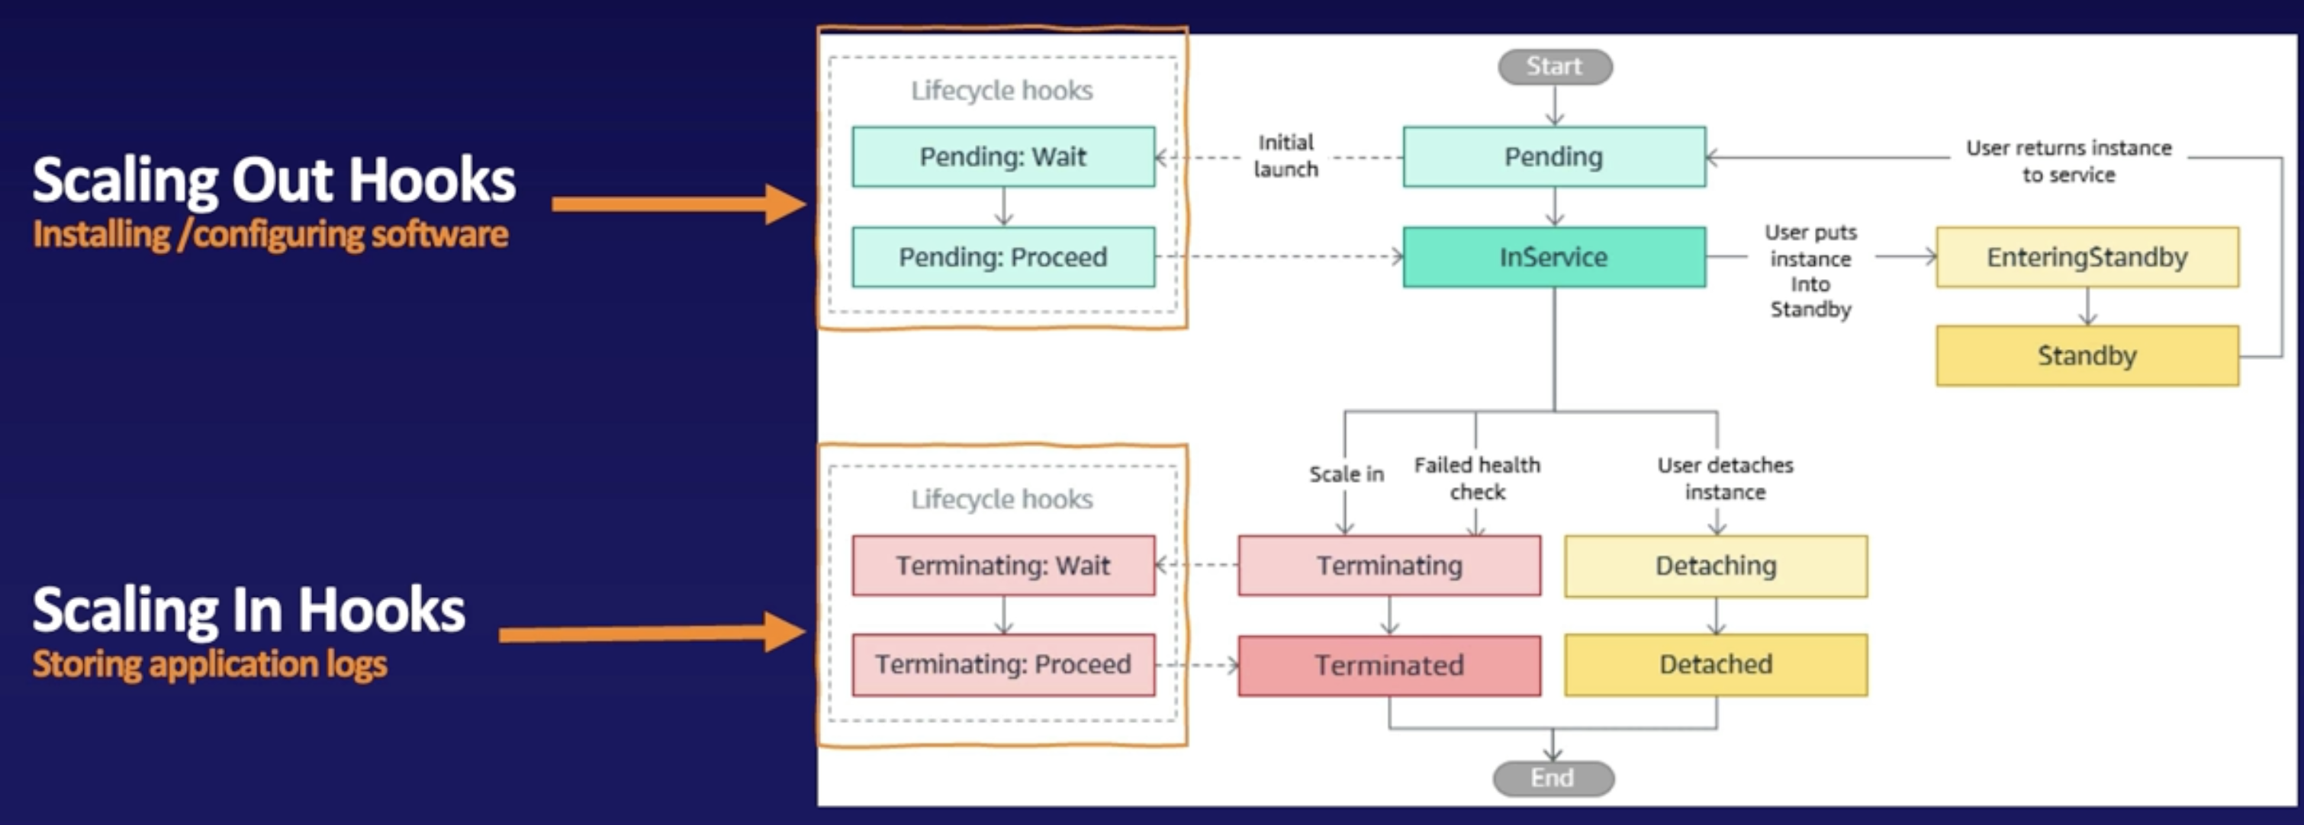

**Scaling Out Hooks:** Installing/Configuring software.

* We go to a “Pending: Wait” and then to a “Pending: Proceed” and then moving to “InService”.
* Use Cases: When you need to install or configure some proprietary software or even third party software.
  + Example: Some time of host endpoint monitoring software where you have to configure it with a specific serial numbers and license keys and you don’t want it active until that’s complete.

**Scaling In Hooks:** Storing application logs on instance shutdown.

* You may be passing logs to CloudWatch, but whenever you have an instance terminate, you may wanna capture any single application log that’s not going to CloudWatch.
* You can do that by kicking off some type of script, storing the logs in S3 and then proceeding to terminate your instance.

* Process of a lifecycle hook:

1. EC2 instance gets launched by EC2 Auto Scaling Group.
2. WAIT state is entered via the Lifecycle Hook capability.
3. While your instance is in the WAIT state, the instance runs a custom script via EC2 user data (bootstrap script) or a 3rd party scripting system to install a proprietary application.
4. Script to install and configure the application.
5. Once the application is validated to be working correctly, the instance sends a complete-lifecycle-action command.

**Demo:** Create an auto-scaling group with EC2 instances.

* EC2 – Auto Scaling groups – Create Auto Scaling group –
* Name: WebServerASG – Launch template –
  + Here you have the option to choose: Switch to launch configuration. Don’t use it unless you have a very specific use case.
* Launch template – select WebServerTemplate (a basic template using Amazon Linux and a Security Group, the rest is default) – Next
* Choose instance launch options – Network – select your VPC –
* AZ (you need to select 2 AZs subnets in order to have HA) –
* Instance type requirements – Manually add instance types –
* Primary instance type: t2.micro – Weight: 100 –
* Instance purchase options – Instances distribution: 100% On-Demand – Next
* Load balancing – no load balancing – skip down to health checks –
* Health checks: is always enabled – Grace period: is the time is going to wait to perform the first health check. By default is in 300 seconds (5 min)
* Additional settings – Enable group metrics collection within CloudWatch
* Next – Group size –
  + Desired: 1 🡪 right now give me one.
  + Minimum:1
  + Maximum: 3
* Scaling policies will be covered in the next lesson – Next
* Add notifications (SNS), skip it – Next – Next – Create Auto Scaling group.
* Once launched the Auto Scaling group – check the tabs
  + Activity: you can see the activity history.
  + Instance management: you can see the instances that belong to the ASG
  + Monitoring: you see different graphs for the ASG and the instances.
  + Instance refresh: If you hit “Start instance refresh” button it will perform a rolling update on your auto-scaling group instances, replacing the old instances for new ones.
    - Especially useful for updating launch templates and forcing them to be updated in the group, or maybe have a stuck instance that for some reason passing a health check.
    - You can start an instance refresh and force it to be refreshed.

**Exam Tips:**

* Auto Scaling is vital to creating a highly available application.
* Remember to select answers that spread resources out over multiple AZ and utilize Load Balancers.
* **Networking**: Auto Scaling groups will contain the location of where your instances will live. Which VPC and which subnet.
* Select an ELB: Vital to select a LB for instances to live behind. If you do this remember to have the security groups in place to allow that traffic.
* Limits: You can set a minimum, maximum, and desired capacity.
* SNS notifications: You can use it as notification tool.
* Balancing: Auto Scaling groups will balance your EC2 instances across the AZs. This is done automatically if you specify 3 EC2 instances or 3 AZs.

**Tips from Udemy course:**

* **What is Auto Scaling Group, ASG:**
  + In real life, the load of your websites and apps can change.
  + In the cloud, you can create and get rid of servers very quickly.
  + ASG are free, you only pay for the used EC2 instances.

* **Goal of an ASG:**
  + Scale out (add EC2 instances) to match an increased load.
  + Scale in (remove EC2 instances) to match decreased load.
  + Ensure we have a minimum and maximum number of EC2 i. running.
  + Automatically register new instances to a load balancer.
  + Re-create an EC2 i. in case a previous one is terminated (ex: if unhealthy)

* **What do you need to create an ASG:**
  + A Launch Template (Launch Configurations are deprecated). It contains:
    - AMI + Instance Type
    - EC2 User Data
    - EBS Volumes
    - Security Groups
    - SSH Key Pair
    - IAM Roles
    - Network and Load Balancer information.
    - Etc.
  + Min Size / Max Size / Initial Capacity.
  + Scaling Policies.

* **CloudWatch Alarms:**
  + It is possible to scale an ASG based on CloudWatch alarms.
  + **Metric:** An alarms monitors what is called a Metric (Average CPU, custom metric, etc. )
  + Metrics such as Average CPU are computed for the overall ASG instances.

* **Scaling Policies:** Let’s you to create more granulated things.
  + **Dynamic Scaling:** 
    - **Target Tracking Scaling:**
      * Simple to set-up
      * Example: I want the average ASG CPU to stay around 40%.
    - **Simple Scaling:** A single rule for a single metric threshold.
      * When CloudWatch alarm is triggered by a single event, that you configured before, like CPU > 70%, then add 2 EC2 instances.
    - **Step Scaling:** The same than Simple scaling but you can add more metrics/actions.
  + **Scheduled Scaling:**
    - Anticipate a scaling based on known usage patterns.
    - Example: You know every Friday at 5pm you will need 5 more servers.
  + **Predictive Scaling:** Continuously forecast load and schedule scaling ahead.

**Good Metrics to scale on:**

* CPUUtilization: Average CPU utilization across your instances.
* RequestCountPerTarget: To make sure the number of requests per EC2 i. is stable.
* Averate Network In / Out: If your app is network bound, there is a lot of uploads and downloads, and you know that network is gonna be a bootleneck for the EC2 i.
* Any custom metric you push to CloudWatch.

**Scaling Cooldowns:**

* After a scaling activity happens, you are in the cooldown period (default 300, 5 min).
* During the cooldown period ASG won’t launch or terminate additional instances (to allow for metrics to stabilize).
* When Scaling Action Occurs: Is Default Cooldown in effect?
  + Yes, Ignore Action.
  + No, launch or terminate.
* Advice: Use a ready-to-use AMI to reduce configuration time in order to be serving requests faster and reduce the cooldown period.

**Steps to create an Auto Scaling Group** (In order of appearance):

What do you need to create an ASG.

* Launch Template
* Network (VPC, AZs). Better to do it here in ASG than in the Launch Template.
* Load Balancer: Yes/No/Create it
* Size: Max/Min/Desirable
* Automatic Scaling (Optional)
  + No Scaling Policies
  + Target Tracking scaling policy (after creating ASG, you can select the other Scaling policies, Predictive and Schedule).
* SNS (optional)
* Done.

**Auto Scaling Policies:**

**Dynamic scaling policies:**

* **Target Tracking scaling policy:** You set one metric, like CPU 50%, and it will scale up or down as much as necessary to achieve it.
  + Metric: CPU / Network In or Out / Load Balancer.
* **Simple Scaling:** One metric that triggers one action, just one single metric/action.
  + Metrics: CloudWatch Alarm.
* **Step Scaling:** Exactly the same than Simple scaling, one metric / one action but you can add more metric/action as you want.
  + Metrics: CloudWatch Alarm.

**Predictive Scaling Policies:** Using machine learning, the instances are scaled on a forecast based in the past.

* Metrics: CPU, Network In or Out, Load Balancer and custom metrics.

**Scheduled actions:** You schedule when to scale out or in.

* To set it up: Add desired capacity and the starting time.

**Diving Deeper into Auto Scaling Policies:**

**Auto Scaling Policies:** When you create an Auto Scaling Group, is an option you can select to have more granular control over the SG.

**It has 3 options to choose:**

* **Simple Scaling:** A single rule for a single metric threshold.
* **Step Scaling:** Is a specific type of scaling policy within AWS EC2 Auto Scaling.
  + Applies stepped adjustments to vary the scaling depending on the size of the alarm breach.

* **Target Tracking Scaling:**

**Exam Tips:** Auto Scaling Policies

* It costs how much? You’ll need a good understanding of how Auto Scaling handles minimum, maximum, and desired capacity for exam.
* You’ll be given scenarios where you’ll need to know the cost implications and reasons why you might or might not want to change one of those numbers.
* **Scale Out Aggressively:** Get ahead of the workload if you need to.

* **Scale In Conservatively:** Once the instances are up, slowly roll them back when not needed.
* **Provisioning:** Keep an eye on provisioning times. Bake those AMIs to minimize it.
* **Costs:** Use EC2 RIs for minimum count of EC2 instances to save money.
* **CloudWatch:** Your go-to tool for alerting Auto Scaling that you need more or less instances.

**Scaling Relational Databases:**

**Types of Scaling:** There are 4 ways of scaling our RDS performance.

* **Vertical Scaling:** Resizing the database compute (EC2) form one size to another can improve the performance.
  + You will pay more for your compute.
  + **Key concept:**  As a SAA you must understand the trades-off between performance and cost.
* **Scaling your Storage:** Storage can be resized, but it’s only able to go up, Not Down.
* **Read Replicas:** Creating read-only copies of our data can help spread out the workload.
  + **Cannot** be used for any data-writing purposes.
  + Not meant to be used as a failover instance for your db (use Multi AZ to do that).
* **Aurora Serverless:** We can offload scaling to AWS Excels with unpredictable workloads.
  + **Scenario question:** If talks about unpredictable reads and writes for your RDS, think about Aurora Serverless.

**Exam Tips:**

* **Scenario question:** Depending on the question, is it viable to change the database types, from RDS to DynamoDB as a scaling choice. In the real world this won’t work so easy, but in the exam is an option.
* **Read Replicas:** For any scenario that mentions read-heavy workloads. Use Multi-AZs for HA.
* **Careful with the storage:** RDS storage only scales up, it won’t scale down. With that you have cost.
* **Vertical Scaling:** Use it to scale your RDS compute. Changing the instance type to a larger one could improve your performance. Have in mind that as a SAA you have to be able to choose the most optimized for your workload. You must be able to compare performance gains vs costs.
* **Multi AZs:** Unless is dev environment turn this on. Remember that Standby instances cannot be directly used.
  + Update: Multi-AZ Cluster DB Deployments deploy HA Reader instances, which can be used for read operations.

* **Aurora everything:** Whenever possible, try to use Aurora if the situation calls for a RDS.

**Scaling Non-Relational Databases:**

**Scaling Options:**

* **DynamoDB:** Scaling is simplified when using DynamoDB, as AWS does all the heavy work.
  + **Provisioned:** 
    - Use Case: Generally predictable workload.
    - Effort to use: Need to review past usage to set upper and lower scaling bounds.
    - Cost: Most cost-effective model.
  + **On-Demand:**
    - Sporadic workload.
    - Effort to use: Simply select on-demand.
    - Cost: Pay small amount of money per read and write.
    - Less cost effective than Provisioned.

**Read Capacity Units (RCU):** DynamoDB unit of measurement for reads per second for an item up to 4 KB in size.

* Anything larger than 4 KB will require an additional read capacity unit.
* One strongly consistent read per second = 4 KB. Means that you can read it just after the write.
  + Important for financial transactions, real time inventory management, etc.
* Two eventually consistent reads per second = 4 KB. Means you have to wait a bit to have the last written data when you try to read it.

**Write Capacity Units (WCU):** DynamoDB unit of measurement for writes per second for an item up to 1 KB in size.

**Exam Tips:**

* Access Patterns: Know if your access patterns are predictable or unpredictable.
* Design Matters: Avoiding hot keys will also lead to better performance.
* Switching: You can switch, but only twice per 24 hours per table.
* Cost: Keep cost in mind when considering which type of table to pick.

**Overview of Disaster Recovery Strategies:**

**Recover Point Objective (RPO):** How much data can you afford to lose, 48 hours? 24 hours? Minutes? Seconds?

* The lower the time, the greater the cost.

**Recover Time Objective (RTO):** In the event of a failure, how fast do you want to fail over?

How much time can the business afford?

* The lower the time, the more expensive the cost.
* How long can your website be down.

**Backup and Restore:** The simplest disaster recovery strategy.

* If something happens to your production system, restore that system from backup.
* Example, we have an EC2 instance and a snapshot of it. The instance fails and we create another instance from that snapshot.

**Pilot Light:** A pilot light in a home hot water system is where a small light burns so that when we want to turn the hot water system on, it starts straight away.

* When a pilot light is burning, it is not consuming the same level of gas as when the system is on.
* **How this works:** We have 3 webservers and a db server in one AZ, and we have only a backup db server in another AZ of the same region.
  + The AZ where the webservers are fails, so we create 3 webservers in the AZ where we had the backup database.
  + We had a “Pilot Light” in the other AZ which is cheaper than having the 3 webserver + the db on it.

**Warm Standby:** You have a scaled-down of your production system already running in another AZ or region.

* You scale this system up in the event of an outage.
* Example: 3 webservers + 1 db in one AZ, and 1 webserver + 1 db server (with live replication). If the 1st AZ fails, the second AZ/Region will scale-up two webservers more.

**Active/Active Failover:** The most expensive one. You have two sites, both active and traffic split between the two.

* If one fails, the other site takes the load. Generally, you have to have both sites at 200% normal capacity to avoid downtime.
* Example, two AZs, each with 3 webservers and 1 db in production, both sites active and connected by a Mirrored Environment.
  + If one AZ fails, the other has the extra resources to cope with that load.

**Exam Tips:**

* **RPO vs RTO:**
  + RPO, Recover Point Objective: At what point in time you want your environment recovered to?
  + RTO, Recover Time Objective: How quickly do you need your environment recovered. How much time can your business handle.

* **4 Different Disaster Recovery Strategies:**
  + Backup and Restore: Cheapest and slowest.
  + Pilot Light: faster that Backup and restore, but some downtime.
  + Warm Standby: Quickly recover from previous one, but slightly more expensive.
  + Active/Active Failover: Most expensive option, but no downtime and lowers RTO and RPO.

**Decoupling Workflows:**

**Tight Coupling:** Is to have a single server for your web/application.

* You have a single webserver and a single database server.
* If one fails, all will fail.

**Loose Coupling:** You have more than one server as webserver and more than one db server, so if something fails, the service will keep working.

* You can have one ELB and 3 webservers for the front end.
* Then another ELB and 3 database servers as a backend, for example.
* This provides a much more reliable website/application.
* Choose **ALWAYS** Loosely Coupled.

**Exam Tips:**

* Choose always Loosely coupled.
* Every level of the application (FE, BE, etc) should be loosely couple.
  + FE can have an ELB.
  + BE can have an ELB, SQS.
  + Make sure there is NO EC2 to EC2 direct calls, use an ELB, SQS, API Gateway, etc.
  + There is no one single solution. Sometimes SQS is the best option, other times API Gateway, etc.

**Messaging with SQS:**

**Poll-Based Messaging:** Is the place (software) where the data generated from one application waits to be collected by another application.

This way you won’t lose this data if the receiver cannot handle it immediately for any reason.

**How this works:**

* Applications, such as web servers, database servers, IoT, etc (message producer), generates data that needs to be processed, stored, or analysed by another application.
* The sender application (producer) tries to send the data to the receiver application (consumer).
* However, if the receiver (consumer) is unable to handle the data immediately due to resource constraints, network issues, or other factors, the data transmission may be unsuccessful or delayed.
* To avoid this, we use Poll-Based Messaging.
* Convert the data. The sender application converts the data into Messages.
  + The message contains:
    - The payload (data to be transmitted)
    - Metadata such as message identifiers, timestamps, and any additional attributes.
    - The format of the messages can be JSON, XML, plain text, big data formats, custom formats, etc.
* Send the data to the Poll-Based Messaging software.
  + - Amazon SQS, RabbitMQ, or Apache Kafka, etc, are some examples.
    - The messaging system stores the messages temporarily until the receiver application is ready to process them.

* Poll the data: The receiver application periodically polls the messaging system to process the data once it has the necessary resources.
  + Poll means that the receiver will connect to SQS and will check if there are messages for him. Poll is to connect and check.
  + If there are messages will download them. If not, it will disconnect and will try again later.

**Simple Queue Service:** Messaging queue that allows **asynchronous** processing of work.

* One resource will write a message to an SQS queue.
* Then another resource will retrieve that message from SQS when is ready.

**Asynchronous:** Means that is not direct (immediate) communication from the sender (application, server, etc) to the receiver. The communication can wait to be delivered, is not necessary to be immediate.

This is when a Poll-Based Messaging like SQS comes in. Is like a buffer where you keep your messages until the receiver has the resources to process it.

**SQS Settings:** Setting you need to understand to make sure the queue works properly.

**Very common exam question.**

* **Delivery Delay:** Default is 0. Can be set up to 15 mins.
  + I write a message to the queue. If the delay is set to something that is not 0, the queue hides the message for the time you specify.
  + When the delay time is 0, the message will be showed in the queue to be taken by the receiver (backend, etc) when its ready.
  + Why to delay messages:
    - Example, I have a web front end, a customer places an order.
    - The user types the credit card information and other info.
    - I need to pass in that information to my backend instance.
    - I want to verify with the bank that the user’s info is correct.
    - So I want to delay the answer to the user until I have the green light from the bank.

* **Message Size:** Messages can be up to 256 KB of text in any format (JSON, yaml, etc).
  + You can adjust the number down.
  + But cannot be higher.

* **Encryption:** SQS provides server-side encryption (SSE) using SQS-owned encryption (SSE-SQS) by default.
  + Not encrypted at rest by default. Is encrypted in transit.
* **Message Retention:** Default is 4 days: can be set between 1 minute and 14 days.
  + Nothing lives in SQS forever.
  + If the retention time is achieved, the message is purged from that queue.
* **Types of Polling:** Polling is to check if there are messages. Is not to pull.

If there are messages, then those are going to be pulled.

* + Short Polling: The default one.
    - The receiver (backed instance, etc) connects to SQS asking if there are messages for him.
    - If not, the instance disconnects and tries again.
    - It connects and disconnects all the time and this have some negative things:
      * Burns CPU cycles in the received (backend instance, etc).
      * Those API calls to SQS are not free, so you are wasting money.
  + Long Polling: Not enabled by default. **Choose this one for the exam.**
    - The receiver connects via API call to SQS asking for messages.
    - If there are no messages it will wait for a while until connects and asks again.
* **Queue Depth:** This can be a trigger for autoscaling.
  + You can use queue depth as a metric for autoscaling EC2 instances.
  + If the queue is too depth, you can scale new EC2 to help to deal with that load.
  + As the queue shrinks, we could spin down those instances.
  + So, too many messages in the queue, spin a new EC2. The queue is back to normal, terminate the instances.
* **Visibility Timeout:** Used to ensure the proper handling of the message to the receiver (consumer application).
  + A consumer polls and downloads a message from the queue. This message is hidden to anyone else to pick it up.
  + If the message has been downloaded and processed properly by the receiver (consumer)**, t**he receiver will send a DeleteMessage API call to SQS confirming that the message can be deleted from the SQS queue.

* + If after the visibility timeout period, no DeleteMessage is received from the receiver (consume), SQS will make visible the message again for another consumer to pick it up.

**Exam Tips:**

* SQS will appear a lot in the exam, you need to be able to explain:
  + All the SQS Settings.
  + Know what changing these settings would do.
  + Know why you’d make that change.
* There are more settings that will be covered in the following lessons.
* Troubleshoot:
  + Why I see lost messages?
  + Why I have messages popping back up?
  + Possible solutions:
    - A lot of time is due misconfigured settings.
    - Maybe Visibility Timeout (VT) was configured too low.
      * Example: VT is set to 5 seconds, but my instances need 15 seconds to process the message.
* **Long Polling:** More efficient with cost and CPU cycles.
* **Size:** Of the messages up to 256 KB, any format.

**Sidelining Messages with Dead-Letter Queues:**

**Dead-Letter Queues, DLQ:** Are targets for messages that cannot be processed successfully.

* Basically, is a failover queue to store messages or inspection and replay later on.
* Works with SQS and SNS.
* Very useful for debugging applications and messaging systems.
* Allow you the ability to isolate unconsumed messages to troubleshoot.
* **Redrive** capability allows you to move the message back into the source queue.
* Are technically just other SQS queues. The way you use them in your application infrastructure design that makes them a dead-letter queue.
* DLQs used with FIFO SQS queues must **ALSO** be FIFO queues.

**Benefits:**

* Configure alarms based on message availability counts.
  + You can set up some type of metric alarm via CloudWatch and you can look for any number of messages on that particular dead-letter queue.
  + Once a message is sent to your dead-letter queue, you can trigger alarms to notify operations teams.
* Allows you to quickly identify which logs to investigate for specific exceptions and errors that occur in your application.
  + You could use an unique identifier within an original message, within the contents, etc, and cross-reference that with CloudWatch Logs.

* Analyse the SQS message contents for any errors.
  + Perhaps they forgot a field in a JSON object, or perhaps they sent the wrong format entirely.
* Troubleshoot consumer permissions that may be missing.
  + Maybe your consumer just can’t read messages from the queue, and they all ended up in the DLQ.
* There may be more benefits.

**How it works:**

* We have a Front-End webserver that delivers to an SQS.
* The Backend polls the SQS messages.
* The message processing fails from our Backend side of the application.
* But we configured a DLQ, meaning the original message content will be wrapped in another message and forwarded to that configured DLQ.
* This allows us to identify and investigate the specific message that was causing us errors.
* If it’s an intermittent error that is not actually an issue, we can replay that within the original queue using Redrive.

**Demo:** Configure an SQS queue with a DLQ in place.

We will set up a Lambda trigger to process a simple JSON object that’s within that message.

If it cannot process it, it’s going to print an error message on why and send it to our DLQ.

* **Create the Lambda function:**
  + Lambda – Functions – ProcessorFunction – [Here the function:](https://github.com/pluralsight-cloud/aws-certified-solutions-architect-associate/blob/main/13-decoupling-workflows/sidelining-messages-with-dead-letter-queues/lambda_function.py) 
    - It pulls the message body from our hold message, making sure all the required fields are in there, and if is not it’s sending it back to that same queue so that we can trigger the maximum retries and it should be sent to our DLQ.
    - We are using an envar of the QUEU_URL and well get that after we create our queues.
    - AWS handles retries for you on the backend before this will actually be sent to the queue again.
* **Create SQS queues:**
  + SQS – Create queue – Standard – Name: **WebOrders-DLQ** – leave Configuration, Encryption and Access policy by default – Redrive allow policy – Enabled – Allow all – skip the rest and Create queue.

* + Create Source queue: SQS – Create queue – Standard – Name: **WebOrders** – leave all by default – Dead-letter queue – Enabled (to send undelivered messages to our DLQ) – Choose queue: WebOrders-DLQ – Maximum receives: 2 – Create queue
    - It specifies the maximum amount of times our source queue can receive the same message before it sends it to the dead-letter queue.
  + That’s it. You can see that DLQ is just another queue just set up to receive failing messages from another queues.
* **Paste the queue URL into the Lambda function:** Get the queue URL for the envar QUEUE_URL located in the lambda function.
  + Amazon SQS – Queues – WebOrders – Details – copy the URL and populated into the Lambda function:
  + Lambda – Functions – ProcessorFunction – Configuration – Environment variables – Edit –
    - Key: QUEUE_URL –
    - Value: paste there the queue url copied before.
* **Create AIM policies to allow connections:** You will need to create 2 AIM policy to allow to log to CloudWatch and to poll our queue and send messages to our queue.

* **Set up Lambda trigger:**
  + Amazon SQS – Queues – WebOrders – Lambda triggers – Configure Lambda function trigger – select our ProcessorFunction – Save (will take ~ 20 secs to be active)
  + Now our Lambda function will pull automatically messages automatically on this queue.

* **Test it:**
  + Correct JSON: Amazon SQS – Queues – WebOrders – Send and receive messages – Message body: paste the [correct](https://github.com/pluralsight-cloud/aws-certified-solutions-architect-associate/blob/main/13-decoupling-workflows/sidelining-messages-with-dead-letter-queues/correct_json.json) JSON and hit Send message.

Correct JSON:

{

"eventId": "0000",

"orderId": "1111",

"customerFirstName": "Made",

"customLastName": "Up",

"customerEmail": "made.up@email.com"

}

* + Go to CloudWatch – Log groups -- /aws/Lambda/ProcessorFunction -- Log streams – refresh until the log comes in – Log stream, click on the log –
  + You will see printed out the events, one line with the event id, another with the customer id, email, etc, so all worked as intended.
  + [Incorrect](https://github.com/pluralsight-cloud/aws-certified-solutions-architect-associate/blob/main/13-decoupling-workflows/sidelining-messages-with-dead-letter-queues/incorrect_json.json) JSON: Amazon SQS – Queues – WebOrders – Send and receive messages – Clear content – paste the incorrect JSON – Send message

Incorrect JSON:

{

"eventId": "0000",

"orderId": "1111",

"customerFirstName": "Made",

"customLastName": "Up"

}

* + Go to CloudWatch – Log groups -- /aws/Lambda/ProcessorFunction -- Log streams – refresh until the log comes in – Log stream, click on the log –
  + You will see a lot of retries. If you check the log entries you will see that says “failed to process message. Invalid message. Returning to queue.”
  + Amazon SQS – Queues – WebOrders-DLQ – Send and receive messages –
  + Receive messages – Poll for messages – a message will appear on the queue –
  + The Receive count is 3 – click on the message – you will see the body of the message that triggered it (you will see the incorrect JSON)

**Exam Tips: DLQ**

* **Any scenario** talking about problems with messages in SQS, think about DLQ and Visibility Timeout.
* Set up CloudWatch alarm to monitor queue depth.
  + Common example is to set an alarm for any message count greater than zero in a DLQ.
* **Monitor:** Make sure you set up an alarm and alert on queue depth.

* **DLQ are not special**: Are set up exactly like other queues. You only set up the other queues to send reject messages into the DLQ.
* **FIFO Requirements** DLQs for FIFO SQS queues must also be FIFO.
* **Retention window:** Messages will be held up to 14 days.
* **Usable with SNS**: You can create SQS DLQ for SNS topics.

**Ordered Messages with SQS FIFO:**

**SQS Message Ordering:**

|  |  |
| --- | --- |
| **Standard** | **FIFO** |
| * **Best-effort ordering:** You can receive your messages out of order in your application, and that will need to be handled. * Duplicated messages * Nearly unlimited transactions per second (scales extremely well). * Better performance. | * Guaranteed ordering of your messages. * No message duplication * 300 transactions per second within your apps. Batching can achieve up to 3,000 messages per second, per API call. * Not so good performance. |

**FIFO High throughput:** Process up to 9,000 transactions per second, per API action without batching.

* Up to 90,000 messages per second by using batching APIs.
* Works with any new or existing FIFO queue.

**Demo:** Create a FIFO queue and view some different settings.

**Create a queue:**

* Amazon SQS – Queues – Create queue – Type: FIFO – Name: Queue.fifo (it has to have the .fifo)
* Configuration – FIFO queue settings –
  + Content-based deduplication – Enable it. This avoids to have a duplicated message with the same data. Network issues, client retry, application logic, etc, can cause this.
  + High throughput FIFO queue – don’t enable it. This will provide more throughput but you won’t be able to select the Duplicate scope options that are just below.
  + Duplication scope – leave default settings.
* Dead-letter queue: Remember if you enable it, the DLQ will need to be FIFO as well, not Standard. **This is critical for the exam.**
* Create.

**Exam Tips:**

* Always choose FIFO if you see Message ordering or Decupled applications.
* FIFO queues do NOT have the same level of performance as Standard queues.
  + You can enable some features to improve it but is not going to be the same.
* You can use Standard but will require a lot more of overhead and infrastructure considerations.
  + Like to create the logic to format the messages in the producer (sender), create the logic to order them in the consumer (receiver), etc.
* Message deduplication ID: Token used for deduplication of send messages. Matching deduplication IDs are not delivered during a deduplication interval.

* Message Group ID: Helps ensures messages are processed one by one in a strict order based on the group.
* It costs more since AWS must spend compute power to deduplicate messages.

**Delivering Messages with SNS:**

**Push-Based Messages:** Any message sent by a producer (sender, like webserver, etc) that arrives at the SNS Topic will immediately be sent to all consumers (receivers, like a db server, etc).

* It’s being pushed out by the producer to all consumers.

**What is SNS:** Simple Notification Service. One to many.

* Is a push-based messaging service in AWS.
* Allows you to set up an application design where you can proactively send messages to different endpoints, including:
  + Emails
  + SQS queues
  + HTTP clients
  + etc
  + That are subscribed to the topic.
* Major use case:
  + Allows you to alert systems and people of certain events and metrics that get crossed in basically real time.
* One message can have many receivers. **One to many.**

**SNS Settings and Quotas:**

* **Subscriber types supported by default:**
  + Kinesis Data Firehose, SQS, Lambda, email, HTTP(S), SMS, and platform application endpoint.
* **Message Size:** Up to 256 KB, of text in any format.

* **DLQ Support:** Messages that fail to be delivered can be stored in an SQS DLQ.
* **FIFO or Standard:** FIFO only supports SQS FIFO queues as a subscriber.
* **Encryption:** Messages encrypted in transit by default, and you can add at rest via AWS KMS.
* **Access Policies:** A resource policy can be added to a topic, similar to S3. Useful for cross-account access.

**Large Messages Payloads:**

* The default limit is 256 KB for message size, but you can use SNS extended library.
* The SNS extended library allows for sending messages up to 2 GB in size.
* The payload is stored in Amazon S3, the SNS publishes a message that contains a reference or accessing that object which contains the data.

**SNS Fanout:**

* Messages published to SNS topic are replicated to multiple endpoints subscriptions.
* Allow for fully decoupled parallel asynchronous processing.

**SNS Architectures:** Be familiar with all of them for the exam and real world.

Web server to SNS to SQS:

* Web App producer for an SNS topic -- Sends a message to the topic and our service
* On the other side we have multiple SQS Queues acting as consumers for the application.
* Each of these queues receive the same message that was sent by the producer (one to many).
* We can leverage those different queues to perform different portions and logic within our applications.
* Example: Maybe the top queue is pulled by our order processing portion of our app.
* It only looks for particular data in that message and does what it needs to do.
* In the bottom we have another app that completes the order fulfilment portion.
* They use the same message but perform different tasks based on the data within that message.

S3 Events:

* We swap the web app for an S3 bucket. The bucket is configured to send S3 events to our SNS topic.
* The logic on the backend can be the same as before, instead of a web app, we have a file uploaded.
* We send that to SNS, and we perform the same logic based on data in that file.

Web App + Kinesis + OpenSearch:

* We have a Web app sending orders to our SNS topic.
* We have a Kinesis Data Firehose subscribed to the topic.
* This allows for massive amounts of data to be ingested and potentially transformed.
* And we can send records to another archive bucket as well as to OpenSearch for performing analytics and viewing dashboard.
* Example: For a web ordering application, can be things like visualizing the most popular products, or maybe he most common countries and origin of orders.

**Message Filtering:** By default, every single message published to a topic is sent to all

subscribers.

* But there is a feature known as Message Filtering that allows you to define a JSON policy, which allows you to define which messages get sent to particular subscribers.
* You filter out messages to different endpoint types based on contents and attributes of the messages.

* Example: Send submitted orders to the fulfilment queue. Send refunded orders to another queue.

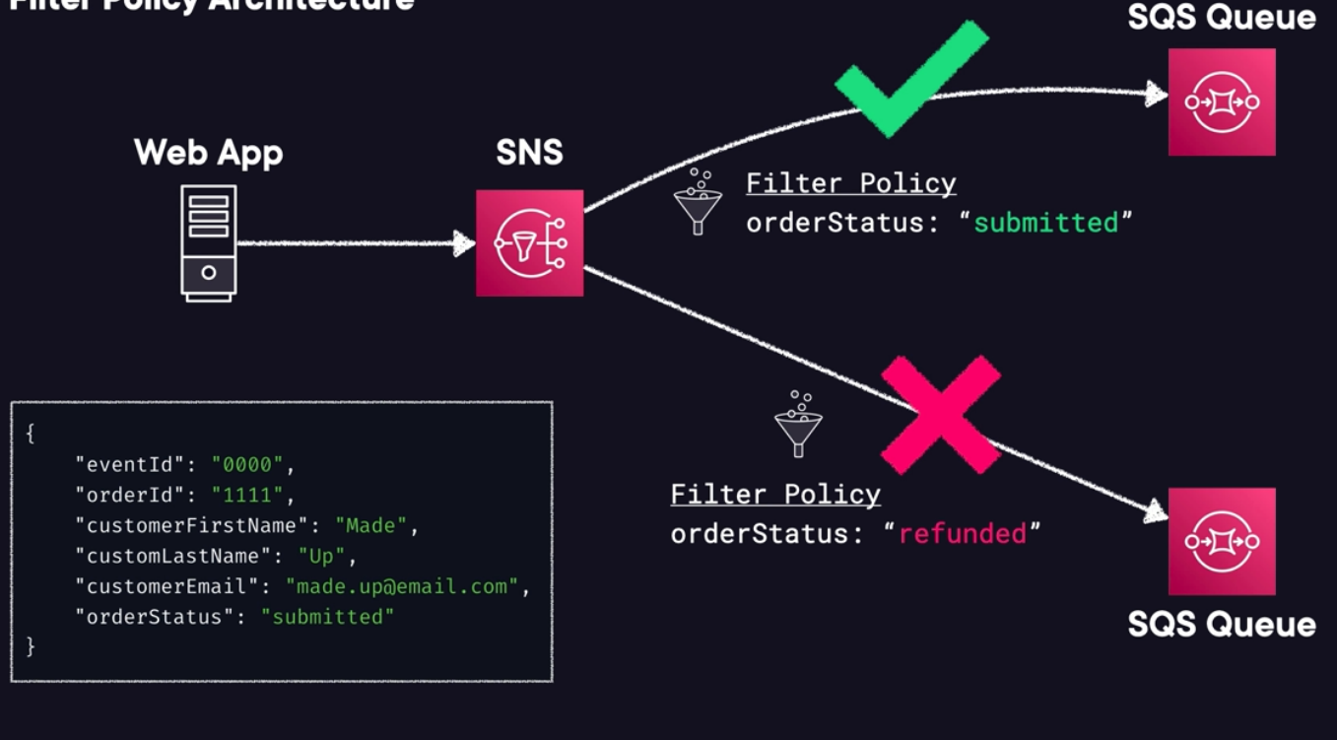

Depending on a specific value within our message, we may want to handle that differently by sending it to a different subscriber for our application.

Bottom left we see the JSON message. This one contains the value “submitted” so will be sent to the fulfilment queue based on the Filter Policies.

**Demo:** Create an SNS Topic. Add a simple email subscription. Test it all out.

**SNS Topic:**

* Amazon SNS – Create topic – Topic name: OpsAlerts – Next step –
* Type: Standard – Display name: Ops Alerts – Encryption – enable it and leave default
* Access policy (IAM) – Basic – leave default – Data protection policy – leave basic –
* Leave all the rest by default and Create.

**SNS Subscription:**

* Select the topic you just created – tab Subscriptions – Create subscriptions –
* Topic ARN: select OpsAlerts – Protocol – Email – Endpoint: add your email –
* Leave the rest by default – Create subscription
* The subscription will be in pending confirmation – you need to confirm the subscription from your email.

**SNS Publish a message to this topic:**

* Amazon SNS – Topics – OpsAlerts – Publish message – Subject: Testing!!! –
* Message body to send to the endpoint: Hello – Publish message –
* Go to your email inbox – You will see your message there.

**Exam Tips:**

* Any scenario involving alerting, think Amazon SNS.
* Any scenario based on Push-based messaging, think about Amazon SNS.
* Be familiar with the different subscriber options but don’t go too deep. You can use:
  + SQS, Lambda, Email, HTTP endpoints.
* SNS only supports custom retry policies for HTTP(S) endpoints.
* You can implement FIFO SNS topics, offering messaging ordering and de-duplication.
* Understand the Fanout architecture. **Exam topic. Very Important to know.**

**Fronting Applications with API Gateway:**

**What is Amazon API Gateway:** Fully managed by AWS, allows you to easily publish, manage, maintain, monitor, and secure your API.

* Allows you to put a safe “front door“ entrance in front of your applications using a RESTful API.
* Integrates with Lambda functions, HTTP endpoints, and other AWS services.

**Notable Features:**

* **Security:** Protect your endpoints attaching a web application firewall (AWS WAF). This helps to prevent layer 7 attacks on your infrastructure.
* **Stop Abuse:** Can easily implement DDoS protection and rate limiting to curb abuse of their endpoints.
  + You can front your gateway with CloudFront or even by throttling requests once they hit the point of receiving an overwhelming number.
* **Easy to Use:** API Gateway is simple to get started with. Easily build out the calls that will kick off other AWS services in your account.

**API Options:**

* **RestFul API:** 
  + You can create API keys for authentication.
  + You can implement Per-client throttles.
  + Validation of requests that are coming in.
  + Easily integrate AWS WAF.

* **HTTP API:** This is RestFul API too, it’s just a simpler version of the full one.
  + Simpler option than REST API.
  + Cheaper, minimal features.

* **WebSocked API:**
  + Collection of WebSocket routes integrated with Lambda functions, HTTP endpoints, and other AWS services.
  + WebSocket: Technology that allows for two-way interactive communication sessions between the user and a server.
  + You can send messages to a server and receive event-driven responses without having to poll for a reply.
  + Example: A mobile app that sends you notifications whenever a message comes in. Amazon application sending order update notifications to your phone.

**Endpoint Types:** **Must know for the exam and the real world.**

* **Edge-optimized**: Default option. API requests get sent through a CloudFront edge location. Best for global users.

* **Regional:** Perfect for clients that reside in the same, specific region. Ability to also leverage with CloudFront if required.
* **Private:** Only accessible via VPCs using interface VPC endpoints.

**Securing your APIs:**

* User authentication can be accomplished to control access to your APIs. Including:
  + IAM roles.
  + Amazon Cognito pools.
  + Even your own custom authorizer using Lambda functions.

* Custom TLS: Edge-optimized endpoints require ACM certs. You have to deploy the cert in us-east-1, only there (like CloudFront).

* Regional endpoints require ACM certs in the same region.
* WAF. You can place WAF in front of your API for DDoS and layer 7 protection.

**API Gateway in Practice:** Simplified example of ACloud Guru ifr.

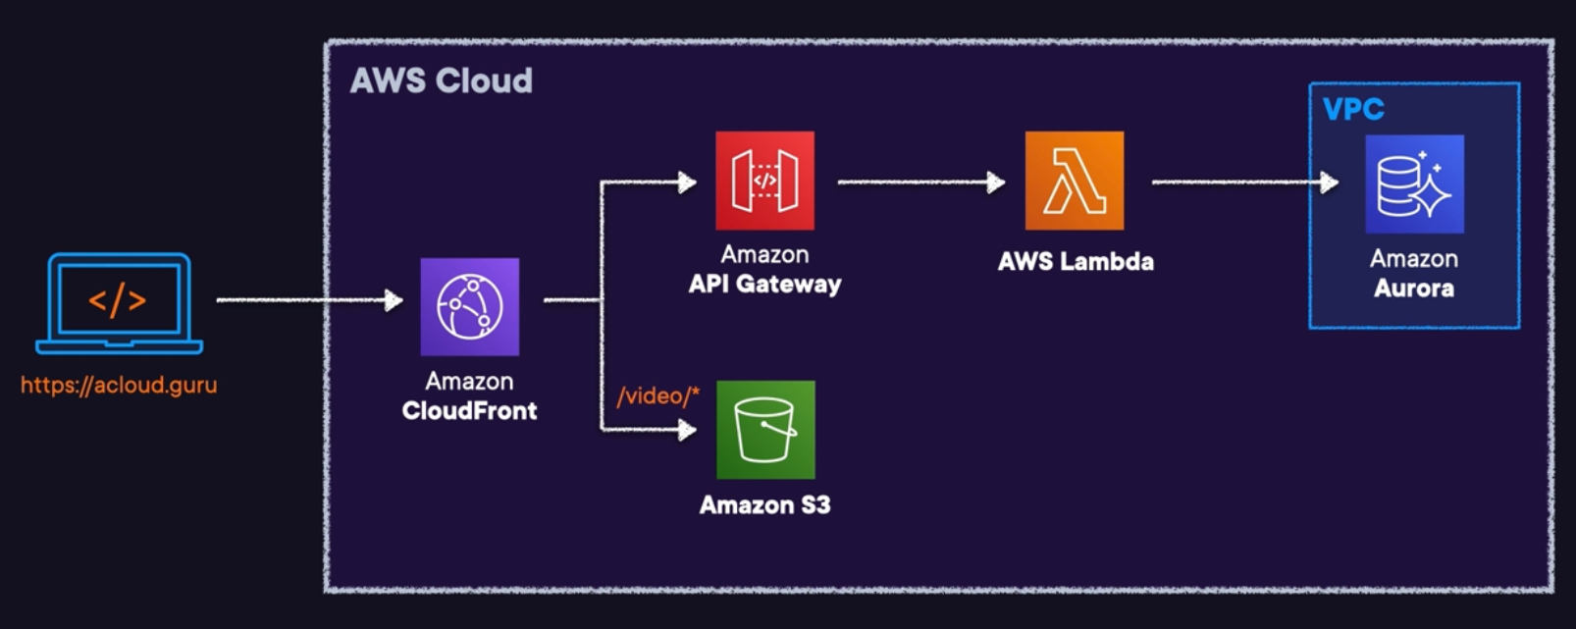

1. The public domain name is hit by the learners computer (acloud.guru)
2. The domain is being sent to Route 53 and to our CloudFront distribution.
3. Then it can go to S3 or API Gateway for specific path patterns.
4. API Gateway is deployed and published to front many different Lambda functions.
5. These Lambda functions perform many different functions within the application.
6. One of those is to reach into an Amazon Aurora private db for various purposes.
7. This is a very simplified example on how we can leverage API Gateway to front other internal private services and interact with those private services that live within things like a VPC and a private subnet.

**Demo:** We will grab an inspirational quote using Lambda and API Gateway.

* Create and deploy a simple API in API Gateway.
* Front a Lambda function.
* Return basic payload upon invocation.
* Publish our API and test.

* Create the backend Lambda function:
  + Lambda – Create function – Function name: InspirationalFunction –
  + Runtime – Python – Change default execution role – Create a new role …
  + Create function.
  + Get into InspirationalFunction – Code – lambda_function – paste [this](https://github.com/pluralsight-cloud/aws-certified-solutions-architect-associate/blob/main/13-decoupling-workflows/fronting-applications-with-api-gateway/lambda_function.py) code there.
  + Hit Deploy – The code gets a random quote from a website, returning that in a response body or returns an error.

* Create RestFul API:
  + Amazon API Gateway – REST API – Build – New API –
  + API name: Inspirational – API endpoint type – Regional – Create API.
* Create a GET method:
  + API Gateway – APIs – Resources – Inspirational – Create Method –
  + Method type – GET – Lambda function –
  + Lambda proxy integration – enable it – select Lambda InspirationalFunction –
  + Create method.
* Test it:
  + API Gateway – APIs – Resources – Inspirational – Test tab –
  + Have in mind that as we added the integration with Lambda to the API Gateway, it allowed API Gateway to invoke our function, it created the necessary permission on the backend that’s not visible.
  + If you do this via some infrastructure as code you will need to create that permission, have that in mind.
  + Hit Test – You have to have the response with 200 status code, the response body with the quote of the day and a bunch of webserver logs stile.
  + If you hit the Test button, you will get more quotes.

* Deploy the API: To make it publicly available.
  + API Gateway – APIs – Resources – Inspirational – Deploy API –
  + Stage – New stage – Stage name: dev – Deploy –
  + Invoke URL – get it and paste it in a browser, you will see a famous quote. If you refresh you will get a new one each time.
  + Have in mind that you can set up your own domain name in API Gateway, so you won’t have to use the default one provided automatically.

**Exam Tips:**

* Understand the logic for APIs: Are the front door to your applications and services.
* Scenarios involving accessing backend services privately should favour API Gateway over other things like using hardcoded access keys and secrets.
* Think about API Gateway always that mentions creating or managing an API.
* API Gateway supports versioning of your API.
* Use Web Application Firewall (WAF) in front your API Gateway to achieve layer 7 protection.
* Remember the different endpoint types:
  + Edge-optimized
  + Regional
  + Private
* Security Options:
  + User authentication can be accomplished to control access to your APIs. Including:
    - IAM roles.
    - Amazon Cognito pools.
    - Even your own custom authorizer using Lambda functions.
  + Custom TLS: Edge-optimized endpoints require ACM certs. You have to deploy the cert in us-east-1, only there (like CloudFront).
  + Regional endpoints require ACM certs in the same region.
  + WAF. You can place WAF in front of your API for DDoS and layer 7 protection.
* API options:
  + RestFul API
  + HTTP API
  + WebSocket API

**Executing Batch Workloads Using AWS Batch:**

**What is Batch:** Batch processing is a method of running automated tasks without user interaction, often used for repetitive or scheduled tasks like backups or data processing. It allows efficient handling of large volumes of data or tasks by executing them in batches or groups.

* Example: A gym needs to bill all its members by the 1st of the month.
  + If you are processing charges manually and one each time is going to be too much time and resource consuming.
  + Instead, the software platform used by the gym generates a file containing charges for all of its members to be processed in bulk. Saving time and resources.
* This feature is vital for Membership or Subscription based businesses, processing recurring payments on weekly or monthly bases.
* You can run batch processing in bash, python scripts, cron, Apache Kafka, etc.

**What is AWS Batch:**

* Managed service that allows you to create and run batch computing workloads within AWS (run on EC2 or ECS/Fargate).
* Makes things Simpler: Removes any heavy lifting for configuration and management of infrastructure required for computing. Scales based on configurations that you set or the infrastructure.
* Will automatically scale to an accurately sized infrastructure based on the number of jobs submitted, and will automatically optimize the distribution of workloads.
* No install required: No installation or maintenance required so you can focus on obtaining and analysing the results.

**Important Components:**

* **Job**: Unit of work that you send to Batch.
  + Example: Shell scripts, executables, Docker images, etc.
* **Job Definitions:** Where you specify how your jobs are to be run.
  + Essentially, the blueprint for the resources in the job.

* **Job Queues:** The job gets submitted to specific queues and reside there until scheduled to run in a compute environment.

* **Compute Environment:** Set of managed or unmanaged compute resources used to run your jobs.

**Choose between EC2 and Fargate:**

|  |  |
| --- | --- |
| **Fargate** | **EC2** |
| * Recommended approach for MOST workloads. * Any job require fast start times (< 30 seconds) * Jobs that require:   16 vCPU or less  No GPUs  120 GiB of memory or less. | * Use it if you need a lot more control over the instance selection. * Choose it if you need:   GPUs  Elastic Fabric Adapter (EFA)  Custom AMIs  High levels of concurrency  Access for Linux Parameters. |

**AWS Batch or AWS Lambda:**

* **Time Limits:**
  + Lambda currently has a 15 min execution time limit.
  + Batch does not have it.
* **Disk Space:**
  + Lambda has limited disk space, and you want to use EFS you have to use a VPC enabled Lambda function to do it. This has overhead and cost specially if you consider the network components.
* **Runtime Limitations:**
  + Lambda is fully serverless but has limited runtimes.

* **Batch Runtimes:**
  + Batch uses Docker, so any runtime can be used.

**Architecture Example using AWS Batch:** This is a realistic workload to use Batch.

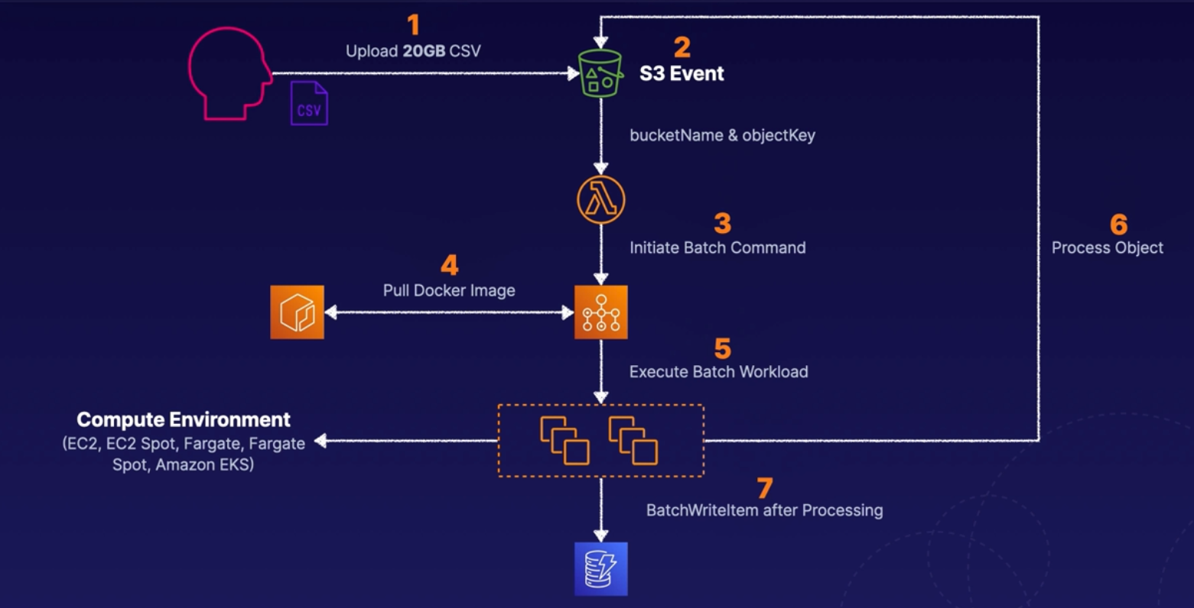

1. Our user uploads a large 200GB CSV to a configured S3 event. We need to process this file within our application.
2. The S3 event can be configured to trigger a Lambda function.
   1. The event can contain the buckedName and the objectKey for sending downstream.
3. We can use that function to trigger a batch command and submit a job to a queue within our Batch service.
4. The batch compute environment and the job pull a custom Docker image that we require to process this large document.
5. We can begin executing the workloads using our configured compute environment, which can be EC2, Fargate or even Amazon EKS.
6. The compute environment can reference the object and the bucket using the job configuration that was sent, and it can begin to process our data in different steps.
7. Once complete, we can have our Batch service run a BarchWriteltem command through our DynamoDB table that we are using to store the massive amount of processed data.

**Managed and Unmanaged Compute Environments:**

|  |  |
| --- | --- |
| **Managed** | **Unmanaged** |
| * AWS manages capacity and instance types. * Compute resources specs are defined when environment is created. * ECS (containers) instances are launched into VPC subnets you specify. * By default uses most recent and approved ECS AMI. * You can user your own AMI. * You can choose Fargate, Fargate Spot, and regular Spot instances. | * You manage your own resources. * AMI must need ECS AMI specs. * You manage everything. * Less commonly used compared to managed. * Good choice for extremlu complex or specific requirements. |

**Exam Tips:**

* Long-Running Workloads: Perfect for anything requiring more than 15 mins (900 secs).
* Managed service.
* Be familiar with definitions:
  + Jobs: Units of work submitted to AWS Batch.
  + Job definitions: Blueprints within the job.
  + All jobs get submitted to queues.
* Lambda or Batch? Lambda has several limitations:
  + Runtimes, execution time limits, and file storage sizes.
* Type of compute depending on number of jobs, GPU allowed, etc, see above:
  + EC2
  + Fargate
* Managed or Unmanaged: See above.

**Brokering Messages with Amazon MQ:**

**Amazon MQ:** Message broker service allowing easier migration of existing applications to the AWS Cloud.

* It offers the ability to leverage multiple programming languages, OS, and messaging protocols.
* The service supports Apache ActiveMQ or RabbitMQ engine types.
* Allows you to easily leverage existing apps without managing and maintaining your own system like you would on prem.

**Differences between SQS and Amazon MQ:**

* Both do more or less the same.
* Amazon MQ is better suited for enterprise messaging scenarios with complex requirements.
* SQS is simpler and more scalable for lightweight messaging needs.

**SNS with SQS or Amazon MQ:**

* Both offers architectures with topics and queues for sending messages. Allows for one-to-one or one-to-many messaging designs.
* If you are migrating an existing app that already uses messaging systems, you likely want to consider Amazon MQ. It’s easy to migrate to this service compared to completely refactoring your architecture to fit SNS and SQS.
* If you are creating a new messaging system, you probably want to take the time to consider using SNS and SQS. They are simpler to use and highly scalable and still accomplish decoupling.
* Amazon MQ requires private networking like VPC, Direct Connect, or VPN.
* SNS and SQS are publicly accessible by default.

**Amazon MQ Brokers:** Amazon MQ offers highly available architectures to minimize downtime during maintenance.

* Architecture depends on the broker engine type.
* Amazon MQ for Apache ActiveMQ with active/standby deployments, one instance will remain available at all times. Configure network of brokers with separate maintenance windows.
* Amazon MQ for RabbitMQ cluster deployments are logical grouping of three broker nodes across multiple AZs sitting behind a Network Load Balancer.

**Exam Tips:**

* Managed broker service for easily migrating message broker systems to the AWS Cloud.
* Allows to leverage Apache ActiveMQ and RabbitMQ.
* Choose this service if you hear anything specific to JMS or messaging protocols like AMQP 0-9-1, AMQP 1.0, MQTT, OpenWire, and STOMP.
* New applications should try SNS with SQS.
* Amazon MQ restricts access to private networking. Must have VPC connectivity, example Direct Connect or Site-to-Site VPN.
* Amazon MQ offers HA architectures that are dependent of the engine type.

**Coordinating Distributed Apps with AWS Step Functions:**

**What is AWS Step Functions:** It’s a serverless orchestration service combining Lambda functions with other AWS services for business applications.

* Provides a graphical console for easier application workflow views and flows.
* Main components:
  + State machines: Particular workload with different event-driven steps within it.
  + Tasks: Specific states within a workflow (state machine) representing a single unit of work.
  + State: Every single step within a workflow.

AWS Functions have two different types of workflows, Standard and Express.

**Executions:** Each workflows has executions, which are instances where you run your workflows in order to perform your tasks.

|  |  |
| --- | --- |
| **Standard Workflow** | **Express Workflow** |
| * Have an exactly-once execution. * Can run for up to one year. * Useful for long-running workflows that need to have an auditable history. * Rates up to 2,000 executions per second. * Pricing based per state transition. If you have one state transition for one year you only are billed for one transition. | * At-least-once workflow execution. You can get some duplication that exists, and you’ll need to handle. * Can run for up to five minutes. * Useful for high-event-rate workloads. * Example: IoT data steaming and ingestion. This data comes in very quickly and in massive waves. * Pricing based on number of executions, durations, and memory consumed. |

**States and State Machines:**

* **Flexible:** Leverage states to either make decisions based on input, perform certain actions, or pass output.
* **Language:** They are using Amazon States Language, ASL.
* States are elements within your state machines. They are referred to by a name.
* Example: Think about an online pickup order: Each step in that workflow is considered a state.

**Integrated AWS Services:** There are a lot of services in AWS that uses this shit.

Lambda, SQS, SNS, API Gateway, etc.

**Different States:**

* **Pass**: Passes any input directly to its output – no work done, just passing data in and then back out.
* **Task:** Single unit of work performed, example, lambda, batch and sns.
* **Choice:** Adds branching logic to state machines.
* **Wait:** Creates a specified time delay within the state machine.
* **Succeed:** Stop executions successfully.
* **Fail:** Stops execution and marks them as failure.
* **Parallel:** Runs parallel branches of executions within state machines.
* **Map:** Runs a set of steps based on elements of an input array.

**Exam Tips:**

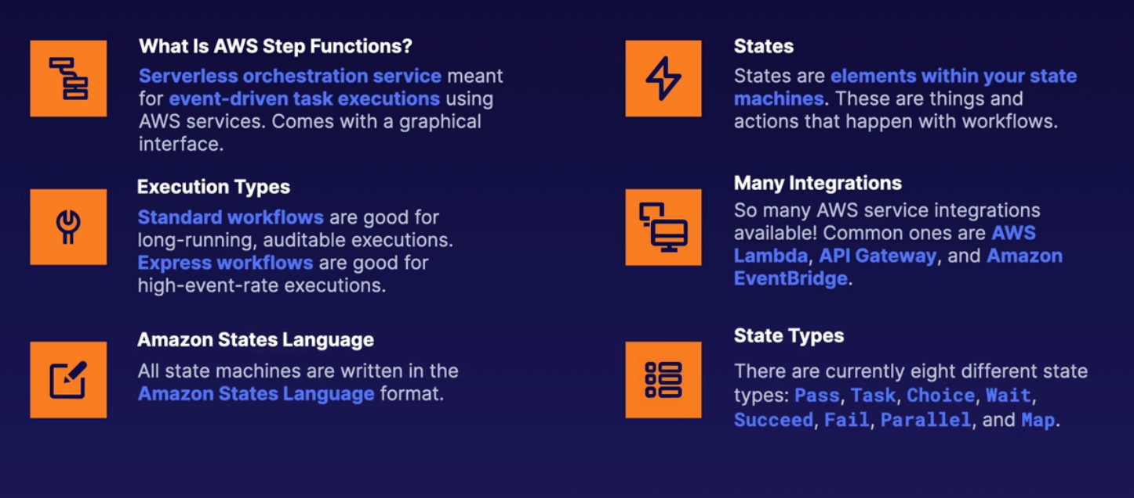

**Ingesting Data from SaaS Applications to AWS with Amazon AppFlow:**

**What AppFlow is:**

* **Integration:** Fully managed integrated service for exchanging data between SaaS apps and AWS services.
  + Example: SalesForce migrating data to Amazon S3.
* **Ingest Data:** Pulls data records from third-party SaaS vendors and stores them in services like S3.
  + Example: Ingesting contact records from SalesForce and putting them on Amazon Redshift table.
  + Example: Pulling support tickets from Zendesk and storing those in an S3 bucket.

* **Bi-Directional:** Data transfers can go both ways. Bi-directional data transfers with limited combinations.
  + However, not all source and destination combinations are supported within the service itself.

**Terms and Concepts:**

* **Flow:** Flows transfer data between sources and destinations. A variety of SaaS applications are supported.

* **Data Mapping:** Determines how your source data is stored within your destinations.
* **Filters:** Controls which data is transferred from a source to a destination.
* **Trigger:** How the flow is started.Supported types:
  + Run on demand.
  + Run on event.
  + Run on schedule.

**Example Diagram:**

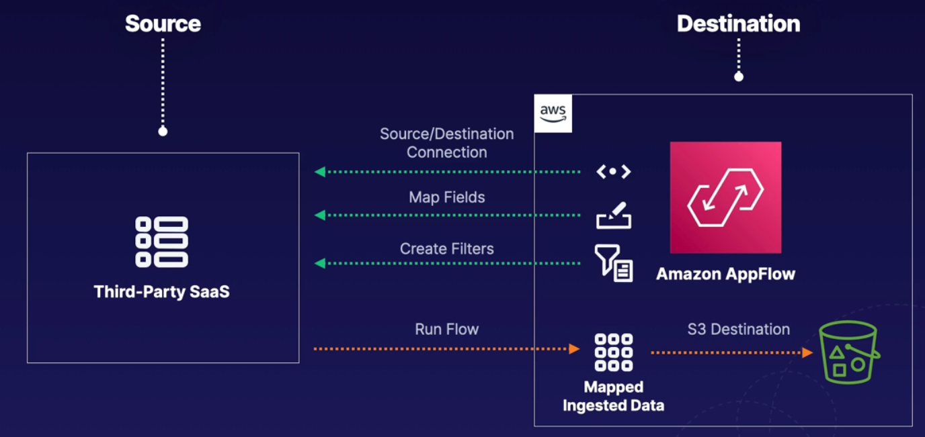

1. Create Source and Destination Connection between source and destination.
2. We Map fields between both sides. So how do we want data that gets ingested to map in our destination bucket.
3. We create Filters. We say: we want this particular type of data to be included or excluded depending on our needs.
4. We are able to run our Flow using some type of trigger. We can run the Flow, ingest the data, maps it, and then stores it in our S3 destination.
   1. Remember the destination can be anything supported, like Redshift, S3, etc.

**Use Cases:** Provided by Amazon, you might see something similar in the exam.

* Transferring Salesforce records to Amazon Redshift.
  + Maybe there is records being created in Salesforce cloud that you want to move and ingest into Redshift so that you can analize them using another AWS service.

* Ingesting and analysing Slack conversations in S3.
  + It can be a scheduled flow trigger that transfers your data from a particular channel into your S3 buckets.

* Migrating help desk support tickets to Snowflake.

* Transferring aggregate data on a scheduled basis to S3. Up to 100 GB per Flow.

**Exam Tips:**

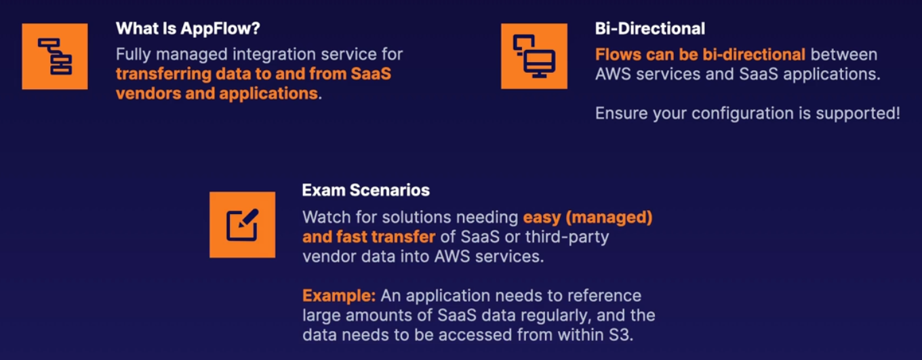

**Decoupling Workflows Exam Tips:**

**4 Questions to Ask in the Exam**

* Is it a synchronous or asynchronous workload?
* What type of decoupling makes sense?
* Does the order of messages matter?
* What type of application load will you see?

**Amazon SQS:** What to Know for the Exam

**SQS can duplicate messages:** This is only once in a while, so if it's happening consistently, check for a misconfigured visibility timeout or if the developer is failing to make the delete API call.

**Queues aren't bi-directional:** If you need communication to return to the instance that sent the message, you'll need a second queue.

Know the defaults: It's important to understand the standard values for all of the SQS settings.

**Nothing lasts forever:** Messages stored in SQS can only persist up to 14 days.

Does order matter? If message ordering is important, make sure to select SQS FIFO.

**Amazon SNS and API Gateway:** What to Know for the Exam

**Proactive notifications** = SNS: Any time a question asks about email, text, or any type of push-based notification, think of SNS.

**CloudWatch & SNS:** Scenarios that talk about getting a notification from a CloudWatch alarm should immediately make you look for SNS in the answer.

**API Gateway:** You don't need to have an in-depth understanding. You only need to know it acts as a secure front door to external communication coming into your environment.

**AWS Batch:** What to Know for the Exam

**Long-running, batched workloads:** Anything related to batch workloads that is long-running (i.e., › 15 minutes) will likely involve AWS Batch.

**Queued workloads:** If you see a question about batch workloads requiring queues, then think of AWS Batch.

**On-demand alternative to AWS Lambda:** Questions regarding an alternative solution to AWS Lambda due to runtime requirements could likely involve the AWS Batch service.

**Amazon MQ:** What to Know for the Exam

**Managed messaging broker:** If there is any mention of a managed broker service, think of Amazon MQ.

**RabbitMQ or ActiveMQ:** Any mention of these two technologies means you should look for Amazon MQ within the answer.

**Specific messaging protocols:** If you see messaging protocols like JMS, AMQP 0-9-1, AMQP 1.0, MQTT, OpenWire, or STOMP, then Amazon MQ has to be in the answer. SNS and SQS cannot handle this specific protocols.

**AWS Step Functions:** What to Know for the Exam

**Serverless orchestration service:** Any questions with this saying will likely involve Step

Functions as the answer.

**Different workflow decision requirements:** Whenever the solution requires different states or logic during workflows (e.g., condition checks, failure catches, or especially wait periods), think of Step Functions.

**Amazon AppFlow:** What to Know for the Exam

**SaaS data ingestion:** For architectures requiring simplified data ingestion from external

SaaS applications into AWS, this is more than likely the correct solution.

**Bi-directional:** Remember that this service can be bi-directional in certain use cases.

Data can be ingested into or out of AWS services depending on configurations.

Common scenario question: Any data being used by a 3rd party SaaS, that needs to live with S3 in a regular basis.

**Big Data:**

**Exploring Large Redshift Databases:**

**The 3 Vs of Big Data:** Refer to the three primary characteristics that are often used to describe and differentiate big data from traditional data.

* **Volume:** The sheer amount of data that is being generated and collected.
  + Big data is characterised by large and massive data sets.
  + Typically exceed the capacity of traditional data processing systems.
  + We are talking ranges from terabytes, petabytes or even exabytes of data.

* **Variety:** Describes the various types of data that makes up Big Data.
  + Includes data from a wide range of sources and formats.
  + Encompasses things like:
    - Structured data, like databases.
    - Semi-structured data. Like XML or JSON.
    - Even unstructured data, like text, image, and video.

* **Velocity:** Pertains to the speed at which data is generated, processed, and analysed.
  + Big data sources can produce data at an incredibly fast pace.
  + You have to be able to keep up with it.
  + Think applications like real-time or rean-realtime data streams from things like warehouses, weather senses, social media posts and comments, or even financial transactions around the globe.
  + Analysing this data is a key challenge in big data applications.

**What is Amazon Redshift:** Fully managed data-warehouse service in the Cloud that can handle massive amounts of data, even on the petabyte scale.

* Super-sized relational database traditionally used in big data applications.
* Received the name due to the desire to have people leave Oracle db and leverage this AWS service instead.

**Redshift Overview and Uses:**

* **Size:** Amazon Redshift is an incredibly large data warehousing solution. It can hold up to 16 PB of data. You don’t have to split up your large datasets.
* **Relational:** This db is relational. You use your standard SQL and business intelligence (BI) tools to interact with it.
* **Based on PostgreSQL:** However, it is NOT used for Online Transaction Processing (OLTP) workloads. It is tailored for analytical and data warehousing tasks.
* **Usage:** Is not meant to be a replacement of standard RDS databases.
* **High Performance:** Offers up to 10x the performance of other data warehousers offered in the cloud. Speed and efficiency.
* **Columnar:** What sets Redshift apart from other services is that the storage of data is column-based instead of row-based. Allows for efficient parallel queries.

**High Availability, Snapshot, and Disaster Recovery:**

* Redshift now supports Multi-AZ deployments. It only spans two AZs at this time.
* Snapshots are incremental and point-in-time. They can be automated or manual. Always contained in S3 (you cannot manage the bucket).
* No option to conversions from Single-AZ to Multi-AZ (or vice versa).

**Important for the exam:** Always favor large batches.

* Scenarios on the exam that are needing to optimize Redshift insert performance should favor large data inserts.
* Leverage large batch inserts whenever you can.

**Redshift Spectrum and Enhanced VPC Routing:**

**Redshift Spectrum:**

* Efficiently query and retrieve data from S3 without having to load the data into Amazon Redshift tables.
* Massive parallelism allows this to run very fast agains large datasets.
* Uses Redshift servers that are independent of your cluster.

**Enhanced VPC routing:**

* All COPY and UNLOAD traffic between your cluster and your data repositories is forced through your VPC.
* Enables you to use VPC features like VPC Endpoints, VPC Flow Logs, etc.

**Exam Tips:**

* Make sure you don’t use Redshift in place of RDS.
* Redshift is a relational DB based on PostgreSQL.
* Supports a lot of data, up to 16 PB.
* You can deploy a Multi-AZ cluster for high availability.
* Use Redshift Spectrum to efficiently and quickly process data in S3.
* Leverage Snapshots for point-in-time recovery, or restoration to other Regions.

**Processing Data with EMR (Elastic MapReduce):**

**What is ETL:** Extracts Perform and Load.

* Are processes that are critical components of data management and analysis.
* **Extract:** It’s a process that involves the systematic extraction of data from various source systems.
* **Transform:** The transforming or reshaping of that data to meet specific business requirements is a major factor.
* **Load:** At the end you finally load it into a target database or a data warehouse for further analysis and reporting.
* ETL processes allow for valuable insights to be gained when you are making critical business decisions.

**What is EMR:** Elastic MapReduce. Managed cluster platform that simplifies running open source big data frameworks, such as:

* Spark
* Hive
* HBase
* Flink
* Hudi
* Presto.

**EMR Storage:** There are 3 types of options.

* Hadoop distributed File System (HDFS):
  + Distributed, scalable file system for Apache Hadoop that distributes stored data across instances. Used for caching results during processing.

* EMR File System (EMRFS):
  + Extends Hadoop to add the ability to directly access data stored in S3 as if it were a part of HDFS.
  + S3 is typically used to store input and output data, not intermediate data.

* Local File System:
  + Locally connected disk created with each EC2 instance.
  + Instance store volumes only remain during the lifecycle of the EC2 instance. So data will go away each time the instance spins down. Do NOT store important data there.

**Clusters and Nodes:** Clusters are groups of EC2 i. within Amazon EMR. Each instance is a node.

**Node Types:**

* **Primary Node:** Manages the cluster, coordinates distribution of data and tasks, tracks health statuses.
* **Core Node:** Runs tasks and stores data in Haddoop Distributed File Systems (HDFS). These are mend to be long-running tasks.
* **Task Node:** Only run one task with no storage on the systems (HDFS). Typically, Spot instances.

**Purchasing Options and Cluster Types:**

* **On-Demand:** EC2 instances. Most reliable purchase option. Will not be terminated. Most expensive choice.

* **Reserved:** Just like other reserved instances. Minimum 1 year. Offers great cost savings. Typically used for primary nodes and core nodes since those are long running.
* **Spot:** Cheapest option available. Can be terminated with little warning. Typically used for task nodes.
* **Long Running or Temporary Cluster:** Clusters can be long-running or transient (temporary).

**EMR Architecture:**

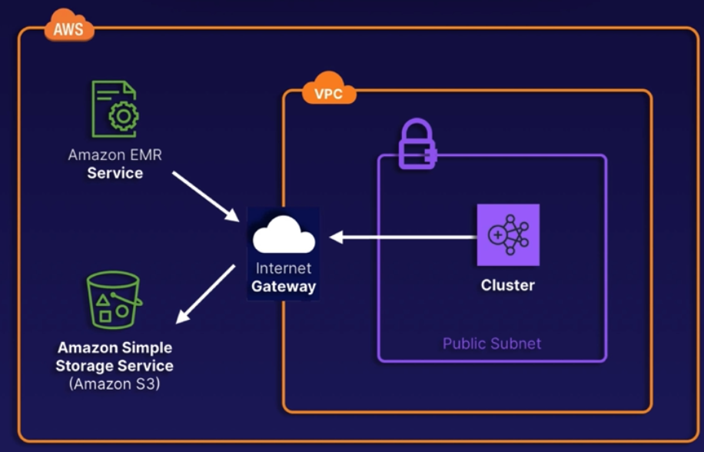

The Cluster needs access to the EMR service which means they need internet access or VPC endpoint access, otherwise EMR cannot manage the cluster properly.

The same connectivity requirements are needed for using S3 or via EMRFS.

You should leverage a VPC endpoint for accessing S3 whenever possible to skip costs.

**Exam Tips:**

* **What Is EMR?** AWS-managed big data platform that allows you to process vast amounts of data.
* **Big Data Frameworks:** Keep an eye out for Apache Hadoop and Apache Spark.
* **EC2 Purchasing Rules Apply:** Remember, you can leverage On-Demand, Reserved, and Spot instances.
* **Storage Type Indicators:** Keyword indicators can include Hadoop Distributed File System (HDFS) and EMR File System (EMRFS).
* **Toolsets to Keep in Mind:** Built-in support for Spark, Hive, HBase, Flink, Hudi, and Presto.
* **Use Cases and Scenarios:** Large dataset processing (ETL), web indexing, machine learning training, and large-scale genomics projects.

**Demo: Processing Data Using EMR**

**Stand up a basic EMR cluster:**

* Amazon EMR – Create cluster – Name: AwesomeCluster – Amazon EMR release: depending in which one you select you will get different versions of the tools and vendors you can choose, even other tools will appear or disappear.
* Application bundle: Spark Interactive – select HBase too – Hbase storage settings –
* select Hadoop Distributed File System (HDFS) – Cluster configuration –
* Instance groups – Primary – c1.medium – this is a demo but in real life you want redundancy and HA, so you should tick Use multiple primary nodes –
* Core – c1.medium – Task 1 of 1 (remember they are for short life tasks) –
* c1.medium – Cluster scaling and provisioning – Set cluster size manually –
* we will set one core and one task node –
* Networking – we will leave the default vpc and subnet for this demo but you don’t have to do it in real life.
* EC2 security groups – you can set up local firewall for each type of nodes, we will leave the default ones and will modify them once the cluster is created –
* Steps (out of the range of SAA exam), this tell the cluster how to process the data –
* Cluster termination – choose manual – Bootstrap actions – you can specify the user data script when creating the instances – IAM roles – Create a service role –
* This will let aws to create it for us – EC2 instance profile for Amazon EMR –
* Create an instance profile – S3 bucket access – select All S3 buckets in … (but don’t do it in real life, this is just for simplicity) –
* Create cluster.

**Streaming Data with Kinesis:**

**What is Kinesis:** Allows you to ingest, process, and analyse real-time streaming data. You can think of it as a huge data highway connected to your AWS account.

Used mostly for Big Data applications.

**2 Versions:** Data Streams and Data Firehose.

|  |  |
| --- | --- |
| **Data Streams** | **Data Firehose** |
| **Purpose**: Real-time streaming for ingesting data.  **Speed**: Real time.  **Difficulty:** You’re responsible for creating the consumer and scaling the stream. | **Purpose**: Data transfer tool to get information to S3, Redshift, Elasticsearch, or Splunk.  **Speed**: Near real time (within 60 seconds).  **Difficulty:** Plug and play with AWS architecture. |

**Data Streams Architecture:**

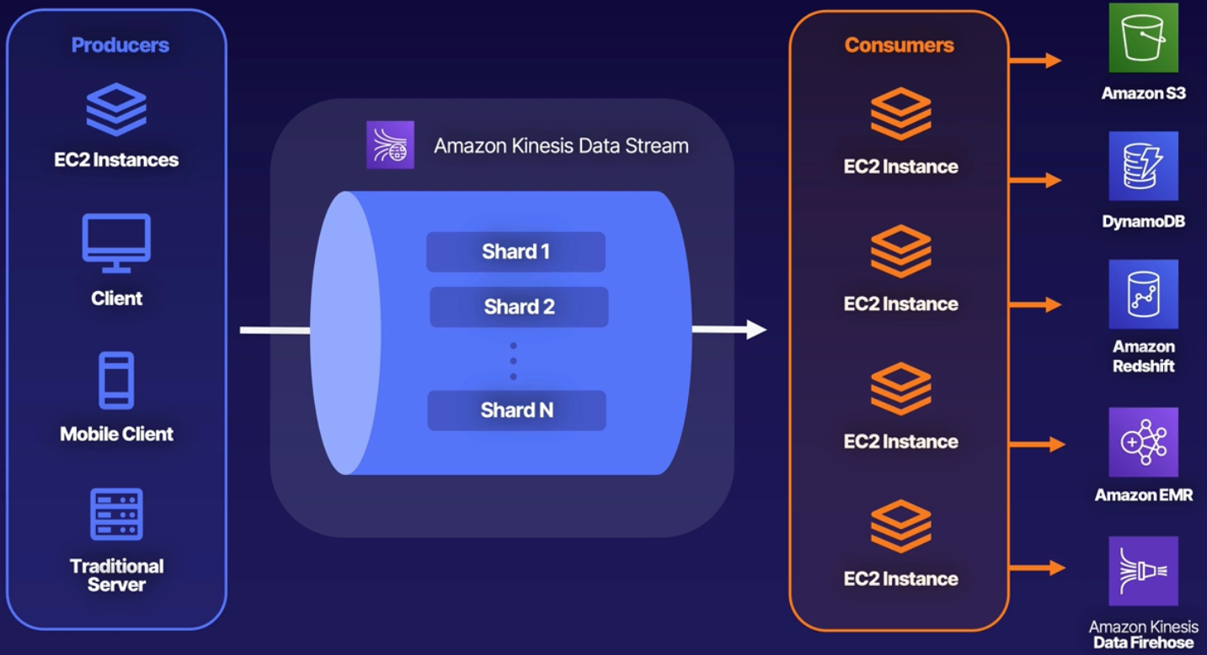

* **Producers:** Producers are just something that’s making data. Maybe is an EC2, maybe a web client, mobile phone, server, etc. Doesn’t matter what it is, is something that is creating information. Could be:
  + A log.
  + Stats on those IOT sensors.
  + the type of data isn’t particularly relevant.

* **Kinesis Data Stream:** You want to move the data from one endpoint to another. You have to decide how many Shards you’re going to create.

* **Consumer:** Is just something that is going to take that data in, process that content, and put it in that endpoint that you have selected, that could be anything. But you will need to write the code.
* This is a lot of work to put together, that’s why AWS created Firehose, which is simpler.

**Data Firehose Architecture:**

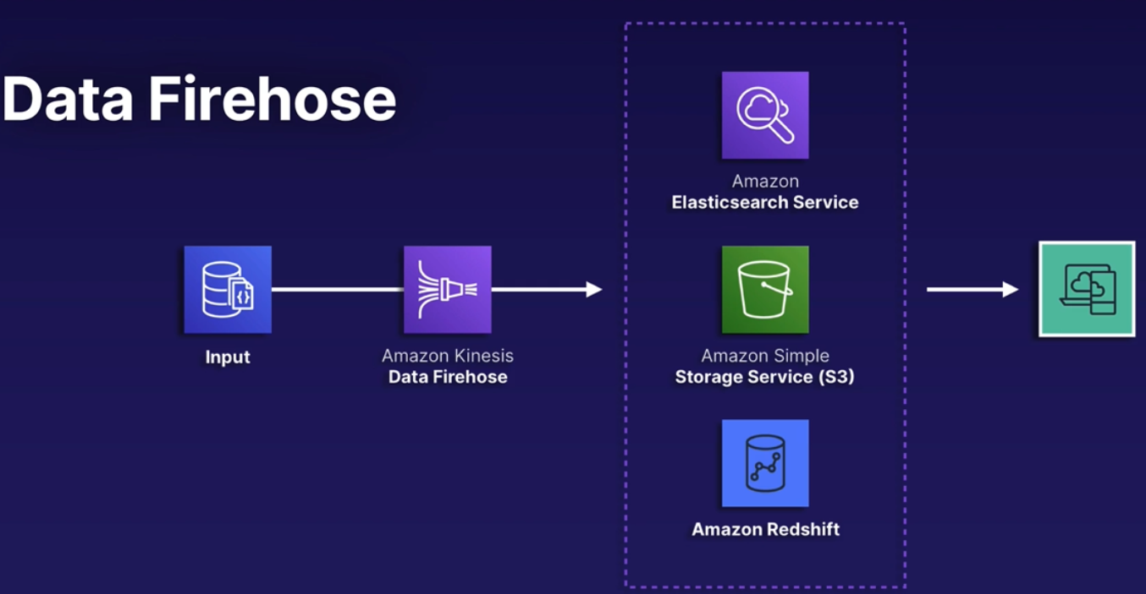

* **Data Firehose** handles the scaling for you.
* Handles building out that consumer, so you won’t have to write that code.
* Here you send data to the service and it has a few supported endpoints where you can put that data.
* Does the same than Data Stream but much more limited.

**Kinesis Data Analytics and SQL:** To process our information we will use Data Analytics, using standard SQL.

Easy:

* It’s very simple to tie Data Analytics into your Kinesis pipeline.
* It’s directly supported by Data Firehose and Data Streams.
* It’s simple to set up a situation where data comes in in one format and gets changed.
* Example: Maybe we want to sanitise our logs. Maybe our IOT devices are not in the format we can easily load into our db.
  + We can run our SQL on this data, effectively in real time as it’s being pushed through.

No Servers:

* Fully managed real-time serverless service.
* It will automatically handle scaling and provisioning of needed resources.

Cost:

* You only pay for the amount of resources you consume as your data passes through.

**Scenario question:** Kinesis vs SQS

When we’re looking for a message broker, which do we pick?

**SQS:** Message broker that is simple to use and doesn’t require much configuration.

It doesn’t offer real-time message delivery.

**Kinesis:**  Is a bit more complicated to configure and is mostly used in big data applications. It does provide real-time communication.

**Exam Tip:**

* **Real Time?** Think Kinesis. There are very few services that offers real-time, Kinesis is one of them.
  + Real Time = Kinesis Data Stream
  + Near real time = Kinesis Data Firehose.

* **Kinesis vs SQS:** Both are message brokers, only Kinesis handles real time data.

* **Transforming Data:** Kinesis Data Analytics. Uses SQL.
* **Scaling:** Data Firehose does. Data Streams don’t.

**Amazon Athena and AWS Glue:**

**What is Athena:** Interactive query service that makes it easy to analyse data in S3 using SQL.

* Allows you to directly query data in your S3 bucket without loading it into a db.

**What is Glue:** Serverless data integration service that makes it easy to discover, prepare, and combine data.

* It allows you to perform ETL workloads without managing underlying servers.
* This replaces EMR.
* Simply using Glue to do that extract, transform load of our data without having to spin up a huge fleet of EC2 instances and use third party open-source tooling to transform that data.

**Athena and Glue:** 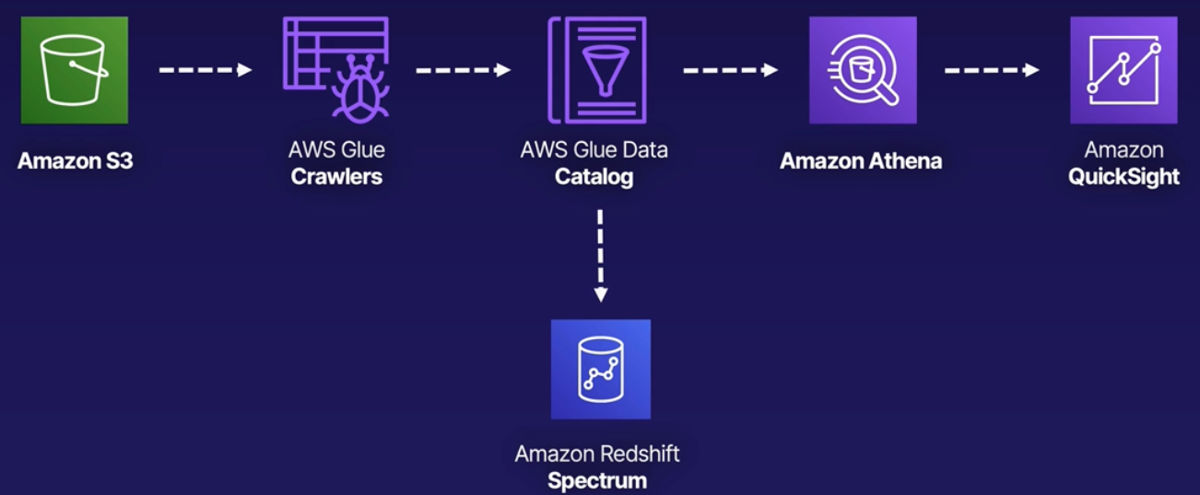

* S3: You have your data coming from different sources, unstructured on S3. You need to put it in a format that you can easily query.
* You use Glue to point to all this S3 data. Is going to build a catalog, a structure for that data.
* Once that is built, you have a few different options:
  + Redshift Spectrum: This allows you to use Redshift without having to load all that data into the Redshift database itself.
  + Amazon Athena: Athena can take that data, that Glue have structured, and run queries on it without having to load it into that database.
    - Then you can use QuickSight, which is Amazon’s version of *Tableau*, it can help you to visualize this data.
    - So you can combine:
      * Storing data on S3
      * Structuring it with Glue.
      * Querying with Athena.
      * QuickSight to give you a dashboard.

**Exam Tips:**

* **Serverless SQL:** Scenarios looking for a serverless SQL solution, **Athena** is for you.
  + Could be data from a Business Intelligence (BI) application.
  + Could be login data.

* **Athena and Glue:** Serverless options, fully managed by AWS.

* They work together very well, although Athena can work alone if the data is already structured.
  + If is not structured, you can do it with Glue (will design a schema for that data).

**Visualizing Data with QuickSight:**

**What is QuickSight:** Fully managed, serverless business intelligence (BI) data visualization service.

* Meant to simplify the process of creating interactive dashboards.
* Allows you to easily create dashboards and share them with specific users and groups.
* Enhance data accessibility and collaboration.

**Features and Use Cases:**

* Useful for business data visualizations, ad-hoc data analytics, and obtaining important data-based business insights.
* Offers extensive integration capabilities, connecting with services like RDS, Aurora, Athena, S3, and many more.
* **SPICE:** Superfast Parallel In-memory Calculation Engine. Robust in-memory engine used to perform advanced calculations.
* Enterprise offering (not free) lets you implement Column-Level Security (CLS), which is going to allow better safeguarding of specific sensitive data (don’t need to know this for the exam).
* Pricing is on a per-session and per-user basis.

**Dashboards, Users, and Groups:**

* Users can be created for accessing the platform.
* In the Enterprise version you can also create Groups to streamline user management.
  + Users and Groups in QuickSight exists only in QuickSight.
  + Don’t confuse them with AWS IAM users and groups.
* Dashboards: Allow for stored configurations and filtering. Each user can have their own dashboard.
* You can share dashboards and analysis results with users and groups. Shared users can see the underlying data.

**Architecture:**



Is exactly the same used in Athena + Glue above.

**Remember for the exam** that you can integrate Athena with QuickSight to build dashboards based on our Athena queries.

**Exam Tips:**

* Need to look to your data? QuickSight.
* Business Intelligence (BI) comes up, QuickSight.
* Integrates with RDS, Aurora, Athena, S3, and many more.
* Remember the diagram with the architecture.
* Per-session and per-user pricing.
* Enterprise edition allows for more advanced capabilities but is not free.
* Be familiar with SPICE: Superfast Parallel In-memory Calculation Engine.

**Moving Transformed Data Using AWS Data Pipeline:**

**What Data Pipeline is:** Extract, Transform, and Load (ETL). Managed service for automating movement and transformation of your data.

**Overview:**

* **Data Driven:** web service that allows you to define data-driven-workflows and automate those.
  + You create steps that are dependent on previous tasks completing successfully.

* **Parameters:** Define your parameters for data transformations. AWS Data Pipeline enforces your chosen logic.

* **Highly Available:** AWS hosts the infrastructure on highly available and distributed infrastructure. Also fault tolerant.
* **Handling Failures:** Automatically retries failed activities. Configure notifications via SNS for failures or even successful tasks.
* **AWS Storage Services:** Integrates easily with Amazon DynamoDB, RDS, Redshift, and S3.
* **AWS Compute:** Works with EC2 and EMR for compute needs.

**Components to know:**

* **Pipeline Definition:** Specify the business logic of your data management needs.

* **Managed Compute:** Service will create EC2 i. to perform your activities or leverage existing EC2.
* **Task Runners:** EC2 poll for different tasks and perform them when found in the pipeline.
* **Data Nodes:** Define the locations and types of data that will be input and output.
* **Activities:** Are pipelines components that define the work to perform.

**Popular Use Cases:**

* Processing data in Amazon EMR using Hadoop streaming.
* Importing or exporting DynamoDB data.
* Copying CSV files or data between S3 buckets.
* Exporting RDS data to S3.
* Copying data to Redshift.

**Diagram:** Exporting MySQL Data to S3 to Generate Reports.

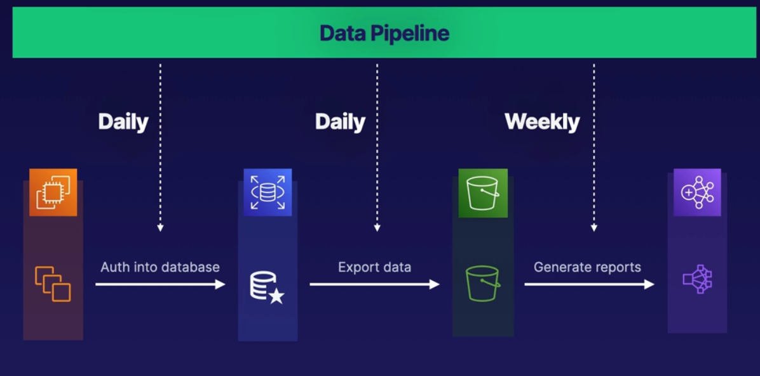

* At the top we have our data pipeline.
* At the bottom we have our resources:
  + EC2, RDS, S3, and Amazon EMR.
* First thing we will do is to set up our task runners to authenticate into our database.
  + We will provide the credentials in a secure manner so our task runners can log in into the db.
* We will export our data from RDS to S3. We will do it using those task runners that are authenticated into the db.
* Once the data is exported to S3 we can leverage that to generate reports in EMR.
* You can set schedules for specific tasks.
  + You may want to authenticate into the db in a daily basis.
  + Maybe you want also to export the db daily to the S3 bucket as well.
  + Maybe you want to generate the report at the end of the week, so weekly reports.

**Exam Tips:**

* **Managed ETL:** Managed AWS service for ETL workflows that automates movements and transformations of your data.
* **Compute Integrations**: Easily integrate it with EC2 and EMR for managed compute needs.
* **Data Driven:** Use data-driven workflows to create dependencies between tasks and activities.
* **Amazon SNS:** Leverage SNS for any failure notifications. Use it for successes and other event-driven workloads as well!
* **Storage Integrations**: There are several integrations, including DynamoDB, RDS, Redshift, and S3.
* **Keywords:** Anything related to managed ETL services, and automatic retries for data-driven workflows.

**Implementing Amazon Managed Streaming for Apache Kafka (Amazon MSK):**

**What is Amazon MSK:** Streaming service used for Apache Kafka.

* **Apache Kafka:** Fully managed service for running data streaming applications that leverage Apache Kafka.
* **Control Plane:** Provides control-plane operations. Create, updates, and deletes clusters as required.
* **Data Plane:** Leverage data-plane operations for producing and consuming steaming data.
* **Existing Application:** Open-source versions of Apache Kafka allow support for existing apps, tools, and plugins.

**Important Components and Concepts:**

* **Broker Nodes:** Specify the amount of broker nodes per AZ you want at time of cluster creation.

* **ZooKeeper Nodes:** Are created for you.
* **Producers, Consumers, and Topics:** Kafka data-plane operations allow creation of topics and ability to produce/consume data.
* **Flexible Cluster Operations:** Perform cluster operations with the console, AWS CLI or APIs within any SDK.

**Resiliency in Amazon MSK:**

* **Automatic Recovery:** Automatic detection and recover from common failure scenarios. Minimal impact.

* **Detection:** Detected broker failures result in mitigation or replacement of unhealthy nodes.
* **Reduce Data:** Tries to reuse storage from older brokers during failures to reduce data needing replication.
* **Time Required:** Impact time is limited to however long it takes Amazon MSK to complete detection and recovery.
* **After Recovery:** After successful recovery, producers and consumer apps continue to communicate with the same broker IP as before.

**Good To know:** Won’t appear in the exam.

* **MSK Serverless:** Cluster type within Amazon MSK

offering serverless cluster management. Automatic provisioning and scaling.

* **Fully Compatible:** MSK Serverless is fully compatible with Apache Kafka. Use the same client apps for producing and consuming data.
* **MSK Connect:** Allows developers to easily stream data to and from Apache Kafka clusters.

**Security and Logging:**

* Integration with Amazon KMS for SSE requirements
* Encryption at rest by default
* By default, TLS 1.2 for encryption in transit between brokers in clusters
* Deliver broker logs to Amazon CloudWatch, Amazon S3, and Amazon Kinesis Data Firehose
* By default, metrics are gathered and sent to CloudWatch.
* All Amazon MSK API calls are logged to AWS Cloud Trail.

**Exam Tips:**

* **Apache Kafka:** Fully managed AWS service for running and building Apache Kafka data streaming applications.
* **Control Plane:** Service handles control-plane operations: creation, updating, and deletion of clusters.
* **Data Plane:** Leverage the same Apache Kafka data-plane operations for producing and consuming data.
* **Automatic Recoveries:** Service detects and automatically mitigates most of the common failures.
* **Encryption:** Integrates with Amazon KMS for SSE needs. Uses TLS 1.2 for in-transit communications.
* **Logging:** Push broker logs to CloudWatch, S3, or Kinesis Data Firehose. API calls are logged to CloudTrail.

**Analysing Data with Amazon OpenSearch Service:**

**What is OpenSearch:** Managed service allowing you to run search and analytics engines for various use cases.

It is the successor of Amazon Elasticsearch Service. So you may see one of those in the exam, just remember they are the same.

**Service Features:**

* **Quick Analysis:** Quickly ingest, search, and analyse data in your clusters.

Commonly part of an ETL process.

* **Stability:** Multi-AZ-capable service with master nodes and automated snapshots.
* **Scalable:** Easily scale cluster infrastructure running the open-source OpenSearch services.
* **Flexible:** It allows for SQL support for business intelligence (BI) apps.
* **Security:** Leverage IAM for access control, VPC security groups, encryption at rest and in transit, and field-level security.
* **Integrations:** Easily integrate it with Amazon CloudWatch, AWS Cloud Trail, Amazon S3, and Amazon Kinesis.

**Diagram:**

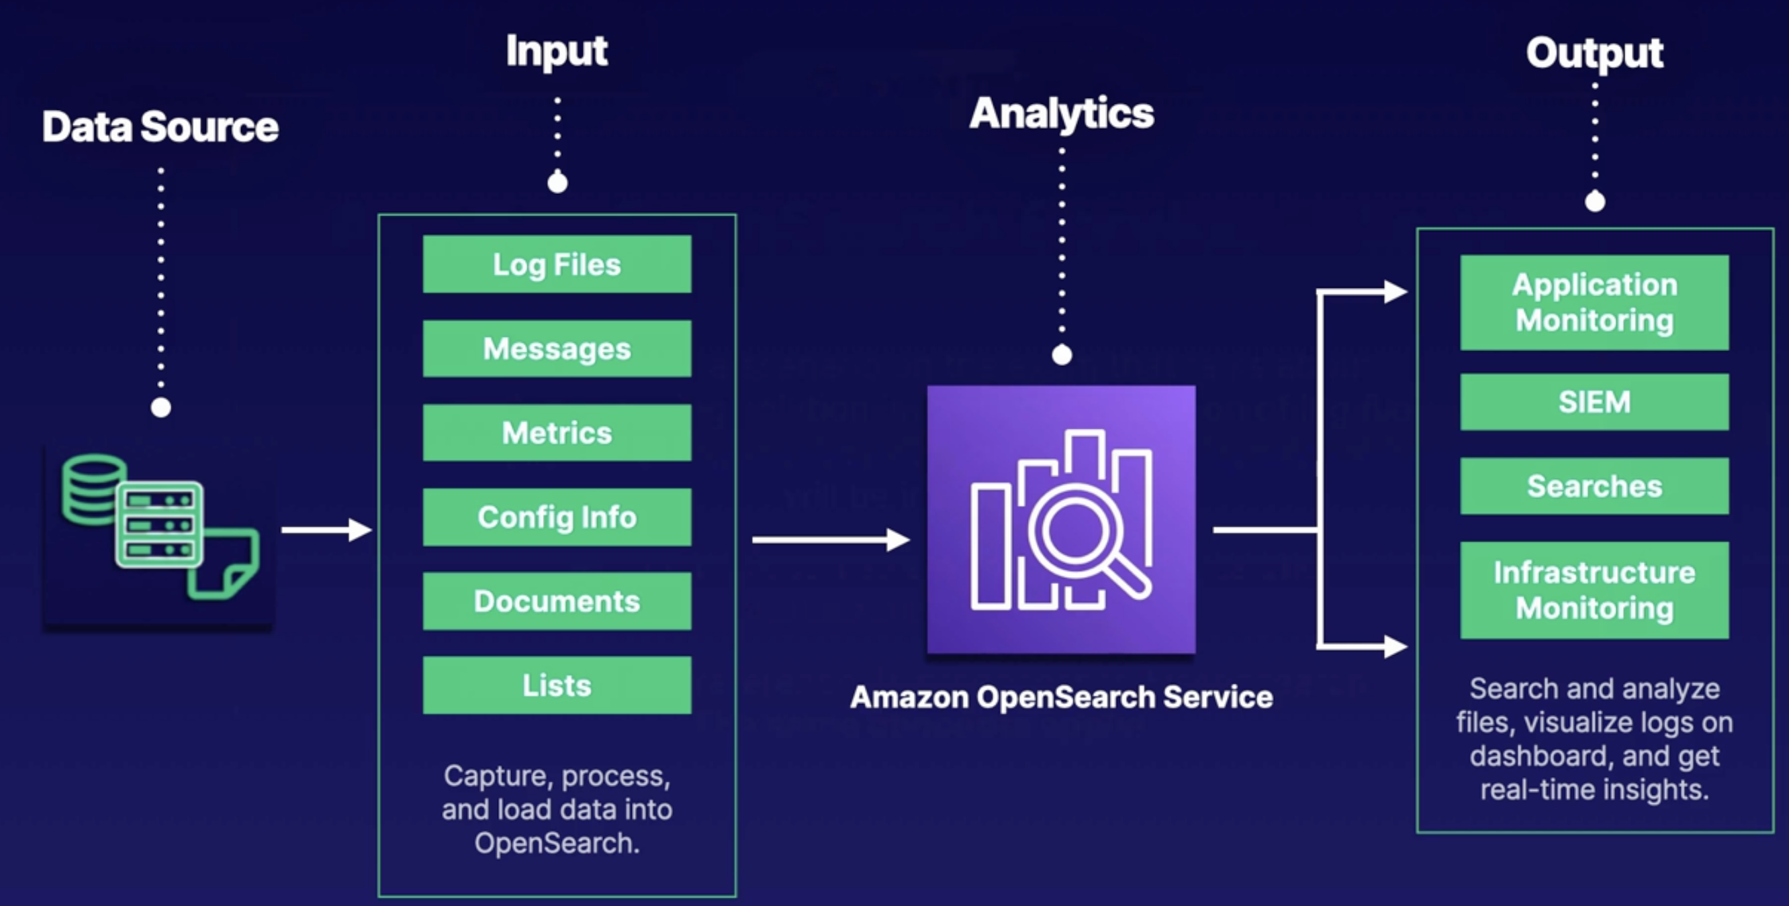

* **Data Source:** Can be anything from logs, servers, whatever you want to output data from.
* **Input:** Whatever you want to capture, process, and load into Amazon OpenSearch.
* **Analytics:** Are completed in OpenSearch service.
* **Output:** After normalizing or performing any analytic we want, we can output data for things like application monitoring, search and analyse files and logs, etc.

**Exam Tips:**

* **Amazon OpenSearch Service:** If you're given a scenario on the exam that talks about creating a logging solution involving visualization of log file analytics or BI reports, there's a good chance OpenSearch will be included.
  + Know that it is used as a managed analytics and visualization service. AWS may still reference its predecessor, Elasticsearch.
  + The same concepts apply!

**Big Data Exam Tips:**

**Questions to ask in the Exam:**

* What kind of database works?
* How much data do you have?
* Is serverless a requirement?
* How do we optimize?

**Redshift and EMR:**

* **While Redshift is a relational database**, it's not a replacement for RDS in traditional applications.
* **Redshift supports single-AZ and multi-AZ deployments.** You can create multiple clusters in different AZs. Multi-AZ supports two AZs at one time. Converting to Multi-AZ requires use of an existing snapshot.
* **EMR is made up of EC2 instances.** This means you can employ your standard EC2 instance cost-saving measures.
* **EMR for Apache Hadoop and Apache Spark**. Remember, this service offers several built-in open-source tools to process vast amounts of big data. It has the ability to leverage HDFS, EMRFS, and local storage.

**Kinesis, Athena, and Glue:**

* **Kinesis is the only service with a real-time response.** If the question asks for a real-time solution to processing or moving data, look for an answer that includes Kinesis.
* **SQS and Kinesis can both be queues.** Each service has its pros and cons. SQS is easier and simpler, and Kinesis is faster and can store data for up to a year.
* **Serverless SQL means Athena.** Any time serverless SQL or querying data that is stored in S3 comes up, think Athena.
* **Glue is a serverless ETL service.** It can help create that schema for your data when paired with Athena.

**QuickSight, OpenSearch or ElasticSearch:**

* **Creating a dashboard?** QuickSight is your go-to tool for visualizing data.
* **OpenSearch** is primarily used for analyzing log files and various documents, especially within an ETL process.
* **Amazon OpenSearch Service** and Amazon Elasticsearch Service (predecessor) are extremely similar, and either may appear on the exam for the time being. They both follow the same concepts.

**Data Pipeline:**

* It is a managed ETL service within AWS.
* Implement automated workflows for movement and transformation of your data.
* It integrates with storage services (e.g., RDS and S3) and compute services (e.g., EC2 and EMR).
* Data-driven and task-dependent ETL workloads are a perfect use case.

**MSK:**

* It is an AWS managed service for building and running Apache Kafka streaming applications.
* The service handles control plane operations for you (creation, updating, and deletion).
* You manage data plane operations.
* Push broker logs to CloudWatch, S3, or Kinesis Data Firehose.
* API calls are all logged to CloudTrail.

**Serverless Architecture:**

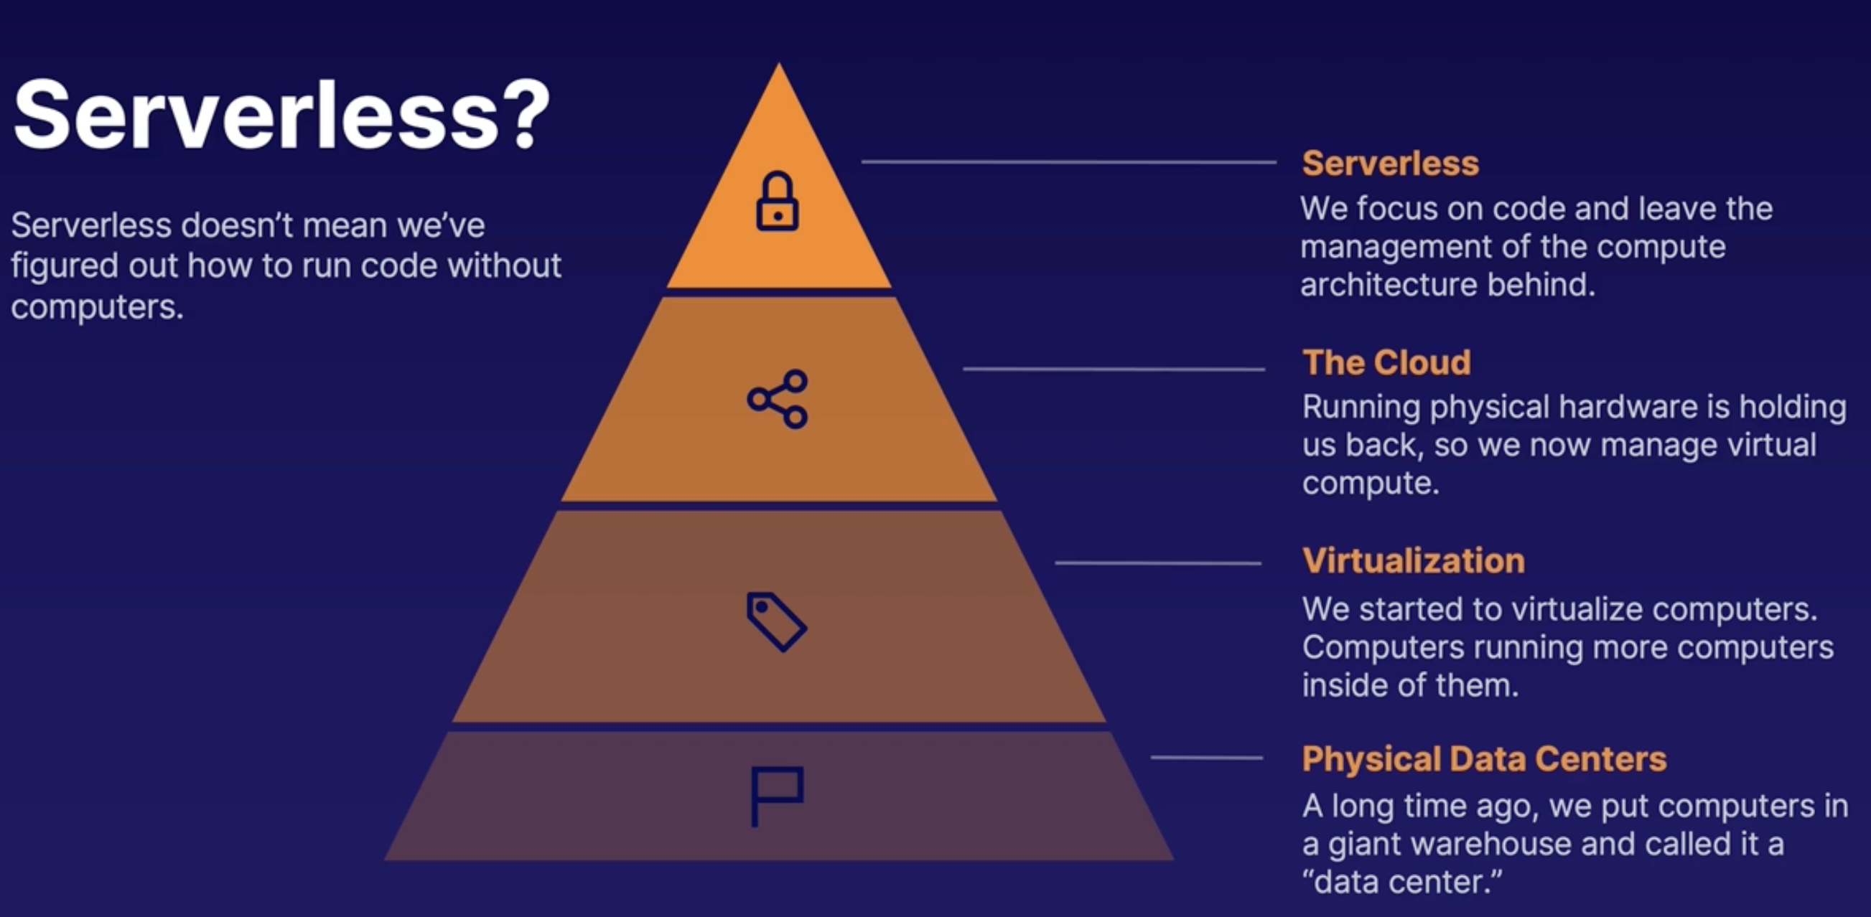

* **Physical Data Centres:** Originally, we put all our computers in datacenters.
  + Our company could build a datacenter or rent some space in one to another company.
* **Virtualization:** Then I can buy a physical computer and run more than one computer inside of it by running virtualization software.

* **The Cloud:** Some companies rented those virtualized OS to other companies that were not interested in having to manage servers in a Datacenter.
* **Serverless:** The same way that another company manages the hardware and the virtualization, they can also manage the OS and let us to focus in the code. We write the code and upload the code, and that’s it. Everything else is handled by AWS. AWS still has physical datacenters, they still have servers, they still virtualize and manage all for us.
* Serverless is just the way of eliminating all the things we don’t care about, the things that aren’t our code or application we just written.

**Serverless Benefits:**

* **Ease to use:** There isn’t much for us to do besides bringing our code. AWS handles almost everything.

* **Event Based:** Serverless compute resources can be brought online in response to an event happening.
* **Billing Model:** Pay as you go in its purest form. You only pay for your provisioned resources and the length of runtime.

**Computing with Lambda:**

**What is AWS Lambda:**

* Serverless compute service that lets you run code without provisioning or managing the underlying servers.
* Say goodbye to overhead and focus on your code, not the servers.
* Run your code on demand with automated calling.
* You run your code in what is called Lambda Functions.

**Lambda Features:**

* **Pricing:** Free tier of 1,000,000 requests and 400,000 GBs of compute per month. After that, pay per request.
* **Integrations:** Integrates with numerous AWS services, including S3, DynamoDB, EventBridge, SQS/SNS, and Kinesis.
* **Built-In Monitoring:** Logging and monitoring can be easily accomplished using Amazon CloudWatch!
* **Easy Configuration:** Easily set memory requirements as needed. Currently able to use up to 10,240 MB! CPU scales with memory.
* **Execution Length:** Used for short-term executions. Time limit of 900 seconds (15 minutes). For anything longer, use ECS, Batch, or EC2!
* **Runtime Support:** Leverage industry-dominant languages including Python, Golang, Java, Node.js, and others.

**Building a Function:**

* **Runtime:** You need to pick up an available runtime or bring your own. This is the environment your code will run in.
  + This is the underlying environment that’s going to host the different required libraries for your application’s code.
  + Example: Python is not going to host the necessary libraries or executables that Node.js will need.

* **Permissions:** If your Lambda function needs to make an AWS API call, you need to attach a role.

* **Networking:** Optionally define the VPC, subnet, and security groups your functions are part of.
  + If you don’t specify networking configurations, then your Lambda function run in an AWS owned VPC with internet access in place. You have no control over that VPC.
* **Resources:** Define the amount of available memory allocated to your function. Automatically allocates CPU power proportional to the amount of memory you configured.

* **Trigger:** What’s going to alert your Lambda function to start? Define a trigger will kick Lambda off if that event occurs.
  + A trigger can be various things, a change in a S3 bucket, messages in a SQS queue, even a scheduled event using EventBridge.

**Lambda Function Quotas:**

|  |  |
| --- | --- |
| **Compute and Storage** | **Deployments and Configuration** |
| * 1,000 concurrent executions * 512 MB - 10 GB disk storage (/tmp) * Integration with EFS if needed * 4 KB for all environment variables * 128 MB - 10 GB memory allocation * Can run for up to 900 seconds | * Compressed deployment package (zip) size must be ≤ 50 MB * Uncompressed deployment package (unzipped) must be ≤ 250 MB * Request and response payload sizes up to 6 MB * Streamed responses up to 20 MB. |

If you have a large deployment package, you should upload it to a S3 bucket and configure your function to reference that for its code.

**Popular Architecture Examples:**

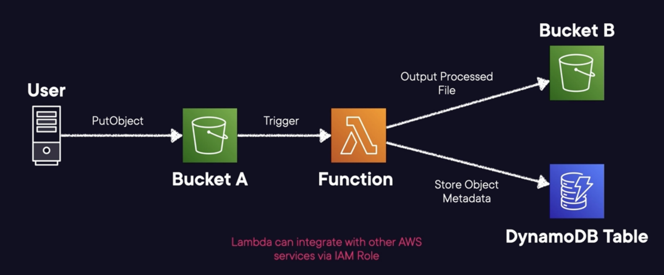

* We have an user/application that is updating a data file
* S3 event is triggered via PutObject from uploaded file.
* Lambda function triggered by S3 event. Performs data processing and manipulation.
* Lambda functions can easily integrate with S3 to trigger this code.
* We triggered the lambda function by this S3 event.
* We can use this function to perform specific data processing and manipulation.
* For the sake of this example, we will use the same function to perform different actions, but in real life you use different actions.
* Remember to leverage an IAM role for the function to interact with this services and resources.

**Another example:**

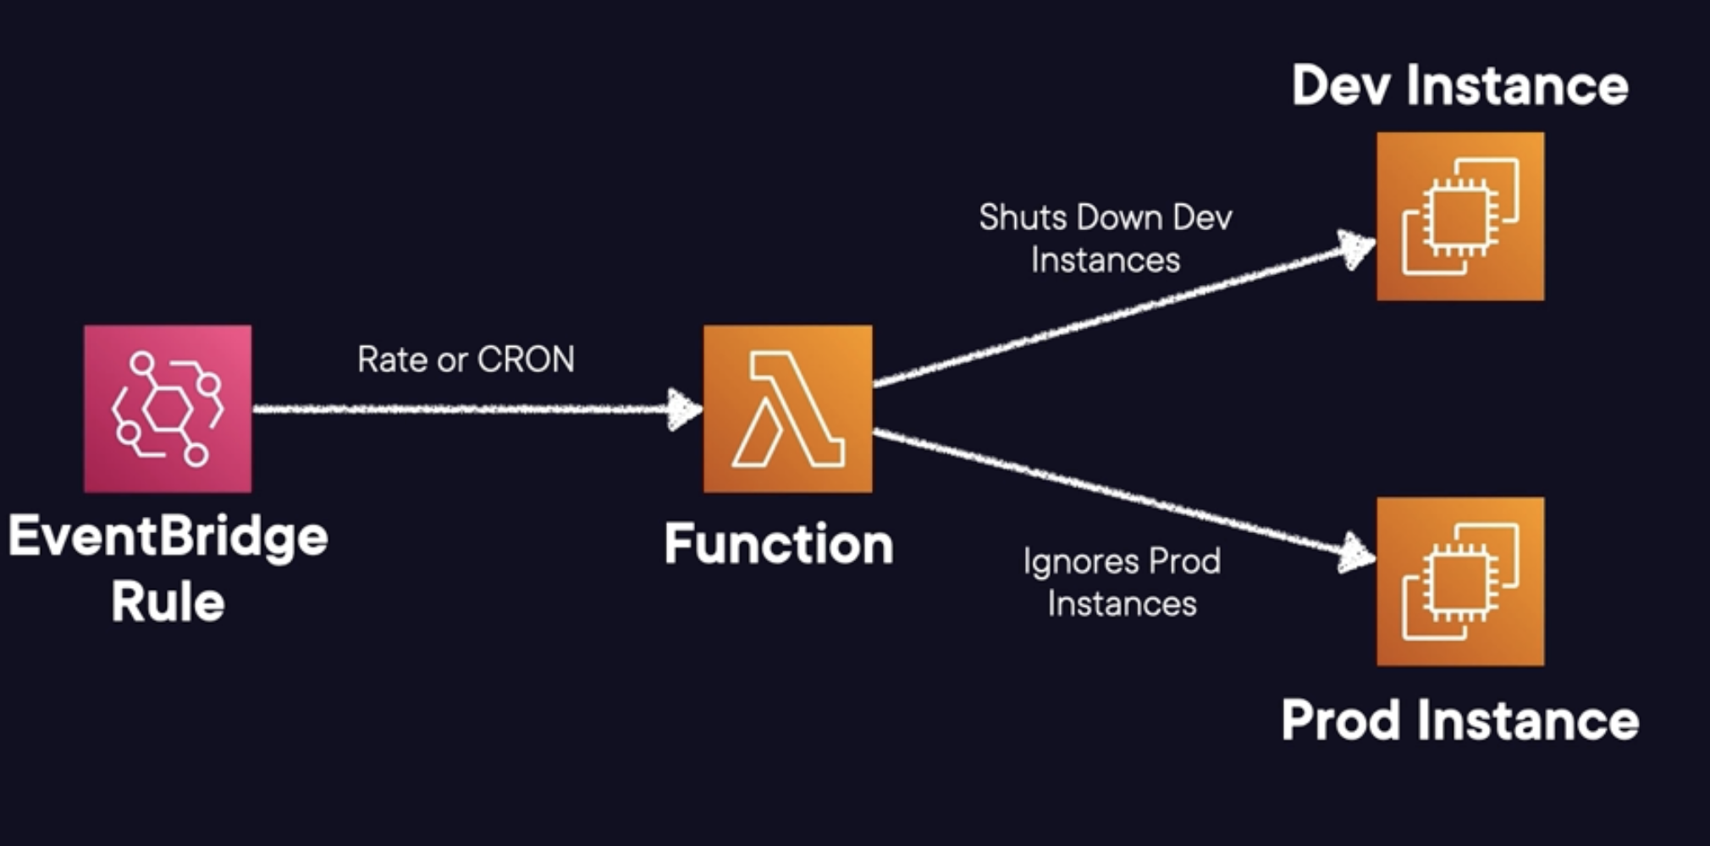

* Created EventBridge Rule to trigger a Lambda function.
* Rule configured to invoke your Lambda function on a schedule basis.
* We can create a rule to check at the end of the day if there are dev instances running and then shutting them down.
* We can also check for prod instances and leave those running so they are up.
* Common cost saving scenario that could come in the exam.

**Exam Tips:**

* Scenarios involving automating operations tasks will likely include Lambda.
* Lambda excels in running small, short, and lightweight functions.
* Know the limitations and general use cases for the service.
* Lambda plays a major role in the AWS ecosystem. It's easily integrated with many services.
* Be familiar with the different triggers that can invoke your Lambda functions.
* Lambda can run inside or outside a VPC (default)

**Leveraging the AWS Serverless Application Repository:**

**Serverless Application Repository:**

* **Serverless Apps:** Allows users to easily find, deploy, or even publish their own serverless applications.
* **Sharing Is Caring:** Ability to privately share applications within orgs or publicly for the world.
* **Manifest:** Upload your application code and a manifest file. Known as the AWS SAM template.
* **Integrations:** Deeply integrated with the AWS Lambda service. Appears within the console.

**Publish and Deploy:**

|  |  |
| --- | --- |
| **Publish** | **Deploy** |
| * Publishing apps makes them available for others to find and deploy. * Define apps with AWS SAM templates. * Set to private by default. * Must explicitly share if desired. | * Find and deploy published applications. * Browse public apps without needing an AWS account. * Browse within the AWS Lambda console. * Be careful of trusting all applications. |

**Exam Tips:**

* **Templates:** Define whole applications via AWS SAM templates. Private by default.
* **Publish or Deploy:** Choice of publishing your own applications or deploying publicly available ones.
* **AWS Lambda:** Heavily integrated with AWS Lambda.

**Container Overview:**

**Containers:** A container is a standard unit of software that packages up code and all its dependencies, so the application runs quickly and reliably from one computing environment to another.

**Virtual Machine vs Containers:**

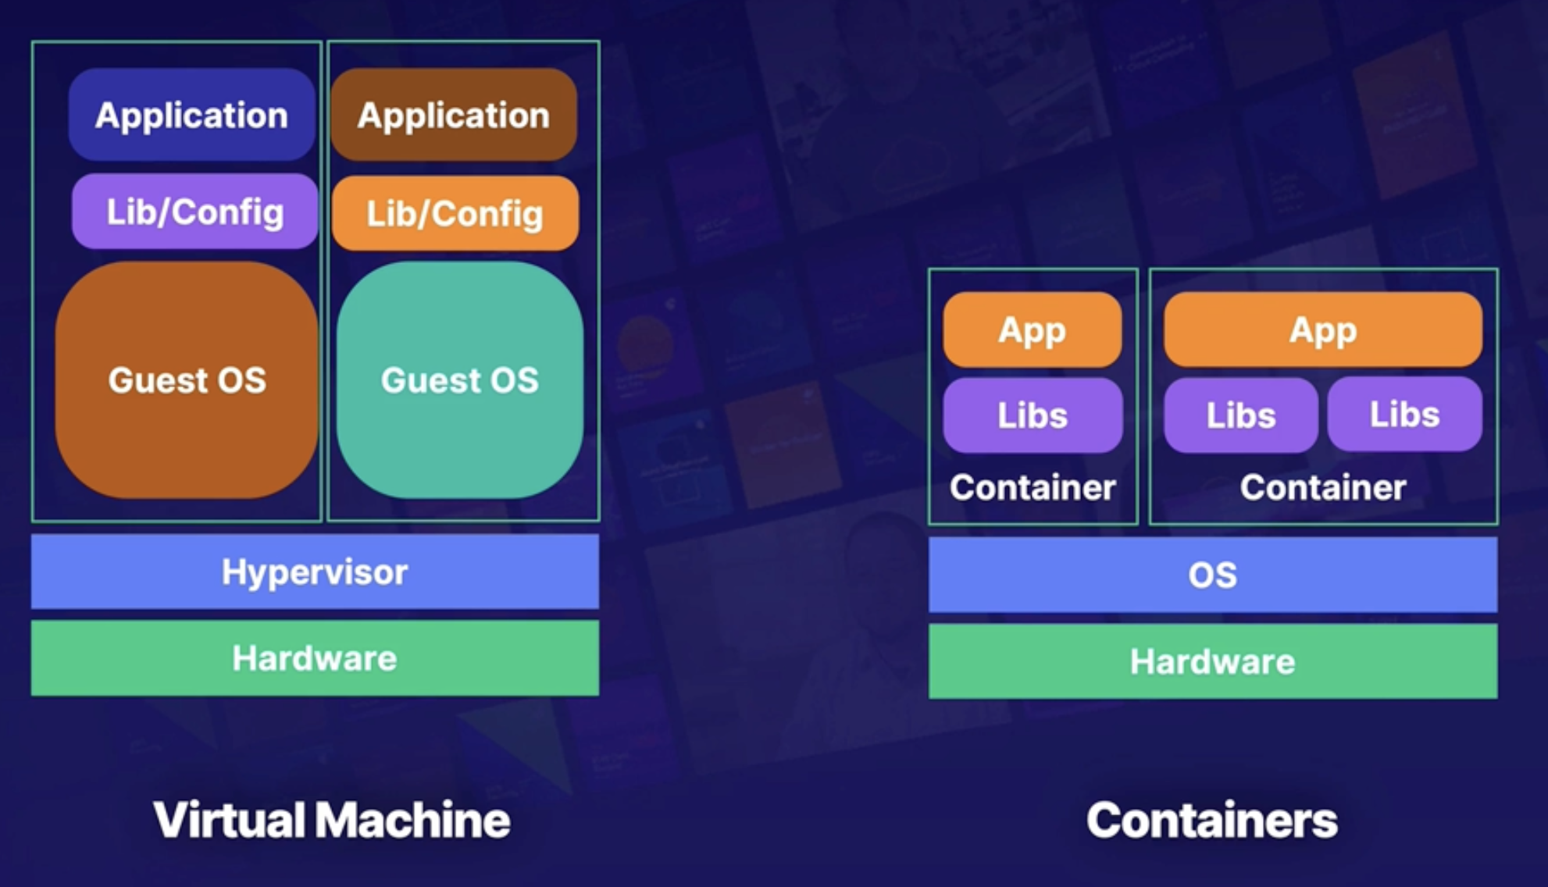

* With containers you don’t need to worry about the OS.
* You can build much more small applications with the containers, so you can fit more in the same place.
* Full OS have software that my application doesn’t need.

**Container Terminology:**

* **Dockerfile:** Text document that contains all the commands or instructions that will be used to build an image.
* **Image:** Immutable file that contains the code, libraries, dependencies, and configuration files needed to run an application.
* **Registry:** Stores Docker images for distribution. They can be both private and public.
* **Container:** A running copy of the image that has been created.

**Build an Image and run a Container:**

[alex@ip-10-0-0-88 container]$ ls code Dockerfile

code Dockerfile

[alex@ip-10-0-0-88 container]$ cat Dockerfile

FROM centos:7 🡪 We use Centos:7 as an image. The rest is going to be build up on top of this image making

Custom for this particular application.

# Install dependencies

RUN yum update -y

RUN yum install httpd -y

# Install app1

RUN rm -rf /var/www/html/* 🡪 remove default apache installation website

ADD code /var/www/html 🡪 will add my code, which is in the local directory, see ls command above.

RUN In -sf /dev/stdout /var/log/httpd/access_10g 🡪 set up logging to troubleshoot in the future.

RUN In -sf /dev/stderr /var/log/httpd/error_log

EXPOSE 80 🡪 expose, open port 80 from inside the container.

CMD ["/usr/sbin/httpd", "-D", "FOREGROUND"] 🡪 run apache

**What this does:**

The end goal is to install apache, listen port 80, add your code, and start apache when you run the container.

Build the image:

[alex@ip-10-0-0-88 container]$ sudo docker build.

**Run the Image as a Containers:**We will run the container in our localhost.

Before check if there is something already running on it:

curl localhost

Get the image id: docker images

Create the container:

sudo docker run -d -p 80:80 384asd123sdf 🡪 this runs the image, binding port 80 on my host with port 80 in the container.

Check if is working:

curl localhost

You have to see the content of the code folder.

**Exam Tips:**

* Containers are more flexible.
* Easier to run on-site and move around to different environments.
* Why to containerise applications:
  + Flexibility
  + Easy to use.
  + It can run on-prem or cloud.
* Dev is prod and prod is dev.

**Running Containers in ECS or EKS:**

**Problems with Containers:**

* A big issue comes with the orchestration of containers.
  + If you are running one container or two it’s ok, but in the real world you need to scale your application and run thousands and is very complicated to run them one by one.

**ECS:** Amazon Elastic Container Service is a service that allows you to easily launch and manage Docker containers running on AWS compute.

**Why to use it:**

* ECS can manage anywhere from one to thousands of containers.
* ECS will appropriately place the containers and keep them online.
* Containers are appropriately registered with chosen load balancers as they come online and go offline.
* Containers can have individual roles attached to them, making security a breeze.
* Extremely easy to set up and scale to handle any workload.

**Other Container Orchestrations:**

* **Kubernetes**: For extremely large-scale complex operations with hundreds of thousands of containers.
  + Open-source alternative to things like ECS, that way you are not locked into the vendor.
  + Can be used on-prem or in the cloud.
  + AWS offers us a managed version, EKS, Elastic Kubernetes Service.
  + Can be overkilled for the majority of workloads, meaning is too much for the majority of workloads, have this in mind for the exam.

**ECS vs EKS:**

|  |  |
| --- | --- |
| **ECS** | **EKS** |
| * Proprietary AWS container management solution. * Best used when you're all in on AWS * You are looking for something simple to orchestrate containers | * AWS-managed version of open-source Kubernetes container management solution * Best used when you're not all in on AWS * Significantly more work to configure and integrate with AWS |

**Exam Tips:**

* Simple container orchestration service for deploying and managing Docker containers.
* If you see containers mentioned, you should think ECS.
* Generally, favour using AWS-designed services over third party.
* Anytime you see open source or Kubernetes, think EKS.
* The exam should not ask too many specifics of ECS or EKS usage.
* Great for long-running applications.

**Removing Servers with Fargate:**

**What is AWS Fargate:** Serverless compute engine, tailored to running Docker containers.

* Offers a convenient platform for running your containerized application in ECS.
* Owns and manages the infrastructure, so you focus on the application development, rather than the infrastructure.
* To utilize it you must use ECS or EKS to orchestrate and deploy your containers. It’s a deployment type for the services.
* Supports Linux and Windows containers.

**ECS Launch Types: EC2 vs Fargate.**

|  |  |
| --- | --- |
| **EC2** | **Fargate** |
| * You are responsible for underlying operating system. * EC2 pricing model * Long-running containers * Multiple containers can share the same host. * Capable of mounting EFS file systems for persistent, shared storage. | * No operating system access. * Pay based on resources allocated and time ran. * Short-running tasks * Isolated environments per container * Capable of mounting EFS file systems for persistent, shared storage. |

**Fargate vs Lambda:**

|  |  |
| --- | --- |
| **Fargate** | **Lambda** |
| * Select Fargate when you have more consistent workloads. * Allows Docker use across the organization and a greater level of control by developers. * Ideal for applications with relatively stable resources. | * Great workloads unpredictable or inconsistent. * Perfect for applications that can be expressed as a single function. * Will automatically scale to handle changes in demand. * Will be limited to a 15 min execution time. * Limited runtime choices. |

**Demo:** Let’s spin up a brand new task in ECS using Fargate launch type.

We will use a public apache image from Docker repo, we will spin up a container with a public IP using the Fargate type.

We don’t have to manage the underlying IFR, you only worry about the container and the task.

**Create Task Definition:**

* Amazon Elastic Container Service – Task definition (is where you define your container specifications and information) –
* Create new task definition (create new one without JSON) –
* Task definition family: httpd – Launch type – Fargate – leave the default OS –
* Network mode – cannot be changed, comes *awsvpc* by default –
* this spins up your container on an underlying host you don’t manage, and will spin up an ENI, so it must be that awsvpc network to work.
* CPU: 1 – Memory: 2 GB – Task Role (is going to allow the tasks themselves the proper IAM permissions to make API calls) leave it in None, but you have to know that this will allow the containers to do the AWS API calls.
* Task execution: used for the container agent to make the API calls: Create new role –
* Container-1—Name: httpd – Image URI: httpd:latest (if is a public registry you can use the name like this, or use a full URI if its private) –
* Container port – you don’t specify the host port, only the container port, leave all by default –
* Leave the rest by default, but have in mind you can set up envar.
* Logging – tick log collection – is going to send the logs to CloudWatch to the region and location that you want.
* HeathCheck – you can configured to help you to keep your container up as much as possible, won’t be necessary to set it up for this demo.
* Leave storage and the rest as default -- Create

**Create new cluster:**

* Amazon Elastic Container Service – Create cluster – Cluster name: DevWebServer –
* Infrastructure – AWS Fargate (serverless) – Create
* Will take a few minutes to create – go to
* Amazon Elastic Container Service – Clusters – DebWebServer – Infrastructure tab –
* You will see there FARGATE and FARGATE_SPOT for the providers (this is different from the EC2 type, as this is managed by AWS) –

**Create new service:**

* Amazon Elastic Container Service – Clusters – DebWebServer – Services tab –
* Create – leave all default – Deployment configuration – leave service
  + Service: for long-running applications.
  + Task: good for immediate small running jobs like a batch job.
* Task definition – Family: httpd (the one we’ve created before) –
* Service name: frontend-service – skip to Networking – use default vpc and subnets –
* Create new security group – Name: AllowHTTP – and create the rule allowing 80 from anywere – in real life you want to lock this into a LB or specific IP address, for this demo we won’t do it, but never do it as is a high security risk.
* Create – wait a few minutes until the service is up. You have to see it as Active.

**See the container:**

* Amazon Elastic Container Service – Clusters – DebWebServer – Services –
* frontend-service – Tasks – you will see the task ID which is a Container –
* this will host the httpd latest image that’s pulled from the public repository –
* Click on the container – Configuration – you will see the Public IP, if you hit on it and all is good you will access the container’s website.

**Exam Tips:**

* You need to know when to choose Fargate compared to Lambda or EC2.
* Fargate can be more expensive, but easier to use, compared to the EC2 launch type.
* Serverless compute option via Amazon ECS.
* ECS or EKS is a requirement, meaning Fargate doesn't work by itself.
* Fargate is for containers and applications that need to run longer.
* You leverage ECS Task Roles for assigning IAM permissions to the containers.

**Amazon EventBridge (CloudWatch Events):**

**Amazon EvenBridge Overview:** Amazon EventBridge (formerly CloudWatch vents) is a serverless event bus.

* Fully managed serverless event bus provided by AWS.
* The service acts as a central nervous system for your serverless applications and helps you build event driven applications.
* It allows you to pass events from a source to an endpoint. Essentially, it's the glue that holds your serverless application together.
* You can easily route and respond to different events and you can trigger actions or even functions and remediations in a scalable and efficient manner.

**EventBridge Concepts:**

* **Events**: A recorded change in an AWS environment, SaaS partner, or one of your own configured applications/services. This includes both real-time and scheduled events.
* **Rules**: Criteria used to match incoming events and send them to the appropriate targets. Based on either event patterns or schedules.
* **Event Bus:** A router that receives events and delivers them to targets (destinations). Every AWS account has a default bus, and you can create other custom buses. Event buses are used to logically separate different types of events and the event processing that goes along with those.

**Rule Triggers:**

* **Event Patters:** Define an event source and event pattern that will trigger your rule.
  + Example: EC2 terminated
  + When the specified event pattern matches incoming events, the rule gets triggered. And then with that, any associated actions get executed.

* **Scheduled:** Set up a recurring schedule for triggering your rule.
  + **Rate-based:** rate(1 hour) 🡪 you trigger the rule at fixed rate.
  + **Cron-based:** cron(0 12** ? *) 🡪 cron offers fine grain control of the rule.

**EventBridge Architecture:** Real world example.

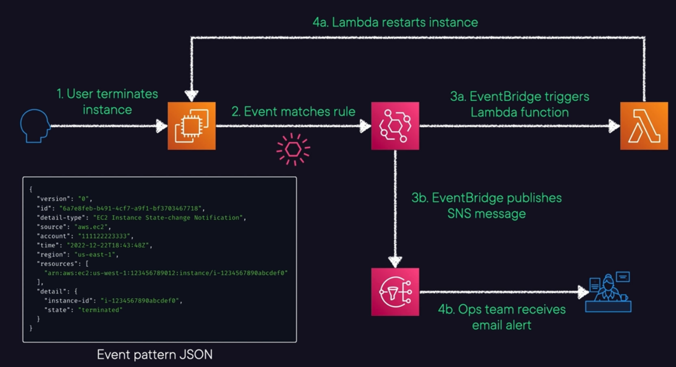

* We have the user and an EC2 hosting some type of service or application.
* Let’s assume your user accidentally terminates or stops the instance running in our account.
* Luckily, we configured an EventBridge rule that looks events matching this termination event. Take a look to the JSON event pattern we will look for.
* EventBridge is very flexible, and we can set it to do different things with a single rule.
  + Example: We can set up this rule to trigger a lambda function.
  + As well as sending messages to an SNS topic containing specific information from this event.
  + We can leverage that function to go ahead and get invoked by our rule and maybe restart that instance or create a brand new one using this same AMI.
  + For SNS we can send an email to our Ops team informing about all this stuff.
* EventBridge is very useful for things like this, Automation and alerting.

**Another example:** Root login events.

{

"source": [

"aws.ec2"

],

"detail-type": [

"EC2 Instance State-change Notification"

],

"detail": {

"state": [

"stopped"

]

}

}

* Leverage EventBridge to watch for root/console logins events and then alert teams.

**Demo:** Let's create a new EventBridge rule that is triggered via an AWS event pattern.

Resources created previously for this demonstration:

* EC2: Created server called SuperimportantServer.
* SNS: Created OpsTeamAlerts with subscription to an email account.
* Lambda function: Explained below.

**What are we going to do:**

* EventBridge rule to look for shutdown event.
* We will send a notification to an SNS topic called OpsTeamAlerts.
* We will trigger a Lambda function (in [python](https://github.com/pluralsight-cloud/aws-certified-solutions-architect-associate/blob/main/15-serverless-architecture/amazon-eventbridge/lambda_function.py)) that restarts the instance that comes in the event.
  + It prints the event.
  + It grabs the instance_ID
  + Restarts the instance.

**Create EventBridge rule:**

* Amazon EventBridge – Rules – Create rule – Name: shutdown – Event bus – default
* all events go to the default event bus.
* Rule type – Rule with an event pattern – Next – Event source – AWS events or EventBridge partner events – Sample event – AWS events –
* Sample events: EC2 Instance Terminate Successful (example event that will come through EventBridge and get passed to our destinations) –
* Creation method – Use pattern form – Event pattern – Event source –
* AWS services – AWS service – EC2 – Event type – EC2 Instance State-change Notification – Event Type Specification 1 – Specific state(s) – stopped – Next –
* Select target(s) – Target 1 – Target types – AWS service – Select a target –
* SNS topic – Topic: OpsTeamAlerts – leave the defaults –
* Add another target – Select a target – Lambda function – Function: Restartinstances –
* Next – Next – Create rule

**Test it:**

* EC2 instances – select SuperimportantServer – Instance state – Stop instance
* You will receive an email informing about the instance being stoped.
* The Lambda function will restart the instance.
* Check CloudWatch – Log groups - /aws/lambda/Restartinstances –
* You will see that the instance has been stoped and started and other stuff.

**Exam Tips:**

* Think EventBridge if you want to trigger an action based on something that happened in AWS.
* Common use case is triggering Lambda functions when an AWS API call happens.
* Be familiar with the possible rule configurations at a high level.
* This is CloudWatch Events successor. You may still see reference to this name.
* This is the fastest way to respond to things happening in your environment.
* Remember you can use a default bus or create a custom bus for cross-account access.

**Storing Custom Docker Images in Amazon Elastic Container Registry (Amazon ECR):**

**Amazon ECR:**

* **Registry:** AWS-managed container image registry that offers secure, scalable, and reliable infrastructure.
* **Private:** Private container image repositories with resource-based permissions via IAM.
* **Supported Formats:** Supports Open Container Initiative (OCI) images, Docker images, and OCI artifacts.

**Components to know:**

* **Registry:** A private registry provided to each AWS account; create one or more for image storage.
* **Authorization Token:** Authentication token required for pushing and pulling images to and from registries.
* **Repository:** Contains all of your Docker images, OCI images, and OCI.
* **Repository Policy:** Control all access to repos and images.
* **Image:** Container images that get pushed to and pulled from your repository.
* Amazon ECR Public is a similar service for public image repositories.

**Features to Know:**

* **Lifecycle Policies:** 
  + Helps management of images in your repositories
  + Defines rules for cleaning up unused images.
  + Ability to test your rules before applying them.
* **Image Scanning:**
  + Help identify software vulnerabilities in your container images.
  + Repositories can be set to on push.
  + Retrieve results of scans for each image.

* **Sharing:**
  + Cross-Region support
  + Cross-account support
  + Configured per repository and per region.
* **Cache Rules:**
  + Pull through cache rules allow for caching public repos privately.
  + Amazon ECR periodically reaches out to check current caching.

* **Tag Mutability:**
  + Prevents image tags from being overwritten.
  + Configured per repository.

**Integrations:**

* **Bring your Own:** You are able to leverage ECR images within your own container infrastructure.
* **Amazon ECS:** Use container images in ECS container definitions.
* **Amazon EKS:** Pull images for your EKS clusters.
* **Amazon Linux:** Amazon Linux containers can be used locally for your software development.

**Exam Tips:**

* **Container Image Storage:** AWS-managed container image registry service.
* **Supported Formats:** Docker images, OCl images, and OCI-compatible artifacts.
* **Lifecycle Policies:** Rules defining when to expire and remove unused or older images.
* **Image Scanning:** Scan on push repository settings allow for identifying software vulnerabilities.
* **Tag Mutability:** Helps prevent image tags from being overwritten.
* **Keywords to Look For:** Questions related to a managed container image registry, OCI repositories, or image integration with Amazon ECS and Amazon EKS.

**Using Open-Source Kubernetes in Amazon EKS Distro:**

**EKS-D:** Amazon EKS Distro (EKS-D) is a Kubernetes distribution based on and used by Amazon EKS.

* **Similarities:** It has the same versions and dependencies deployed by Amazon EKS.
* **Differences:** EKS-D is fully managed by you unlike Amazon EKS, which is managed by AWS.
* **Where you can run it:** Anywhere, on-prem, in the cloud, or somewhere else.
* **Your responsibility:** You are fully responsible for upgrading and managing your platforms.

**Exam Tips:**

* **Keywords:** Look out for questions related to self-managed Kubernetes deployments that are similar to Amazon EKS.
* **Uses:** Use EKS-D when you need to run versioned deployments of clusters outside of AWS-managed services.
* **Not Common:** It does not commonly appear on exams and functions like EKS Anywhere.

**Orchestrating Containers Outside AWS Using Amazon ECS Anywhere and Amazon EKS Anywhere:**

**EKS Anywhere:**

* **On-Premises EKS:** An on-premises way to manage Kubernetes (K8s) clusters with the same practicesused for Amazon EKS.
* **EKS Distro:** Based on EKS Distro Allows for deployment, usage, and management methods for clusters in data centers.

* **Lifecycle:** Offers full lifecycle management of multiple K8s clusters Operates independently of AWS.

**EKS Anywhere concepts:**

* **Control Plane:** K8s control plane management is operated completely by the customer.
* **Location:** K8s control plane location is entirely within a customer data center or operations center.
* **Updates:** Cluster updates are done entirely via manual CLI or Flux.
* **Curated Packages:** Curated packages offer extended core functionalities of K8s cluster.
* **Enterprise Subscription:** Curated packages require an Enterprise Subscription.

**ECS Anywhere:**

* **ECS Anywhere:** Feature of Amazon ECS allowing the management of container-based apps on-premises.
* **No Orchestration Needed:** No need to install and operate local container orchestration software, meaning more operational efficiency.
* **Completely Managed:** Completely managed solution enabling standardization of container management across environments.
* **Inbound Traffic?** Keep in mind, no ELB support makes inbound traffic requirements less efficient.
* **External:** New launch type noted as EXTERNAL for creating services or running tasks.

**ECS Anywhere requirements:**

* You must have the SSM Agent, ECS agent, and Docker installed.
* You must first register external instances as SSM Managed Instances.
* Easily create an installation script within the ECS console.
* Scripts contain SSM activation keys and commands for required software.
* Execute scripts on your on-premises VMs or bare-metal servers.
* Deploy containers using the EXTERNAL launch type.

**Example Diagram:**

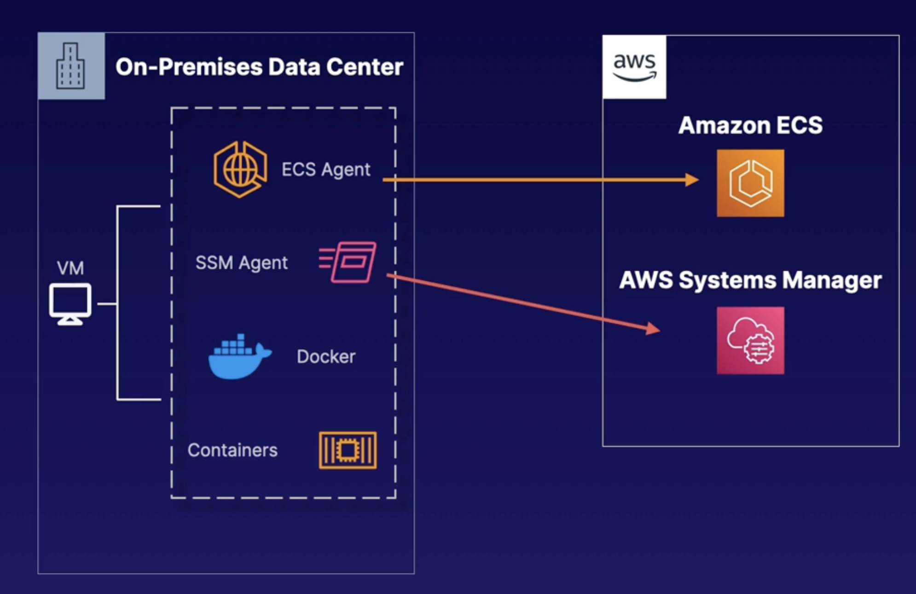

* We have our datacenter with our VM. This is where we want to run our ECS cluster.
* First thing to do is to install all the agents.
  + ECS agent, SSM agent, Docker, Containers.
  + There are more steps between, but this is a high-level representation.
* Once the agents are installed you must configure them with the AWS accounts.
  + ECS agent is going to talk with Amazon ECS in our account, keeping track on what version you are on, the cluster status, etc.
  + SSM Agent is is communicating with System Manager which allows you to run your scripts and see them as managed instances, within the console.

**Exam Tips:**

**EKS Anywhere:**

* **Not Common:** This service is not commonly featured on the exams.
* **Anywhere:** Based on the EKS Distro, it allows you to run EKS K8s clusters on-premises.
* **AWS Efficiency:** Distro allows customers to maintain similar operational efficiency to Amazon EKS.
* **Managed by You:** Everything is managed by you, including control plane management and location.

**ECS Anywhere:**

* **Amazon ECS:** It is a feature within the Amazon ECS service itself.
* **Anywhere:** It allows for AWS-managed container orchestration anywhere on-premises.
* **Requirements:** You must have SSM Agent, ECS agent, and Docker installed.
* **Register and Deploy**: Execute scripts containing required steps and use the EXTERNAL launch type.

**Auto Scaling Databases On Demand with Amazon Aurora Serverless:**

**Aurora Serverless Overview:** Automatically adjusts database capacity based on actual usage.

For Aurora Database service you need to specify the compute capacity (CPU and memory), with Aurora Serverless you don’t need to do it.

* Two terms to be able to differentiate for the exam: Aurora Provisioned and Aurora Serverless

* **On Demand:** On-demand and Auto Scaling configuration for the Amazon Aurora database service.
* **Automate:** Automation of monitoring workloads and adjusting capacity for databases.
* **Based on Demand:** Capacity adjusted based on application demands.
* **Billing:** Charged only for resources consumed by DB clusters; per-second billing.
* **Budget Friendly:** Helps customers stay well within budgets via the Auto Scaling and per-second billing features.

**Aurora Serverless Concepts:**

* Aurora Capacity Units (ACUs): Measurements on how your clusters scale
* ACU: Aurora Serverless v1 DB Clusters can scale down to zero ACUs. Unlike v1, Aurora Serverless v2 clusters can't scale down to zero but only to their minimum specified ACU value. Allocated (quickly) by AWS-managed warm pools.
* Combination of about 2 GiB of memory, matching CPU, and networking capability
* Same data resiliency as Aurora provisioned: six copies of data across three AZs.
* Multi-AZ deployments for establishing highly available clusters.

**Popular Use Cases:**

* **Variable Workloads:** Unpredictable or sudden activity.
* **Multi-Tenant Apps:** Let the service manage database capacity for each individual app.
* **New Apps:** Unsure what database instance needs are required.
* **Dev and Test:** Development or testing of new features.
* **Mixed-Use Apps:** App might serve more than one purpose with different traffic spikes.
* **Capacity Planning**: Easily swap from pro visioned to serverless or vice versa.

**Exam Tips:**

* **On Demand:** On-demand and Auto Scaling version or Aurora Database service. Capacity adjusted for you.
* **ACU:** Aurora Serverless v1 DB Clusters can scale down to zero ACUs. Unlike v1, Aurora Serverless v2 clusters can't scale down to zero but only to their minimum specified ACU value.
* **Popular Exam Scenarios:** Variable workloads, new applications, capacity planning, and development/ testing needs.
* **Resilient:** Data resiliency is the same as Aurora provisioned: six copies of data across three AZs.
* **Multi-AZ:** Implement Multi-AZ deployment for highly available workloads.

**Using AWS X-Ray for Application Insights:**

**Service Overview:** Is like Datadog.

* **App Insights:** Collects application data for viewing, filtering, and gaining insights about requests and responses.
* **Downstream:** View calls to downstream AWS resources and other microservices/ APIs or databases.
* **Traces:** Receives traces from your applications for allowing insights.
* **Multiple Options:** Integrated services can add tracing headers, send trace data, or run the X-Ray daemon.

**AWS X-Ray Exam Concepts:**

* **Segments:** Data containing resource names, request details, and other information
* **Subsegments:** Segments providing more granular timing information and details.
* **Service graph:** Graphical representation of interacting services in requests.
* **Traces:** Trace ID tracks paths of requests and traces collect all segments in a request.
* **Tracing header:** Extra HTTP header containing sampling decisions and trace ID.
* Tracing header containing added information is named X-Amzn-Trace-Id.

**AWS X-Ray Demon:**

* AWS software application that listens on UDP port 2000. It collects raw segment data and sends it to the AWS X-Ray API.
* When the daemon is running, it works along with the AWS X-Ray SDKs.

**AWS Integrations:** Where you can install this Demon.

* EC2: Installed, running agent.
* ECS: Installed within tasks.
* AWS Lambda: Simple on/off toggle and is built-in and available for functions.
* AWS Elastic Beanstalk: Configuration option.
* Amazon API Gateway: Added to stages as desired.
* Amazon SNS and SQS: View time taken for messages in queues and topics.

**Exam Tips:**

* **Application Insights:** Collects data for gaining insights to application requests and responses.
* **Important Terms:** Traces, tracing headers, and segments.
* **Integrations:** Many AWS integrations available, such as EC2, Lambda, and API Gateway.
* **Exam Keywords:** Scenarios involving app request insights, viewing response times of downstream resources, and HTTP response analysis.

**Deploying GraphQL Interfaces in AWS AppSync:**

**What is AWS AppSync:**

* Robust, scalable GraphQL interface for application developers
* Combines data from multiple sources (e.g., Amazon DynamoDB and AWS Lambda)
* Enables data interaction for developers via GraphQL
* GraphQL: Data language that enables apps to fetch data from servers.
* Seamless integration with React, React Native, iOS, and Android.

**Exam Tips:**

* **Scalable GraphQL Interface:** Service for scalable GraphQL interfaces for application developers.
* **Keywords:** GraphQL, fetching app data, declarative coding, and frontend app data fetching

**Serverless Architecture Exam Tips:**

**4 Questions to Ask in the Exam:**

* Is the application right for containers?
* Do you need those servers?
* Is the application AWS specific?
* How long does the code need to run?

**AWS Lambda:**

* Lambda loves roles: Whenever you're talking about credentials and Lambda, ensure you're attaching a role to the function.
* Be familiar with Lambda triggers: You'll commonly see questions asking what can kick off a Lambda function. Know that S3, Kinesis, and EventBridge (formerly CloudWatch Events) are common triggers.
* Know Lambda's limitations: Functions should be short. You can allocate up to 10 GB of RAM and 15 minutes of runtime.
* Any AWS API call: Can be a trigger to kick off an EventBridge rule. This is faster than trying to scrape through Cloud Trail.

**Container and Images:**

* Open source = Kubernetes: If the question asks for a container management solution

that can run in AWS and on-premises, you'll want to consider Amazon EKS or EKS Anywhere.

* Fargate can't work alone: In order to use Fargate, you must be using Amazon ECS or EKS. Not all scenarios specify ECS and EKS, and they make it sound as if Fargate is a service by itself.
* Containers are flexible: Containers can encompass just about any workload. Generally, it's preferred to use containers rather than EC2 on the exam.
* Know the basics: While the exam doesn't cover containers themselves in too much depth, it's good to know you start with a Dockerfile, build an image, upload that to a repo, and then run it on a host.
* AWS-managed image registry: If there is mention of an AWS service needed for image storage or image vulnerability scanning, think of Amazon ECR.

**Amazon Aurora Serverless:**

* On-demand or auto scaling database: Questions regarding auto scaling databases should likely involve Amazon Aurora Serverless databases.
* Variable traffic or workloads: If designing a new application with unknown workloads or traffic spikes to the database, look for answers including this service.
* Capacity planning: When questions mention capacity planning for a new application with a database or a development environment, then they likely are going to be using Amazon Aurora Serverless.

**AWS X-Ray:** Is like Datadog.

* On-demand or auto scaling database: Questions regarding auto scaling databases should likely involve Amazon Aurora Serverless databases.
* Variable traffic or workloads: If designing a new application with unknown workloads or traffic spikes to the database, look for answers including this service.
* Capacity planning: When questions mention capacity planning for a new application with a database or a development environment, then they likely are going to be using Amazon Aurora Serverless.

**AWS AppSync:**

* **Managed GraphQL:** Questions that ask about the best architecture for a managed GraphQL interface for any frontend application or developer will more than likely include AWS AppSync.

**Security:**

**DDoS Overview:**

**What is a DDoS Attack:**

* A Distributed Denial of Service (DDoS) attack is an attack that attempts to make your website application unavailable to your end users.
* This can be achieved by multiple mechanisms, such as large packet floods, by using a combination of reflection and amplification techniques, or by using large botnets.

**Layer 4 DDoS Attack:** **SYN flood.**

* A Layer 4 DDoS attack is often referred to as a **SYN flood.** It works at the transport layer (TCP).
* To establish a TCP connection a 3-way handshake takes place. The client sends a SYN packet to a server, the server replies with a SYN-ACK, and the client then responds to that with an ACK.
  + **What should happen:** After the "3-way handshake" is complete, the TCP connection is established. After this, applications begin sending data using Layer 7 (application layer protocol), such as HTTP etc.

* **SYN Floods:** A SYN flood uses the built in patience of the TCP stack to overwhelm a server by sending a large number of SYN packets and then ignoring the SYN-ACKs returned by the server. Basically, manipulating the 3-way-handshake.
* This causes the server to use up resources waiting for a set amount of time for the anticipated ACK that should come from a legitimate client.
* **What Can Happen?** There are only so many concurrent TCP connections that a web or application server can have open, so if an attacker sends enough SYN packets to a server, it can easily eat through the allowed number of TCP connections.
  + This then prevents legitimate requests from being answered by the server.

**Amplification Attack:** NTP server (Network Time Protocol)

* This is where an attacker may send a third-party server (such as an NTP server) a request using a spoofed IP address.
* Amplification/reflection attacks can include things such as NTP, SSDP, DNS, CharGEN, SNMP attacks, etc.
* **What Can Happen?** That server will then respond to that request with a greater payload than the initial request (usually within the region of 28-54 times larger than the request) to the spoofed IP address.
* This means that if the attacker sends a packet with a spoofed IP address of 64 bytes, the NTP server would respond with up to 3,456 bytes of traffic.
* Attackers can coordinate this and use multiple NTP servers a second to send legitimate NTP traffic to the target.

**Amplification Attack explained:**

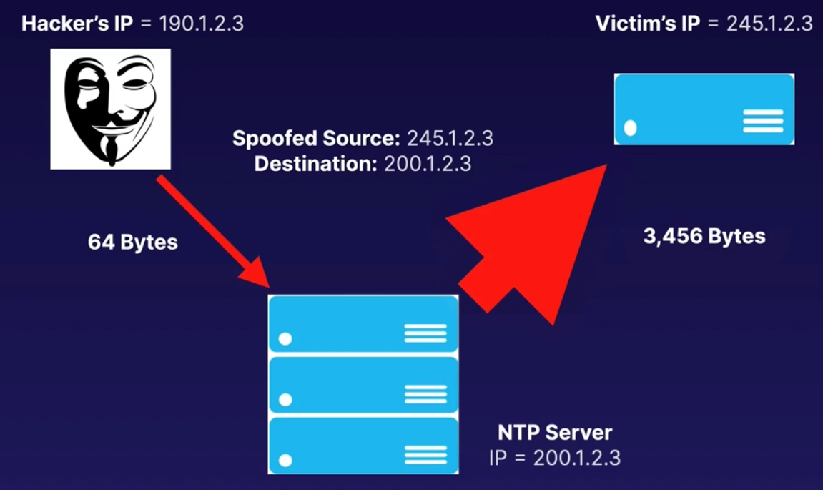

* We have the hacker’s IP and the Victim’s IP.
* We have the NTP server.
* The hacker send’s the spoofed (victim’s IP) source address: 245.1.2.3 to the destination (NTP Server) 200.1.2.3
  + And that’s 64 bytes in size.
* The NTP server then replies back to the spoofed IP (victim’s IP) and sends 3,456 bytes of traffic.

**Layer 7 Attack:**

* A Layer 7 attack occurs where a web server receives a flood of GET or POST requests, usually from a botnet or a large number of compromised computers.

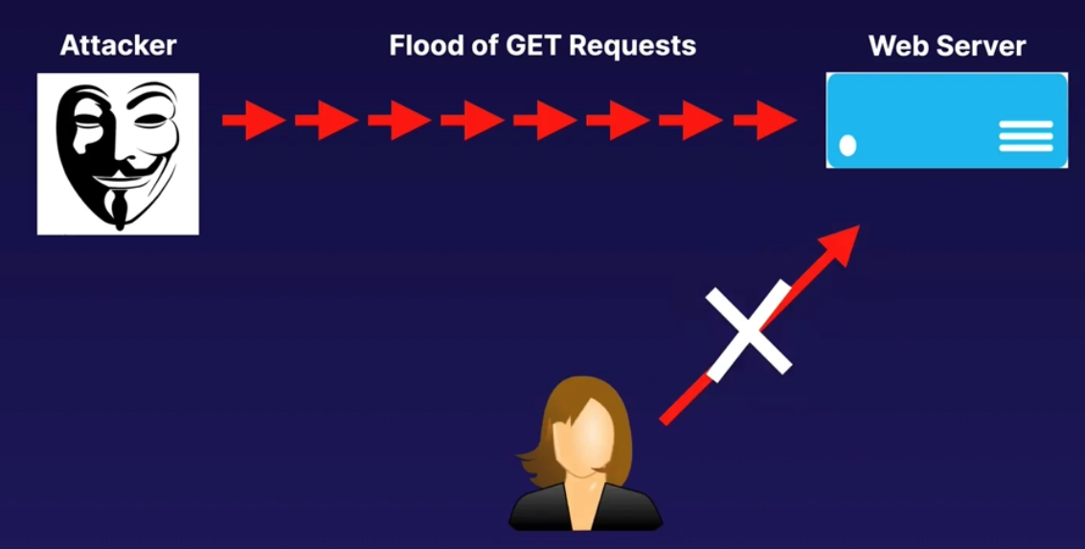

* We have the attacker and the Webserver. The attacker sends a lot of GET requests.
* The attacker does this using a bot net.
* Then we have the end user trying to access the website but he cannot do it because the webserver is responding to all those GET requests from the attacker.

**Exam Tips:**

* A Distributed Denial of Service (DDoS) attack attempts to make your website or application unavailable to your end users.
* Common DDoS attacks include Layer 4 attacks such as SYN floods or NTP amplification attacks.
* Common Layer 7 attacks include floods of GET/POST requests.

**Logging API Calls with CloudTrail:**

**What is CloudTrail:** A CCTV that monitors your AWS accounts.

* AWS Cloud Trail increases visibility into your user and resource activity by recording AWS Management Console actions and API calls.
* You can identify which users and accounts called AWS, the source IP address from which the calls were made, and when the calls occurred.

* Think of Cloud Trail as CCTV monitoring for your AWS account.

**How CloudWatch works:**

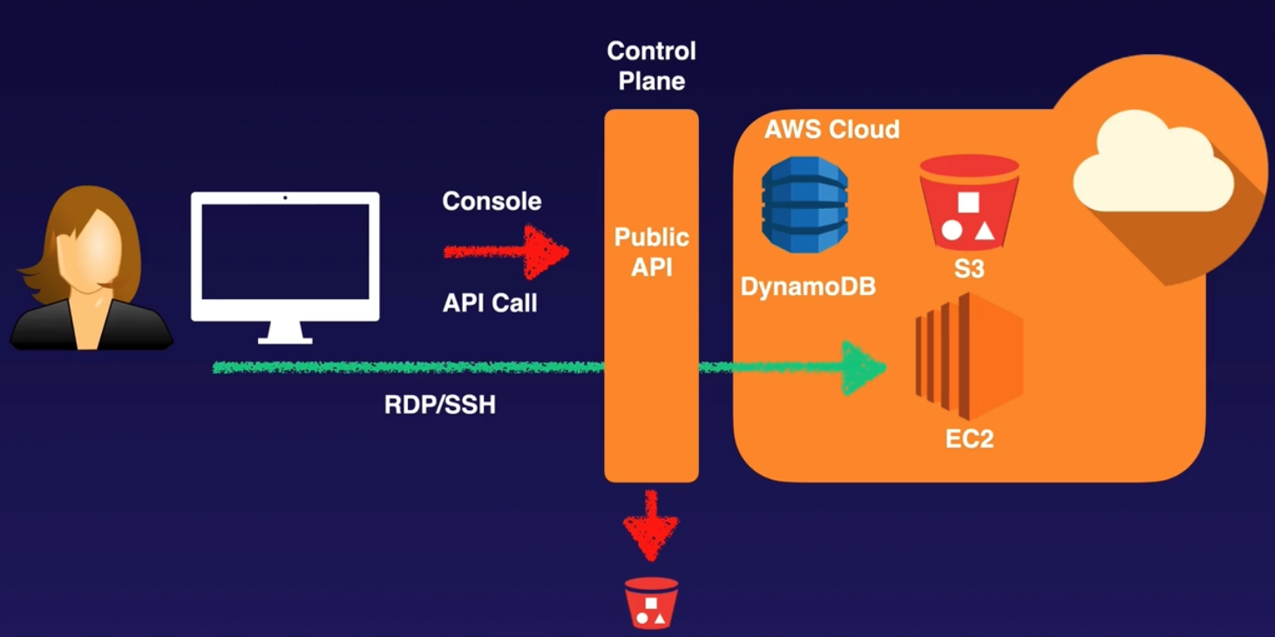

* We have our end user, we have the control plane (our interface into AWS).
* Then the user uses AWS Console to create or use any resource, and that will use API calls.
* CloudWatch is recording those API calls.
* RDP/SSH aren’t logged as they don’t use API calls.

**What makes API Calls:**

* AWS SDKs
* AWS Command Line Interface (CLI)
* HTTP Requests
* AWS Management Console

**What is logged:**

* Metadata around API calls.
* The identity of the API caller.
* The source IP address of the API caller
* The request parameters
* The time of the API call
* The response elements returned by the service.

**What Cloud Trail Allows:**

* After-the-fact incident investigation
* Near real-time intrusion detection
* Industry and regulatory compliance

**Exam Tips:**

* Remember that Cloud Trail is basically just CCTV for your AWS account.
* It logs all API calls made to your AWS account and stores these logs in S3.

**Protecting Applications with Shield:**

**What is AWS Shield:** Free DDoS protection.

* Protects all AWS customers on Elastic Load Balancing (ELB), Amazon CloudFront, and Route 53.
* Protects against SYN/UDP floods, reflection attacks, and other Layer 3 and Layer 4 attacks.

**AWS Shield Advanced:**

* Provides enhanced protections for your applications running on Elastic Load Balancing (ELB), Amazon CloudFront, and Route 53 against larger and more sophisticated attacks.
* Offers always-on, flow-based monitoring of network traffic and active application monitoring to provide near real-time notifications of DDoS attacks.
* Gives you 24/7 access to the DDoS Response Team (DRT) to help manage and mitigate application-layer DDoS attacks.
* Protects your AWS bill against higher fees due to Elastic Load Balancing (ELB), Amazon CloudFront, and Amazon Route 53 usage spikes during a DDoS attack.

**Cost:**

* Normal AWS Shield: Free.
* AWS Shield Advanced: $3,000 / month.

**Demo:** How to turn it on. DON’T DO IT.

* Security, Identity & Compliance – WAF & Shield – AWS shield – Getting started –
* Subscribe to Shield Advanced – tick all the boxes – Subscribe to Shield Advanced

**Exam Tips:**

* Shield Protects Against Layer 3 and Layer 4 Only.
* Remember what Shield is at a high level and that it's used to protect against DDos.
* If you see a scenario question talking about DDoS mitigation or protection against Layer 3 and Layer 4 attacks, think AWS Shield.
* Advanced costs $3,000 USD a month but will give you a dedicated 24/7 DDoS Response Team.

**Filtering Traffic with AWS WAF:**

**What is AWS WAF:** Layer 7 Firewall.

* AWS WAF is a web application firewall that lets you monitor the HTTP and HTTPS requests that are forwarded to Amazon CloudFront or an Application Load Balancer.
* AWS WAF also lets you control access to your content.

**What can you do with it:**

* You can configure conditions such as:
  + What IP addresses are allowed to make this request.
  + What query string parameters need to be passed for the request to be allowed.
* The Application Load Balancer or CloudFront will either allow this content to be received or give an HTTP 403 status code.

**Important Info:** It operates at Layer 7.

**At a basic level, AWS WAF allows:**

1. Allow all requests except the ones you specify.
2. Block all requests except the ones you specify.
3. Count the requests that match the properties you specify.

**Conditions:** You can define conditions by using characteristics of web requests such as the following:

* IP addresses that requests originate from.
* Country that requests originate from.
* Values in request headers.
* Presence of SQL code that is likely to be malicious (known as SQL injection)
* Presence of a script that is likely to be malicious (known as cross-site scripting)
* Strings that appear in requests — either specific strings or strings that match regular expression (regex) patterns.

**Exam Tips:**

* WAF Operates at Layer 7
* In the exam, you will get scenario-based questions asking how to block Layer 7 attacks.
* Always think of WAF whenever you hear the term Layer 7.
* WAF can block 7 DDoS attacks as well as things like SQL injections and cross-site scripting.

**Guarding Your Network with GuardDuty:**

**What is Amazon GuardDuty:** GuardDuty is a threat detection service that uses machine learning to continuously monitor for malicious behaviour.

* Unusual API calls, calls from a known malicious IP.
* Attempts to disable CloudTrail logging.
* Unauthorized deployments
* Compromised instances.
* Reconnaissance by would-be attackers
* Port scanning, failed logins

**GuardDuty Features:**

* Alerts appear in the GuardDuty console and CloudWatch Events.
* Receives feeds from third parties like Proofpoint and CrowdStrike, as well as AWS Security, about known malicious domains and IP addresses, etc.
* ﻿﻿Monitors Cloud Trail logs, VPC Flow Logs, and DNS logs.
* Centralize threat detection across multiple AWS accounts.
* Automated response using CloudWatch Events and Lambda.
* Machine learning and anomaly detection.

**Setting Up GuardDuty: GD is Threat Detection with AI**

* It takes 7-14 days to set a baseline – is looking what is normal behaviour on your account.
* Once active, you will see findings on the GuardDuty console and in CloudWatch Events only if GuardDuty detects behaviour it considers a threat.

**GuardDuty Pricing:** 30 days free. Then charges based on:

* Quantity of Cloud Trail events.
* Volume of DNS and VPC Flow Logs data.

**Exam Tips:**

* Remember what GuardDuty is and what it allows you to do.
* Uses Al to learn what normal behavior looks like in your account and to alert you of any abnormal or malicious behavior.
* Updates a database of known malicious domains using external feeds from third parties.
* Monitors Cloud Trail logs, VPC Flow Logs, and DNS logs.
* Findings appear in the GuardDuty dashboard. CloudWatch Events can be used to trigger a Lambda function to address a threat.

**Centralizing WAF Management via AWS Firewall Manager:**

**What Is Firewall Manager:**

* Firewall Manager is a security management service in a single pane of glass.
* This allows you to centrally set up and manage firewall rules across multiple AWS accounts and applications in AWS Organizations.

**Manage Security across Multiple Accounts:**

* Using Firewall Manager, you can create new AWS WAF rules for your Application Load Balancers, API gateways, and Amazon CloudFront distributions.
* You can also mitigate DDoS attacks using AWS Shield Advanced for your Application Load Balancers, Elastic IP addresses, CloudFront distributions, and more.

**Benefits of Firewall Manager:**

* Simplify Management of Firewall Rules across Your Accounts: One single pane of glass allows you to manage security across multiple AWS services and accounts.
* Ensure Compliance of Existing and New Applications: Firewall Manager automatically enforces security policies that you create across existing and newly created resources, across multiple accounts.

**Exam Tips:**

* See a scenario about multiple AWS accounts and resources that need to be secured centrally?
* Think AWS Firewall Manager

**Monitoring S3 Buckets with Macie:**

**What is Macie:** Macie uses machine learning and pattern matching to discover sensitive data stored in S3.

Automated Analysis of Data:

* Uses Al to recognize if your S3 objects contain sensitive data, such as PII, PHI, and financial data.
* Alerts you to unencrypted buckets.
* Alerts you about public buckets.
* Can also alert you about buckets shared with AWS accounts outside of those defined in your AWS organizations.
* Great for frameworks like HIPAA and GDPR.

**What is PII:** Personally Identifiable Information.

* Personal data used to establish an individual's identity.
* This data could be exploited by criminals, used in identity theft and financial fraud.
* Home address, email address, Social Security number.
* Passport number, driver's license number.
* Date of birth, phone number, bank account, credit card number.

**Macie Alerts:**

* You can filter and search Macie alerts in the AWS console.
* Alerts sent to Amazon EventBridge can be integrated with your security incident and event management.
* (SIEM) system
* Can be integrated with AWS Security Hub for a broader analysis of your organization's security posture.
* Can also be integrated with other AWS services, such as Step Functions, to automatically take remediation actions.

**Exam Tips:**

* Remember what Macie is and what it allows you to do.
* Macie uses Al to analyze data in S3 and helps identify PIl, PHI, and financial data.
* Great for HIPAA and GDPR compliance as well as preventing identity theft.
* Macie alerts can be sent to Amazon EventBridge and integrated with your event management systems.
* Automate remediation actions using other AWS services, such as Step Functions.

**Securing Operating Systems with Inspector:**

**What Is Amazon Inspector:**

* Amazon Inspector is an automated security assessment service that helps improve the security and compliance of applications deployed on AWS.
* Amazon Inspector automatically assesses applications for vulnerabilities or deviations from best practices.

**Assessment Findings:**

* After performing an assessment, Amazon Inspector produces a detailed list of security findings prioritized by level of severity.
* These findings can be reviewed directly or as part of detailed assessment reports that are available via the Amazon Inspector console or API.

**Assessment Types:** 2 types.

1. **Network Assessments:** Network configuration analysis to checks for ports reachable from outside the VPC Inspector agent is not required.

1. **Host Assessments:** Vulnerable software (CVE), host hardening (CIS Benchmarks), and security best practices Inspector agent is required.

**How does it work:**

1. Create assessment target
2. Install agents on EC2 instances: AWS will automatically install the agent for instances that allow Systems Manager Run Command.
3. Create assessment template.
4. Perform assessment run.
5. Review findings against rules.

**Exam Tips:**

* Going into the exam, remember what Inspector is: It's used to perform vulnerability scans on both EC2 instances and VPCs.
* These are called host assessments and network assessments. You can run these assessments once or, alternatively, run them weekly.

**Managing Encryption Keys with KMS and CloudHSM:**

**What Is KMS:** AWS Key Management Service (AWS KMS) is a managed service that makes it easy for you to create and control the encryption keys used to encrypt your data.

**Integration:** AWS KMS is integrated with other AWS services, such as EBS, S3, and RDS, as well as other services to make it simple to encrypt your data with encryption keys you manage.

**Controlling Your Keys:** AWS KMS provides you with centralized control over the lifecycle and permissions of your keys.

* You can create new keys whenever you wish, and you can control who can manage keys separately from who can use them.

**СМK:** A customer master key (CMK) is a logical representation of a master key.

* The CMK includes metadata, such as the key ID, creation date, description, and key state.
* The CMK also contains the key material used to encrypt and decrypt data.

**Getting Started:**

* You start using the service by requesting the creation of a CMK.
* You control the lifecycle of the CMK as well as who can use or manage it.

**HSM:**

* A hardware security module (HSM) is a physical computing device that safeguards and manages digital keys and performs encryption and decryption functions.
* An HSM contains one or more secure crypto processor chips.

**3 ways to generate a CMK:**

* AWS creates the CMK for you. The key material for a CMK is generated within HSMs managed by AWS.
* Import key material from your own key management infrastructure and associate it with a CMK.
* Have the key material generated and used in an AWS CloudHSM cluster as part of the custom key store feature in AWS KMS.

**Key Rotation:**

* You can choose to have AWS KMS automatically rotate CMKs every year, provided that those keys were generated within AWS KMS HSMs.
* Automatic key rotation is not supported for imported keys, asymmetric keys, or keys generated in an AWS CloudHSM cluster using the AWS KMS custom key store feature.

**Policies:**

* The primary way to manage access to your AWS KMS CMKs is with policies. Policies are documents that describe who have access to what.
* Policies attached to an IAM identity are called identity-based policies (or IAM policies), and policies attached to other kinds of resources are called resource-based policies.

**Key Policies:**

* In AWS KMS, you must attach resource-based policies to your customer master keys (CMKs). These are called key policies.
* All KMS CMKs have a key policy.

**3 Ways to control permissions:**

* Use the key policy. Controlling access this way means the full scope of access to the CMK is defined in a single document (the key policy).
* Use IAM policies in combination with the key policy. Controlling access this way enables you to manage all the permissions for your IAM identities in IAM.
* Use grants in combination with the key policy. Controlling access this way enables you to allow access to the CMK in the key policy, as well as allow users to delegate their access to others.

**CloudHSM:**

* AWS CloudHSM is a cloud based HSM that enables you to easily generate and use your own encryption keys on the AWS Cloud.
* It is a physical device, entirely dedicated to you, that can be deployed in a highly available fashion.

**KMS vs CloudHSM:**

|  |  |
| --- | --- |
| **KMS** | **CloudHMS** |
| * Shared tenancy of underlying hardware * Automatic key rotation * Automatic key generation | * Dedicated HSM to you * Full control of underlying hardware * Full control of users, groups, keys, etc. * No automatic key rotation. |

**AWS KMS:**

* AWS Key Management Service (AWS KMS) is a managed service that makes it easy for you to create and control the encryption keys used to encrypt your data.
* You start using the service by requesting the creation of a CMK. You control the lifecycle of the CMK as well as who can use or manage it.

**Exam Tips:**

**3 ways to generate a CMK:**

* AWS creates the CMK for you. The key material for a CMK is generated within HSMs managed by AWS.
* Import key material from your own key management infrastructure and associate it with a CMK.
* Have the key material generated and used in an AWS CloudHSM cluster as part of the custom key store feature in AWS KMS.

**3 Ways to control permissions:**

* Use the key policy. Controlling access this way means the full scope of access to the CMK is defined in a single document (the key policy).
* Use IAM policies in combination with the key policy. Controlling access this way enables you to manage all the permissions for your IAM identities in IAM.
* Use grants in combination with the key policy. Controlling access this way enables you to allow access to the CMK in the key policy, as well as allow users to delegate their access to others.

**KMS vs CloudHSM:** See above.

**Storing Your Secrets in Secrets Manager:**

**What is Secrets Manager:** Secrets Manager is a service that securely stores, encrypts, and rotates your database credentials and other secrets.

* Encryption in transit and at rest using KMS.
* Automatically rotates credentials.
* Apply fine-grained access control using IAM policies.
* Costs money but is highly scalable.

**What else can Secrets Manager do:**

* Your application makes an API call to Secrets.
* Manager to retrieve the secret programmatically.
* Reduces the risk of credentials being compromised.

**What can be stored:**

* RDS credentials
* Credentials for non-RDS databases
* Any other type of secret, provided you can store it as a key-value pair (SSH keys, API keys).

**Automatic Rotation: IMPORTANT for the exam**.

* If you enable rotation, Secrets Manager immediately rotates the secret once to test the configuration.
* So if you have your credentials hard coded in your application:
  + Ensure all of your applications that use these credentials are updated to retrieve the credentials from this secret using Secrets Manager.

**Disable Rotation:**

* If your applications are still using embedded credentials, do not enable rotation because the embedded credentials will no longer work and this will break your application.

**Enable Rotation:**

* This is the recommended setting if your applications are not already using embedded credentials (i.e., they are not going to try to connect to the database using the old credentials).

**Exam Tips:**

* Secrets Manager can be used to securely store your application secrets: database credentials, API keys, SSH keys, passwords, etc.
* Applications use the Secrets Manager API.
* Rotating credentials is super easy — but be careful!
* When enabled, Secrets Manager will rotate credentials immediately.
* Make sure all your application instances are configured to use Secrets Manager before enabling credential rotation.
* It costs money.

**Storing Your Secrets in Parameter Store:**

**What is Parameter Store:** Its free. Similar to Secrets Manager but with limitations.

* Parameter Store is a capability of AWS Systems Manager that provides secure, hierarchical storage for configuration data management and secrets management.
* You can store data such as passwords, database strings, Amazon Machine Image (AMI) IDs, and license codes as parameter values. You can store values as plain text or encrypted data.

**2 Big Limits to Parameter Store:**

* Limit to the number of parameters you can store (currently 10,000)
* No key rotation.

**Exam Tips:**

* **Parameter Store or Secrets Manager:**
* In the exam, you will get scenario-based questions asking if you should use Parameter Store or Secrets Manager. If you are trying to minimize cost, choose Parameter Store.
* If you need more than 10,000 parameters, key rotation, or the ability to generate passwords using CloudFormation, use Secrets Manager.

**Temporarily Sharing S3 Objects Using Presigned URLs or Cookies:**

**All objects in S3 are private by default:**

* Only the object owner has permission to access these objects.
* However, the object owner can optionally share objects with others by creating a presigned URL, using their own security credentials, to grant time-limited permission to download the objects.

**Presigned URLs:**

* When you create a presigned URL for your object, you must provide your security credentials, specify a bucket name and an object key, and indicate the HTTP method (or GET to download the object) as well as expiration date and time.
* The presigned URLs are valid only for the specified duration.

**Access:** **Popular scenario-based question.**

Anyone who receives the presigned URL can then access the object. For example, if you have a video in your bucket and both the bucket and the object are private, you can share the video with others by generating a presigned URL.

**Presigned Cookies:**  This can be useful when you want to provide access to multiple restricted files. The cookie will be saved on the user's computer, and they will be able to browse the entire contents of the restricted content.

* Example: A stock photo website. If you pay a subscription, you will have access and will be able to download the ones you want.

**Demo:** Create a presigned URL.

**Create S3 bucket:**

* S3 – Create bucket – Bucket name: Pollasenvinagre123 – leave the rest by default –
* Create bucket

**Upload a photo:** ryanandfaye.jpeg

* S3 – select the bucket Pollasenvinagre123 – Upload – add files – select one picture: ryanandfaye.jpeg –
* Upload – If you click on the Object URL you won’t be able to access due the permissions, remember S3 is private by default.

**Presign s3 object:** You have to have an EC2 instance with S3_Admin_Access IAM policy.

* Access your EC2 instance via ssh – as you have S3 admin rights, you can see and interact with the AWS cli.
* Presign the image ryanandfaye.jpeg:
* aws s3 presign s3:// Pollasenvinagre123/ryanandfaye.jpeg --expires-in 3600
* 3600 seconds is one hour.
* It will create a large URL link, this is the one that will everyone using that long link to see the photo. This link will work for one hour.

**Exam Tips:**

* **Presigned URLs:** If you see a scenario question where you need to share private files in your S3 buckets, think presigned URLs.

**Advanced IAM Policy Documents:**

**Amazon Resource Names, ARN:** Uniquely identifies a resource within Amazon.

* **ARNs all begin with:**
  + arn:partition:service:region:account_id:
    - Partition: aws | aws-cn (China)
    - Service: s3|ec2|rds, etc
    - Region: us-east1, etc
    - Account_id: 12 digit account number.
* **And end with:**
  + resource
  + resource_type/resource
  + resource_type/resource/qualifier
  + resource_type/resource: qualifier
  + resource_type: resource
  + resource_type: resource:qualifier
* **Examples:**
  + arn:aws: dynamodb:us-east-1:123456789012: table/orders
  + arn:aws: ec2:us-east-1:123456789012: instance/* 🡪 wildcard, mean all the instances within that region and account number.
  + arn:aws: **iam::** 123456789012 :user/ ryan 🡪 there is an Omited value because IAM doesn’t have region, so that’s why there are ::
  + arn:aws: **s3:::**my_awesome_bucket/image.png 🡪 :::, S3 doesn’t have region (so two ::) and is S3 is universal namespace so no account id either (so another : )

**IAM Policies:**

* JSON document that defines permissions
* Identity policy
* Resource policy
* No effect until attached.
* Comes as a list of statements.

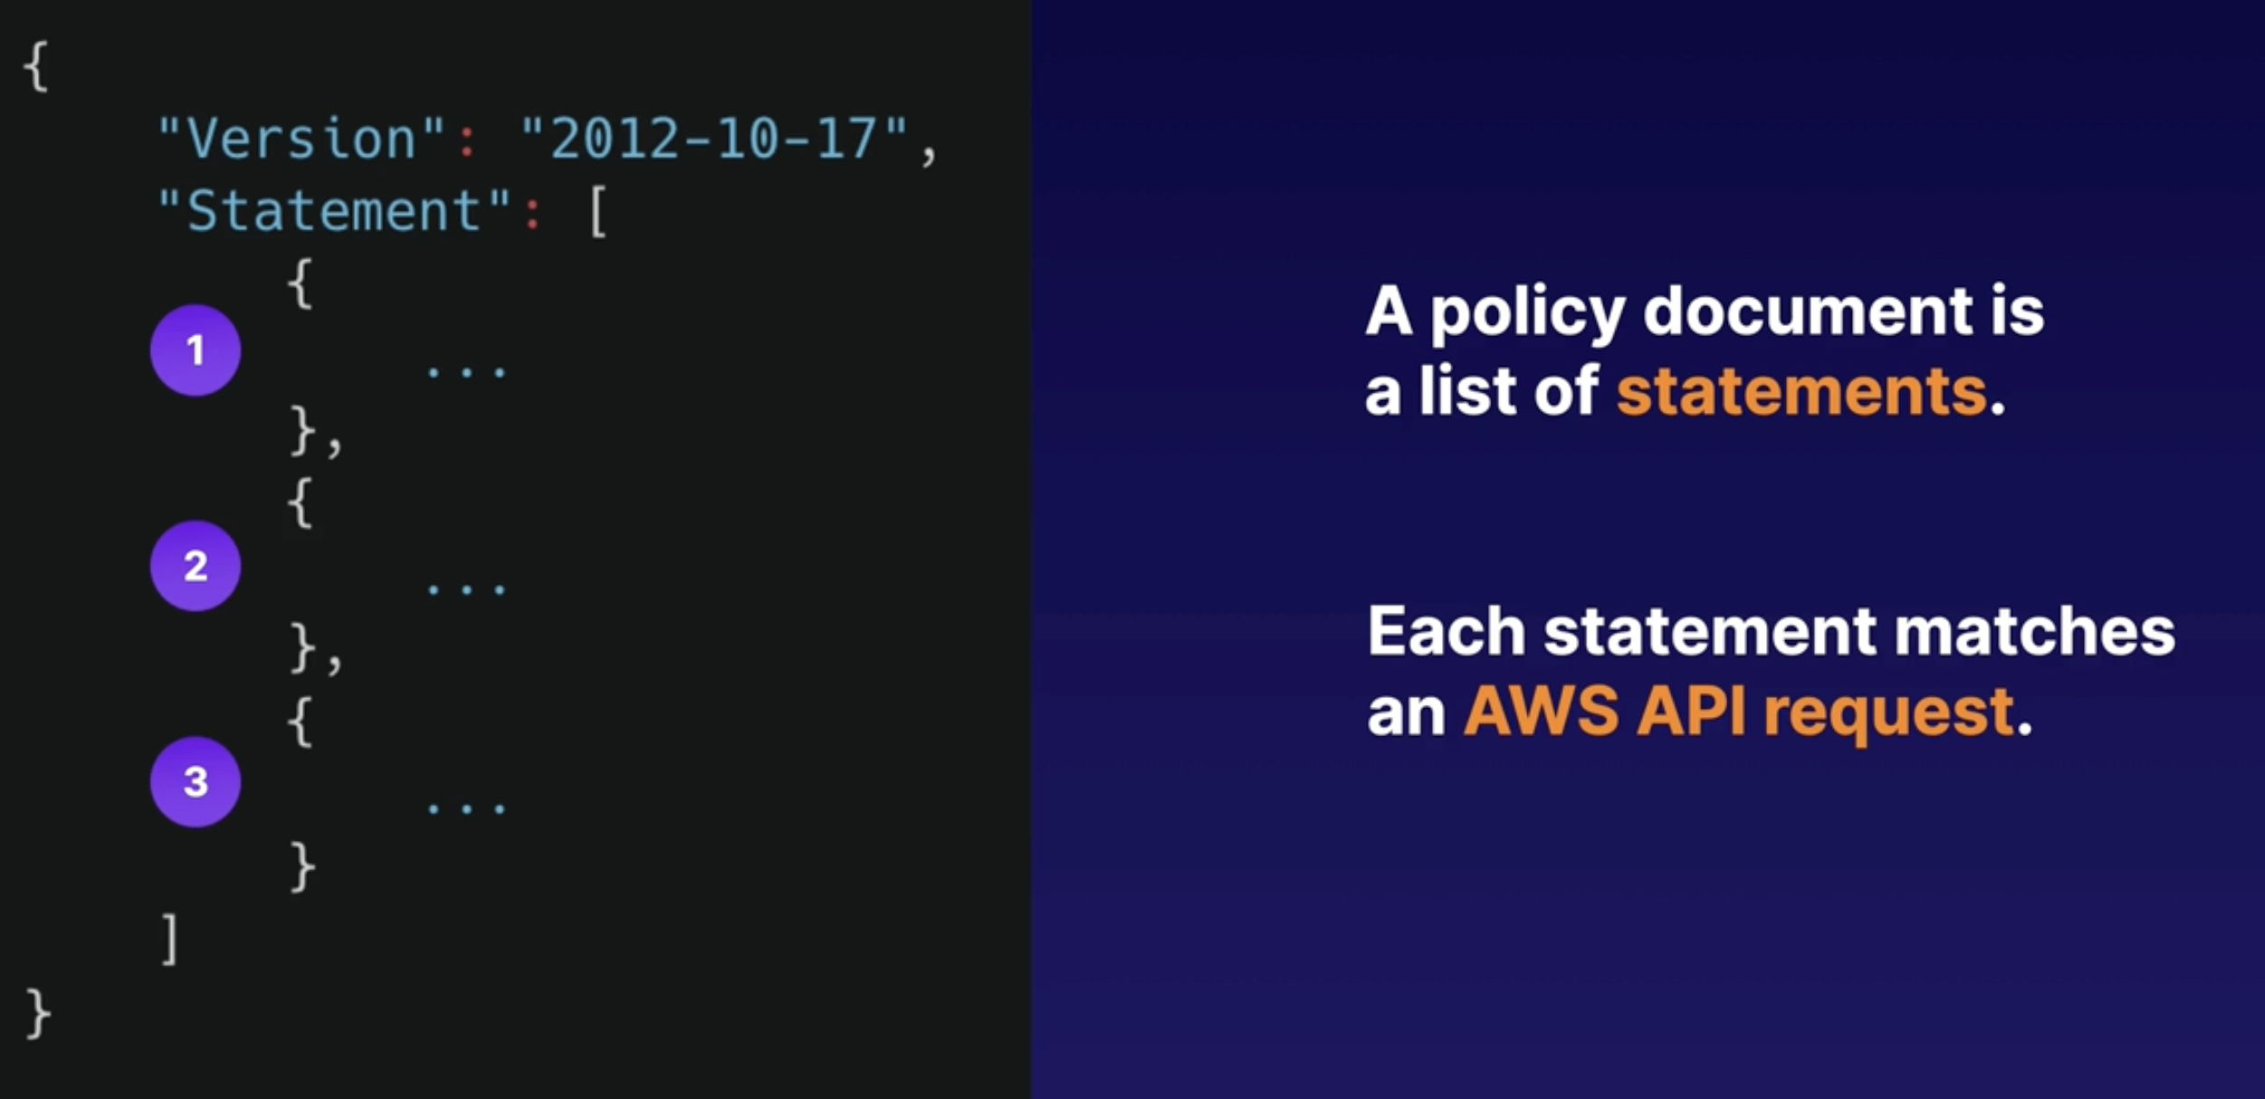

* It always starts with the version number, at the time of the capture is 2012-10-17
* Then we have the Statement, which starts with a square bracket.
* Then a policy document is just a List of statements {}{}{} 🡪 3 statements here.
* Each statement matches an AWS API request.
  + Every time you are using the AWS Console or programmatically, you are making an API request.
  + Example:
    - You provision an EC2 instance, that’s an API request
    - If you create an IAM user, another API request.
    - If we retrieve an object from S3, API request.

**More concrete example of IAM policy:**

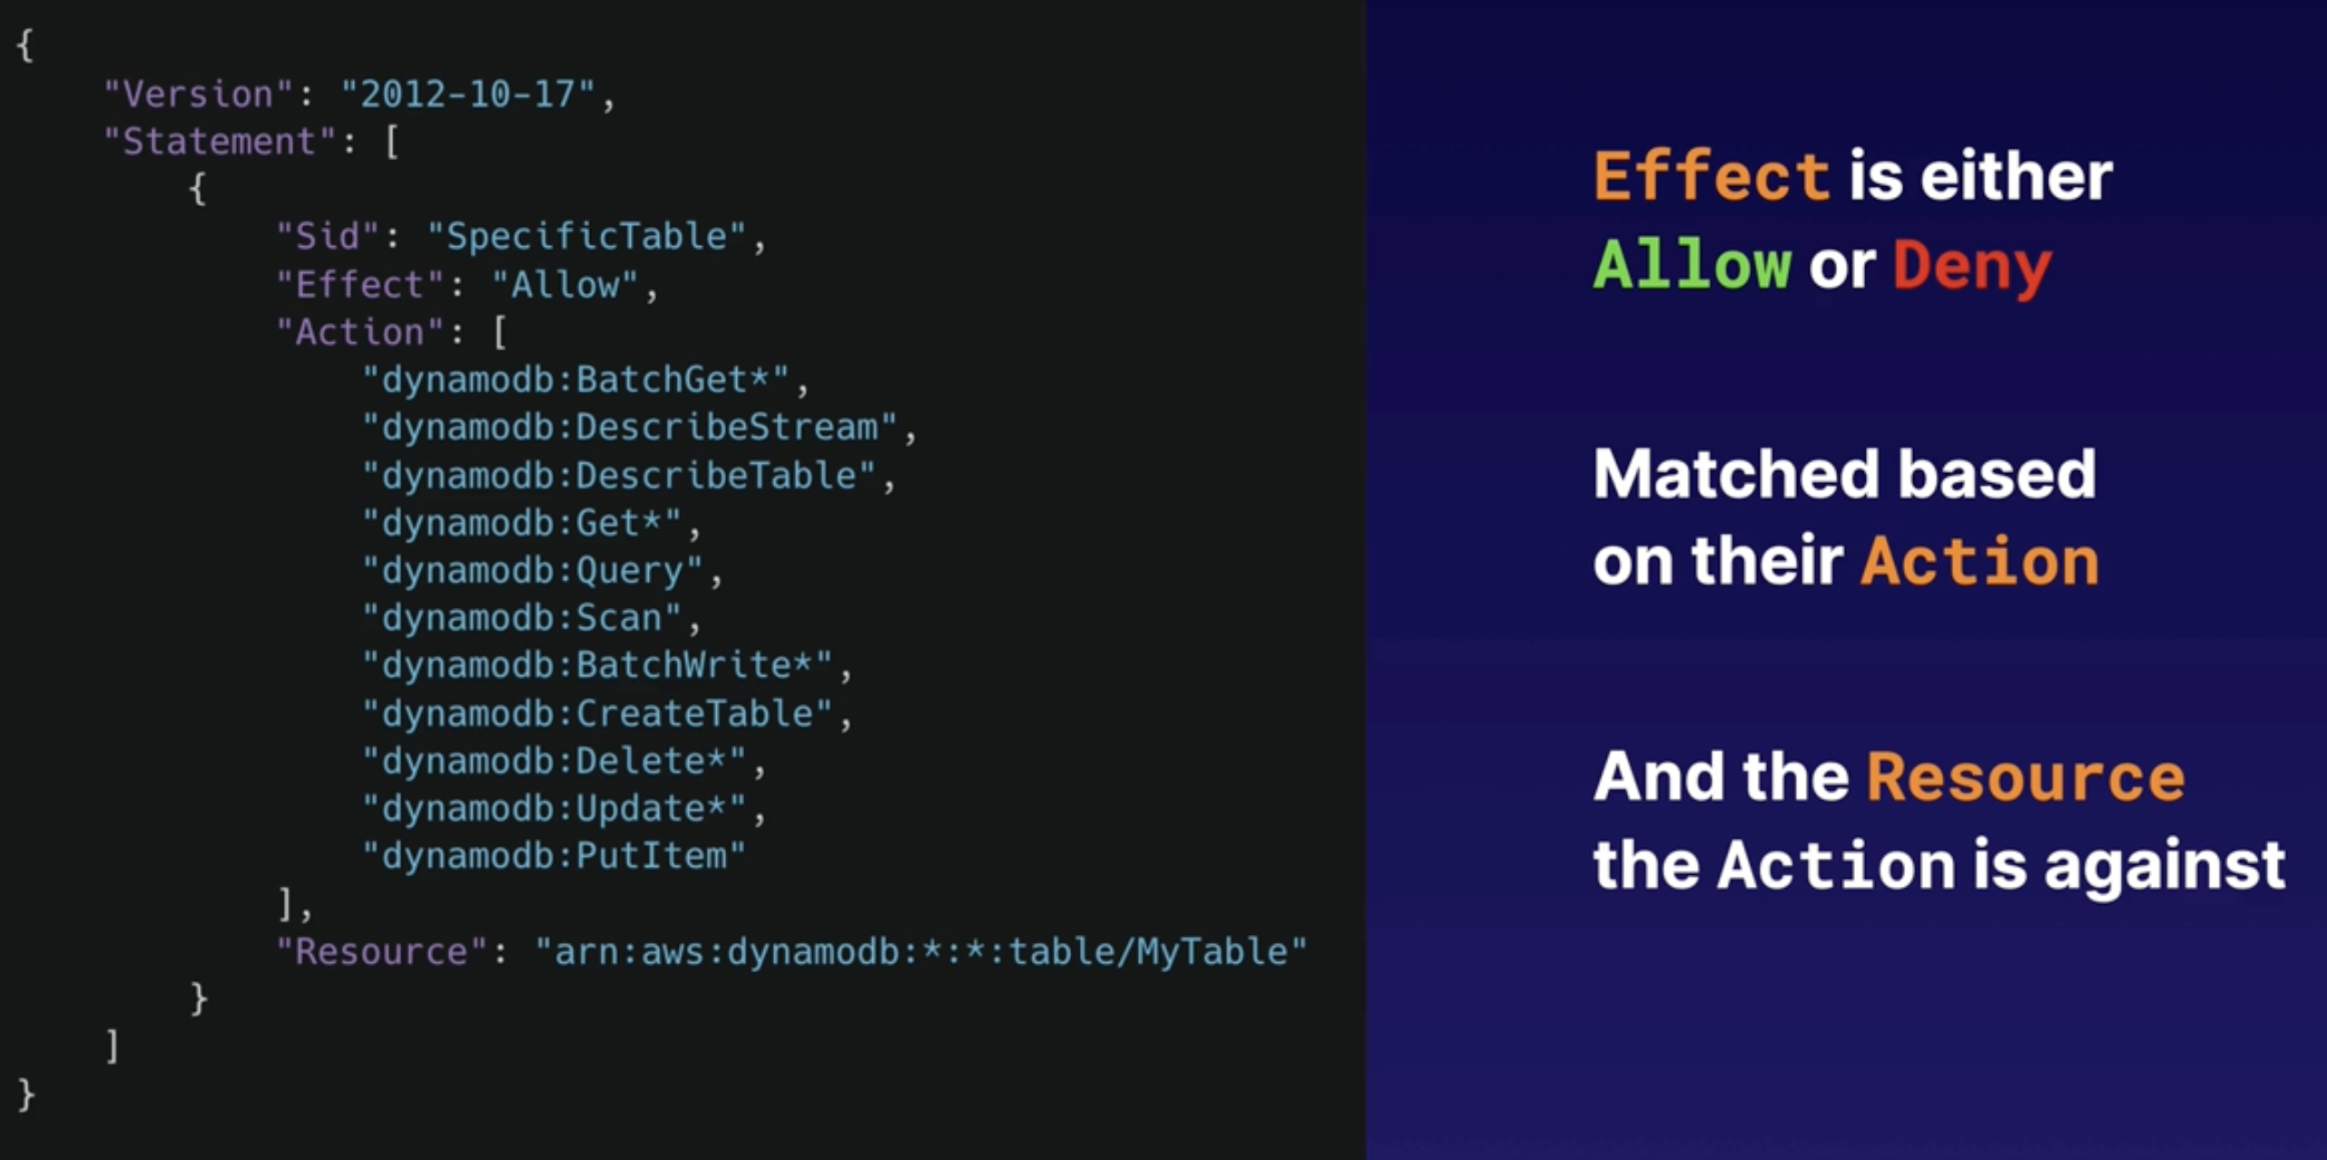

* We have the version and the statement.
* The first thing we see in the statement is the Sid (Statement ID), which is a human readable string that tells you what this policy is going to do.
* Then we have an Effect, which either an Allow or Deny.
* In this particular case we are going to allow an action and we are going to define what actions we allow with which AWS service.
* We are going to allow a few DynamoDB actions.
  + Actions with Wildcard (*) means that takes everything that comes later, example: “dynamodb: Delete*" , it will take as well Delete, DeleteItem or DeleteTable and any action that starts with Delete…
* The Resource is what the action is against.

**Permission Boundaries:**

* Used to delegate administration to other users.
* Prevent privilege escalation or unnecessarily broad permissions.
* Control maximum permissions an IAM policy can grant.
* **Use Cases:**
  + Developers creating roles for Lambda functions.
  + Application owners creating roles for EC2 instances.
  + Admins creating ad hoc users.

**Exam Tips:**

* Not explicitly allowed == implicitly denied
* Explicit deny › everything else.
  + Example: You have an S3 explicitly denied, if you have an allow below it doesn’t matter, will be denied by the one before. An explicit deny is greater than anything else.
* Only attached policies have effect.
* AWS joins all applicable policies.
* AWS managed and customer managed.

**AWS Certificate Manager:**

**What is Certificate Manager:**

* AWS Certificate Manager allows you to create, manage, and deploy public and private SSL certificates for use with other AWS services.
* It integrates with other services - such as Elastic Load Balancing, CloudFront distributions, and API Gateway - allowing you to easily manage and deploy SSL certificates in your AWS environment.

**Benefits of AWS Certificate Manager:**

1. **Cost:** No more paying for SSL certificates. AWS Certificate Manager provisions both public and private certificates for free. You will still pay for the resources that utilize your certificates (such as Elastic Load Balancing).
2. **Automated Renewals and Deployment:** Certificate Manager can automate the renewal of your SSL certificate and then automatically update the new certificate with ACM-integrated services, such as Elastic Load Balancing, CloudFront, and API Gateway.
3. **Easier to Set Up:** Removes a lot of the manual process, such as generating a key pair or creating a certificate signing request (CSR). You can create your own SSL certificate with just a few clicks in the AWS Management Console.

**Exam Tips:**

* **Know What It Is:** In the exam, you will get scenario-based questions around SSL certificates and what services you should use to integrate SSL certificates.
* **Supported Services:** AWS Certificate Manager integrates with Elastic Load Balancing, CloudFront, and API Gateway.
* **Benefits:** AWS Certificate Manager is a free service that saves time and money. Automatically renew your SSL certificates and rotate the old certificates with new certificates with supported AWS services.

**Auditing Continuously with AWS Audit Manager:**

**What is Audit Manager:**

* With it, you can continually audit your AWS usage to make sure you stay compliant with industry standards and regulations.
* Audit Manager is an automated service that produces reports specific to auditors for PCI compliance, GDPR, and more.

**Use Cases:**

* **Transition from Manual to Automated Evidence Collection:** It allows you to produce automated reports for auditors and reduces the need to compile these reports manually.
* **Continuous Auditing and Compliance:** It works on a continuous basis so that, as your AWS environment evolves and adapts, you can produce automated reports to evaluate your environment against industry standards (such as PCI compliance).
* **Internal Risk Assessments:** You can create a new framework from the beginning or customize prebuilt frameworks. You can also launch assessments to automatically collect evidence, helping you validate if your internal policies are being followed.

**Exam Tips:**

* **Continuous Audits with AWS Audit Manager:** If you have a scenario question about HIPAA or GDPR compliance that asks about continuous auditing or automating auditing reports...

**Downloading Compliance Documents from AWS Artifact:**

**What Is Artifact:** **It’s a distractor for the exam.**

* Artifact is a single source you can visit to get the compliance-related information that matters to you, such as AWS security and compliance reports or select online agreements.

**What's Available:**

* There are a huge number ofcompliance reports available, such as AWS Service Organization Control (SOC) reports, Payment Card Industry (PCI) reports, and GDPR reports, as well as other certifications (including ISO reports, HIPAA, and more).

**Demo:**

* AWS Artifact – View Reports – search for: pci – click on the one you want – you can download it.

**Exam Tips:**

* This comes up in the exam quite a bit and is often used as a distractor.
* You simply have to know what it is.
* See a scenario question asking about audits and the need for compliance reports?
* Think AWS Artifact.

**Authenticating Access with Amazon Cognito:**

**What Is Cognito:**

* Cognito provides authentication, authorization, and user management for your web and mobile apps in a single service without the need for custom code.
* Your users can sign in directly with a username and password they create or through a third party (e.g., Facebook, Amazon, Google, or Apple).

**Cognito provides the following features:**

* Sign-up and sign-in options for your apps
* Access for guest users
* Acts as an identity broker between your application and web ID providers, so you don't need to write any custom code.
* Synchronizes user data across multiple devices.
* Recommended for all mobile applications that call AWS services.

**Use Cases:**

* **Authentication:** Users can sign in using a user pool or a third-party identity provider, such as Facebook.
* **Third-Party Authentication:** Users can authenticate using identity pools that require an identity provider (IdP) token.
* **Access Server-Side Resources:** A signed-in user is given a token that allows them access to resources that you specify.
* **Access AWS AppSync Resources:** Users can be given access to AppSync resources with tokens received from a user or identity pool in Cognito.

**User Pools and Identity Pools:**

* The two main components of Cognito are user pools and identity pools.
* User pools are directories of users that provide sign-up and sign-in options for your application users.
* Identity pools allow you to give your users access to other AWS services. You can use identity pools and user pools either separately or together.

**How it works:**

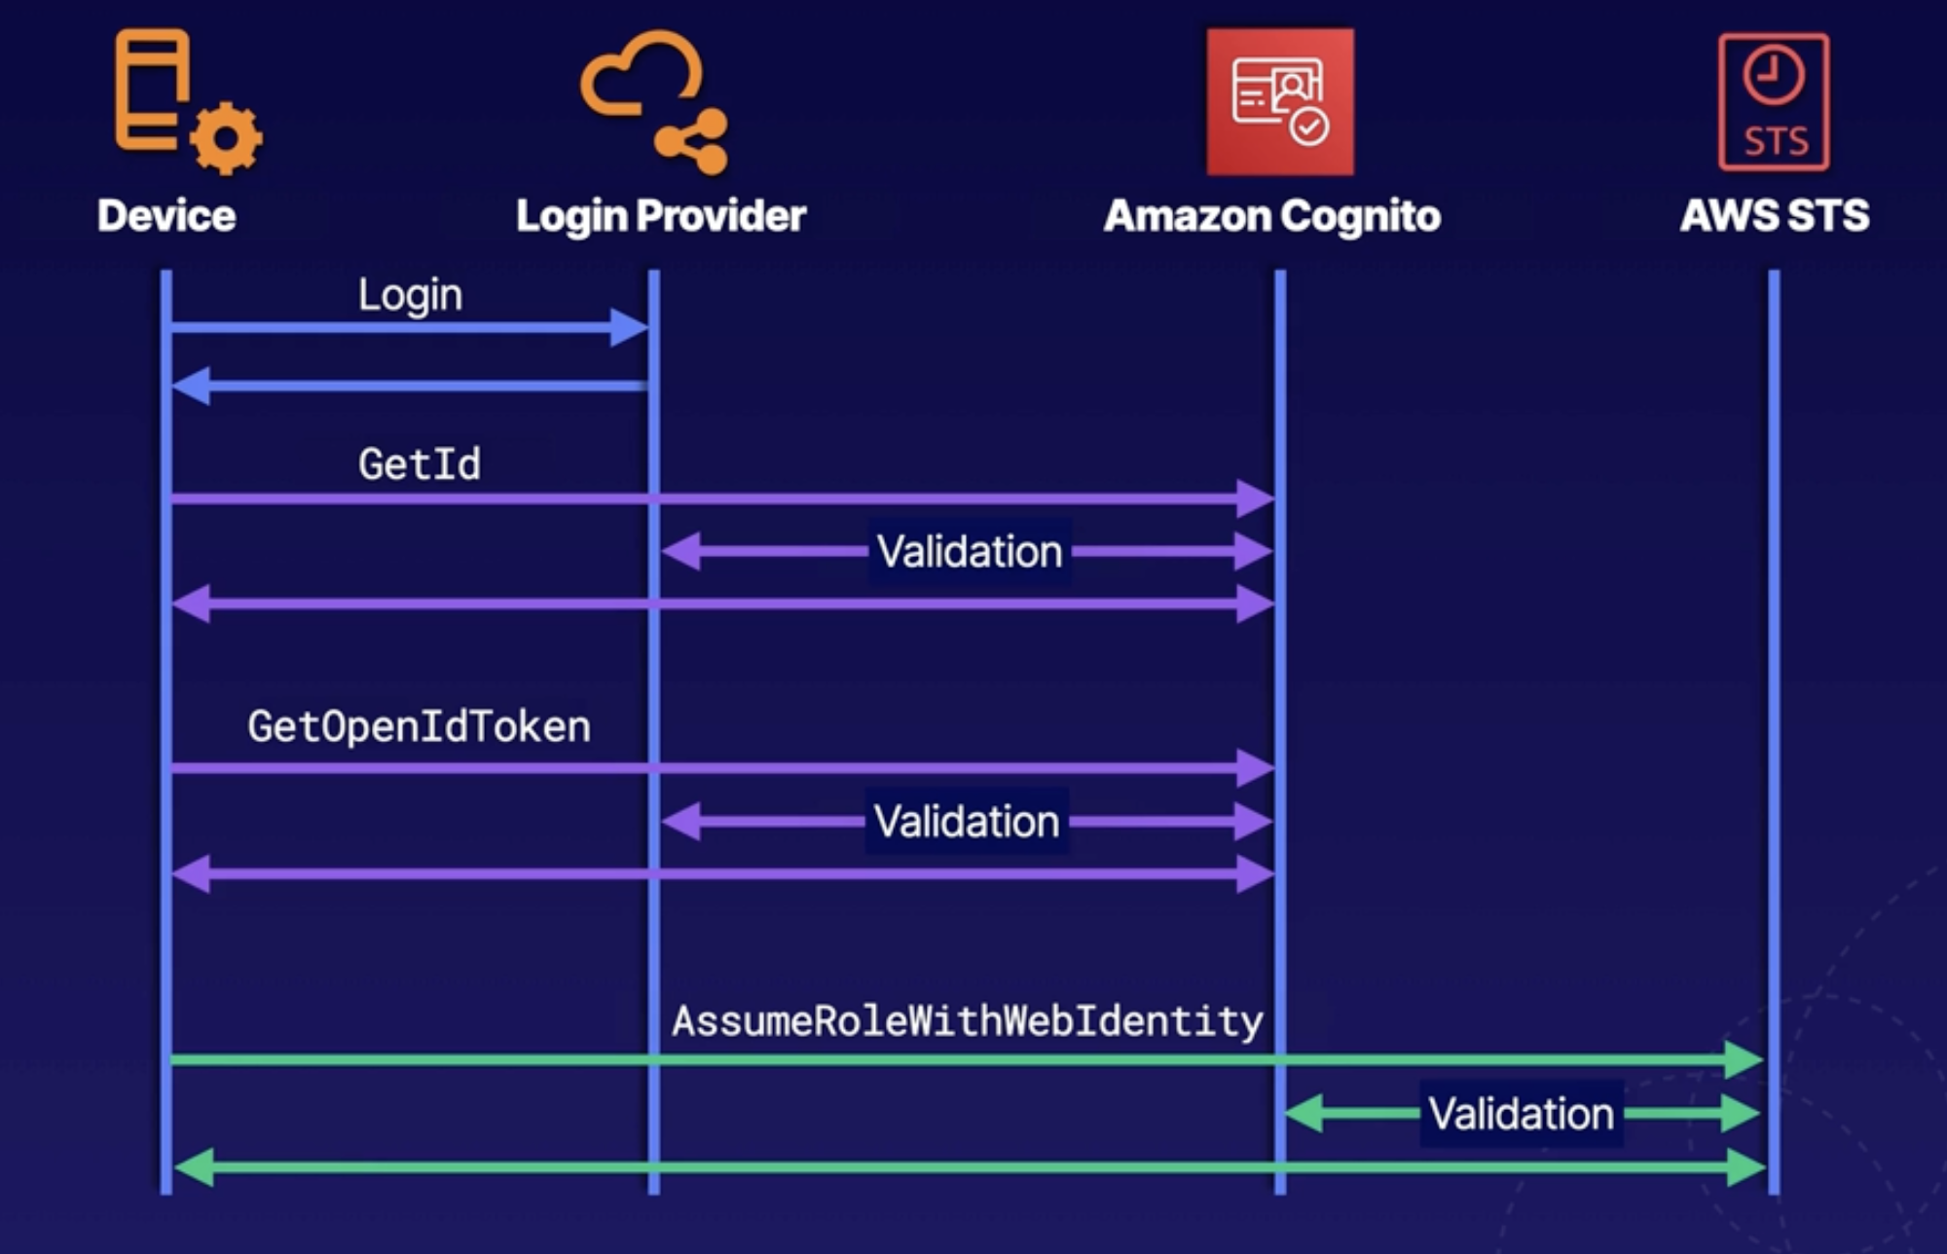

* Our device sends a login request to a login provider, then it’ll send a GetId request to Amazon Cognito.
* Cognito will do a validation to the login provider to make sure that you are an authorized user.
* Then you send a GetOpenIdToken to Cognito. It will do the validation with the login provider.
* Then you get an AsumeRoleWithWebIdentity, which is sent to STS (Security Token Service).
* And then validates back against Cognito.

**Cognito Sequence: You need to know this for the exam.**

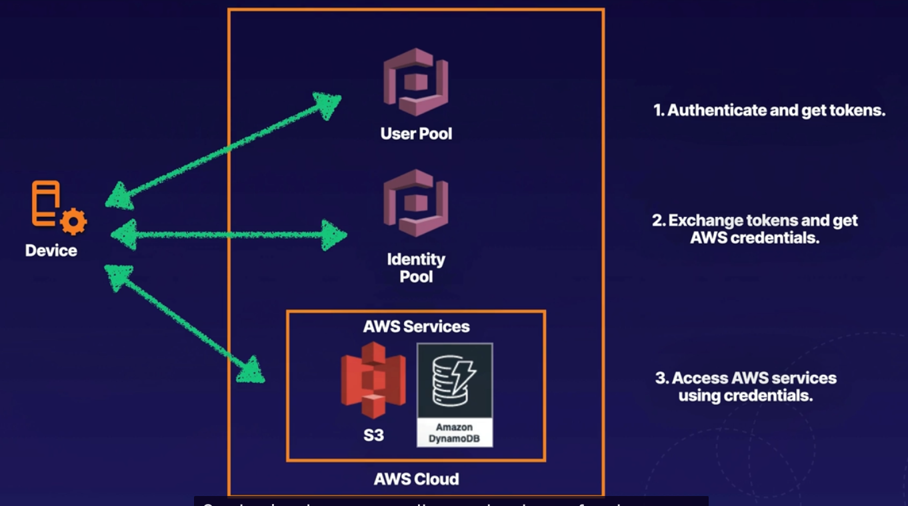

1. You have an app on your phone, and you try to log in and access the resource that application is designed to use.
   1. Example: Use Dropbox app and store files up in S3.
2. You are using your Dropbox app and it’s connecting to a user pool in Cognito.
3. You are authenticating and getting tokens.
4. Once you got that token your device will exchange that token with an identity pool.
5. The identity pool will give some AWS credentials.
6. You can use those AWS credentials to access your AWS services.

**Exam Tips:**

* User pool: User directories that provide sign-up and sign-in options for users of your application.
* Identity pool: Allows your users to access other AWS services.
* You can use identity pools and user pools separately or together.

* Remember the Cognito Sequence above.

**Analyzing Root Cause Using Amazon Detective:**

**What Is Detective:**

* Using Detective, you can analyse, investigate, and quickly identify the root cause of potential security issues or suspicious activities.
* Detective pulls data in from your AWS resources and uses machine learning, statistical analysis, and graph theory to build a linked set of data that enables you to quickly figure out the root cause of your security issue.

**Detective Sources:**

* Detective uses a number of sources within your AWS account (including VPC Flow Logs, Cloud Trail logs, Amazon Elastic Kubernetes Service audit logs, and Amazon GuardDuty findings) to automatically create an overview of your users, resources, and the interactions between them over time.

**Detective Sources:**

* **Triage Security Findings:**
  + If you have a suspected security instance, you need to be able to quickly assess if it's in fact real or a false positive.
  + Detective generates visualizations that can show you what resources, IP addresses, and AWS accounts are connected to your security incident to determine if the finding is an actual malicious activity or not.

* **Threat Hunting:**
  + In comparison to root cause analysis, you can also be proactive and go threat hunting.
  + Detective helps with threat hunting by creating detailed visualizations on specific resources, such as IP addresses, AWS accounts, VPC, and EC2 instances.

**Exam Tips:**

* Detective operates across multiple AWS services and analyzes the root cause of an event.
* Do not confuse this with Inspector, which is an automated vulnerability management service that continually scans EC2 and container workloads for software vulnerabilities and unintended network exposure.
* Detective can be a distractor.

**Protecting VPCs with AWS Network Firewall:**

**What is AWS Network Firewall:**

* Network Firewall is a managed service that makes it easy to deploy physical firewall protection across your VPCs. It has a managed infrastructure (i.e., a physical firewall that is managed by AWS).
* Network Firewall includes a firewall rules engine that gives you complete control over your network traffic, allowing you to do things such as block outbound Server Message Block (SMB) requests to stop the spread of malicious activity.

**Benefits of Network Firewall:**

* Network Firewall has physical infrastructure in the AWS datacenter that is managed by AWS staff — so you don't need to worry about management overheads.
* AWS Network Firewall works with AWS Firewall Manager, so you can centrally manage security policies across existing and newly created accounts and VPCs. It also provides an intrusion prevention system (IPS) that gives you active traffic flow inspection.

**Use Cases:**

* **Filter Internet Traffic:** You can use methods like access control list (ACL) rules, stateful inspection, protocol detection, and intrusion prevention to filter your internet traffic.
* **Filter Outbound Traffic:** You can use a network firewall to provide the URL/ domain name, IP address, and content-based outbound traffic filtering. This will help you to stop possible data loss and block known malware communications.
* **Inspect VPC-to-VPC Traffic:** You can automatically inspect traffic moving from oneVPC to another as well as across multiple accounts.

**Exam Tips:**

* If you have a scenario question about filtering your network traffic before it reaches your internet gateway, or if you require intrusion prevention systems or any hardware firewall requirements think about **AWS Network Firewall.**

**Leveraging AWS Security Hub for Collecting Security Data:**

**What Is Security Hub:**

* Security Hub is a single place to view all your security alerts from services like Amazon GuardDuty, Amazon Inspector, Amazon Macie, and AWS Firewall Manager.
* It works across multiple accounts.

**Use Cases for Security Hub:**

* **Conduct Cloud Security Posture Management (CSPM):** Use automated checks that comply with common frameworks (such as CIS or PCI DSS) to help reduce your risk.
* **Correlate Security Findings to Discover New Insights:** Aggregate all your security findings in one place, allowing your security staff to more easily identify threats and alerts.

**Exam Tips:**

* If you have a scenario question about a single place to view all your security alerts across multiple AWS security services and accounts...
* Think AWS Security Hub.